Tidewater Winds Alto/Bari Saxophone Audition

1
Ferling
Etude
Measure 1 to fermatta
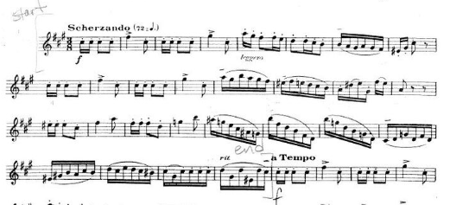
2
Holst
2nd Suite in F
2nd Mvt. Letter [A] to Fine
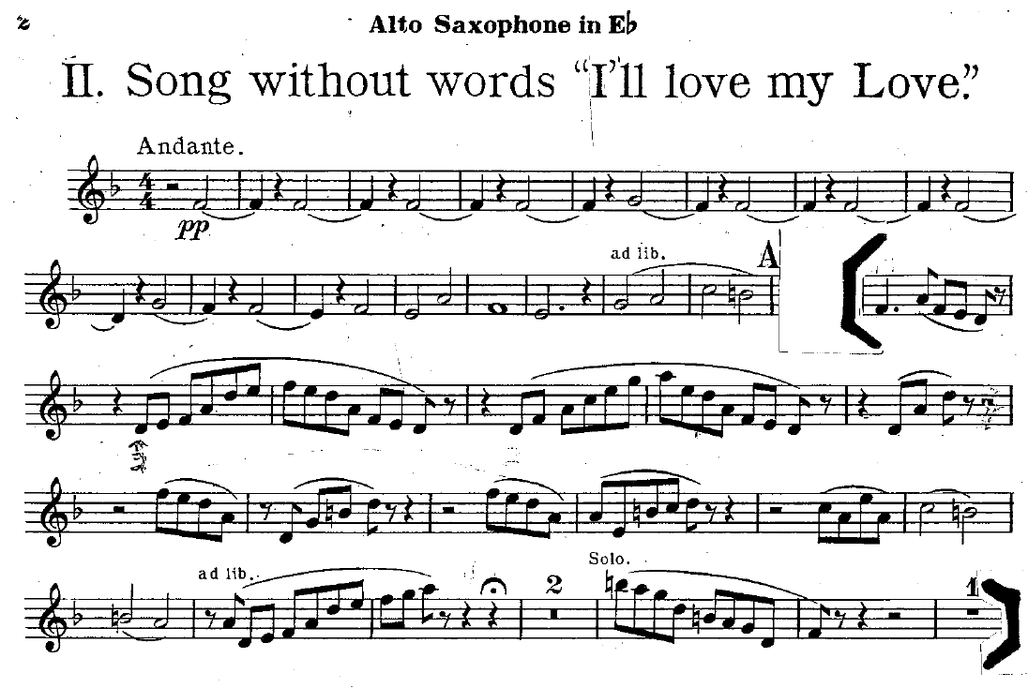

3
Holst
Second Suite in F
Mvt. III, Measure 6 to Fine
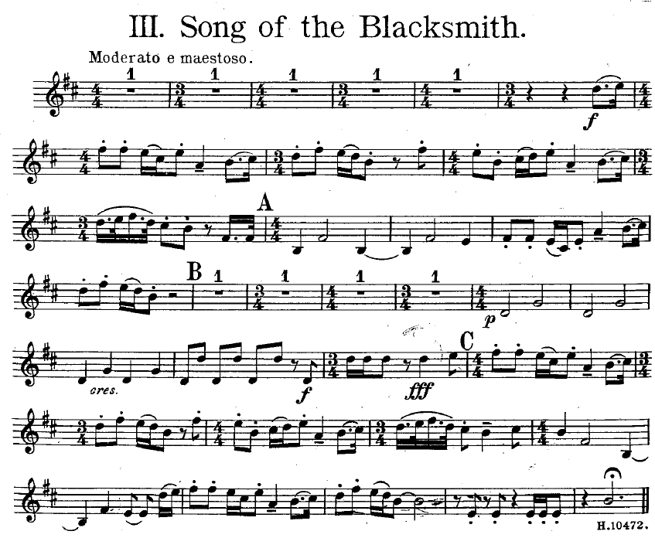

4
Jazz Excerpt
Entire Etude – Swing
♩=160
♩=142 (Bari)

