Tidewater Winds Tenor Saxophone Audition

1
Ferling
Etude
Measure 1 to fermata
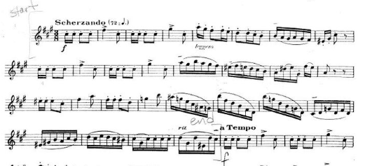
2
Holst
2nd Suite in F
1st Mvt. Letter [H] to 8 after [K]
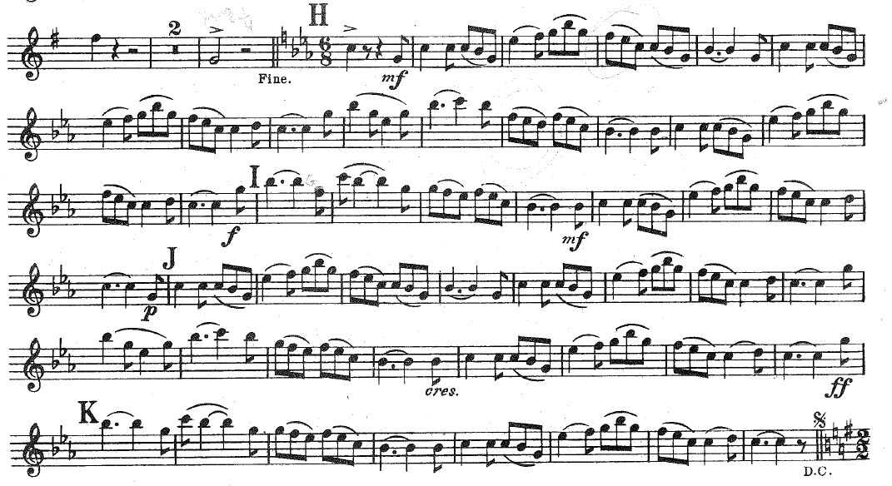

3
Reed
Armenian Dances, Part II
Mvt. I, Measure [17] to 5 after [41]

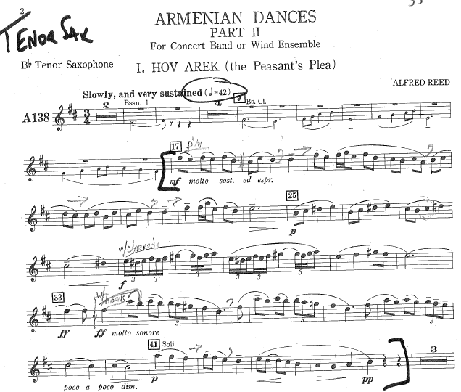

4
Jazz Excerpt
Entire Etude – Swing
♩=160
