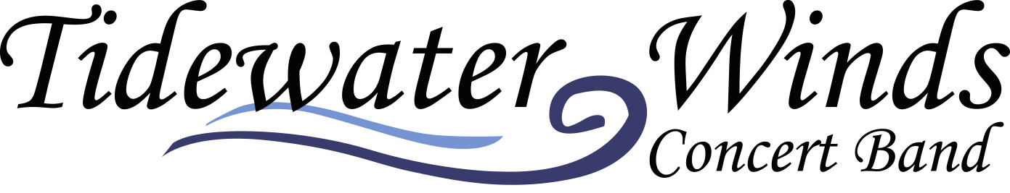

Tidewater Winds Concert Band
presents
Student Intern Auditions 2020

Limited seats are offered as part of our summer education music intern program. Promising students are selected to perform side-by-side with our professional musicians during the summer. Each student will serve as an ambassador to their home city while representing the Tidewater Winds. Those accepted receive…

- Master Classes
- Lesson Vouchers
- Mentoring
- Guest Speakers
- Professional Training
- Ensemble Training
- Music Career Class

Audition repertoire is on our web site

Tentative Audition Date is May, 2020… Location TBA!
http://www.tidewaterwinds.org/audition-information!

