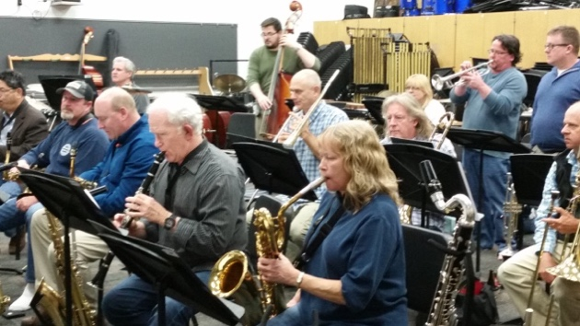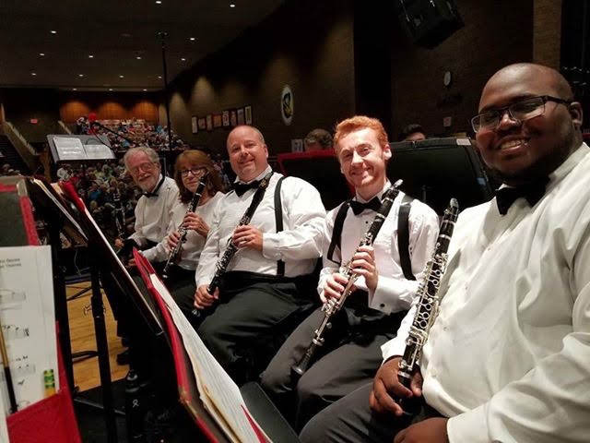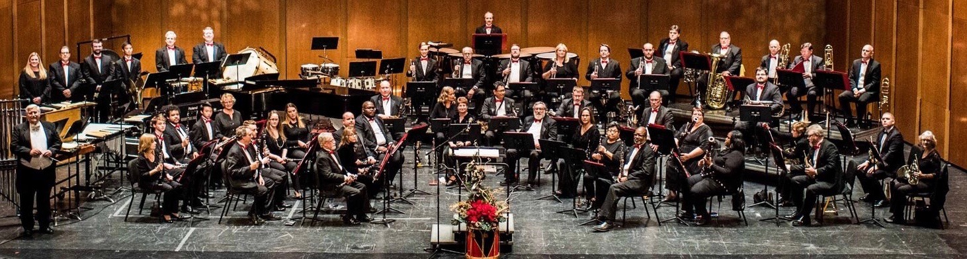

[**WWW.TIDEWATERWINDS.ORG**](http://WWW.TIDEWATERWINDS.ORG)

**757-480-0953**

STUDENT MASTER CLASSES

TIDEWATER WINDS IN PARTNERSHIP WITH VIRGINIA BEACH PUBLIC SCHOOLS AND THE VIRGINIA BEACH FINE ARTS COMMISSION PRESENT A SERIES OF 7 MASTER CLASSES AND ONE PERFORMANCE FOR MIDDLE AND HIGH SCHOOL BAND STUDENTS. THE SERIES OF PRE-RECORDED VIDEO INSTRUCTIONS CAN BE ACCESSED BY YOUR MUSIC TEACHER AND IS FREE TO USE AS A LESSON GUIDE, INSTRUCTION PROMPT OR SUPPLEMENTARY TRAINING FOR BAND AND GENERAL MUSIC STUDENTS.

[WWW.TIDEWATERWINDS.ORG](http://WWW.TIDEWATERWINDS.ORG)

TIDEWATER WINDS MUSICIANS AND STAFF ARE HERE FOR OUR MUSIC EDUCATORS AND STUDENTS WITH ANY SUPPORT YOU MAY NEED AS YOU TRANSITION BACK TO NORMAL CLASSROOM INSTRUCTION SOON!

**757-480-0953**

**WWW.TIDEWATERWINDS.ORG**

*Exceptional Programming*

View