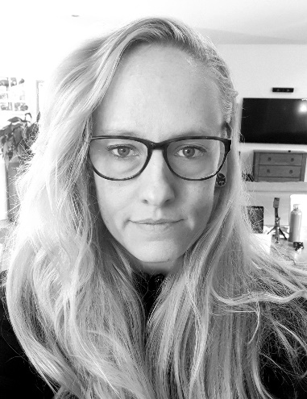About **Me**

I'm Claire Greenhalgh, a Zimbabwe-born, Australian maverick, provocateur, and challenger of the status quo, who immigrated to Melbourne in the 80s. I have 2 children, a husband and a dog who are the centre of my universe.

My journey has been driven by a deep passion for helping people live abundantly while leaving minimal footprints (an endeavour that I consider combines “shovelling shit uphill” and then nurturing seeds into a forest.)

I hold a Bachelor of Applied Science from Deakin University (2000) and embarked on a Master of Environmental Management from Melbourne University (incomplete) to further deepen my understanding of scientific processes. Balancing boldness with practicality, I possess a unique ability to envision and shape the future, and I'm driven by a relentless passion for sustainable innovation *within* the current economic system. Currently, my focus is on disrupting the market with a cutting-edge solution that holds a no-loose outcome.

Throughout my entrepreneurial journey spanning over 7 years, I've become adept at wearing multiple hats and tackling various roles within companies. I've successfully navigated challenges over the last few years, from pre-pandemic establishing and running a community sustainability activity centre (Social Enterprise), to establishing a six-figure, boutique, eco-retail refillery store, during the pandemic.

In every aspect of my work, I approach problem-solving with a hands-on mindset. A fundamental aspect of my work is to gain a deep understanding of customer’s needs. By empathizing with their desires and concerns, I am able to deliver exceptional value through tailored solutions. By prioritizing customer feedback and engaging in ongoing dialogue, I consistently strive to refine and enhance the experiences my ventures provide. Building these long-lasting, reciprocal relationships are at the core of my successes.

My dedication extends beyond business success. I am deeply committed to social and environmental causes, consistently striving to integrate charitable goals into all of my ventures. This commitment was recognized with the prestigious Wodonga Council Eagle Award at the Australia Day Celebrations in 2018.

I am now obsessed with bringing “The Product Pod Machine” to market and arranging a foundation for the economic success of this evolution for all businesses globally.

Thank you for taking the time to learn a little about my highlights. I'm eager to connect with you and discover more about your own journey and how I can help you make the world a better place.

Big Love - Claire