Support missionaries for Casa Hogar de Oasis
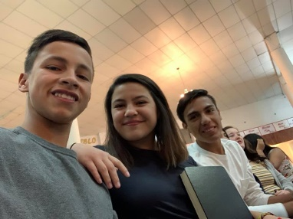
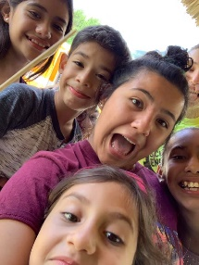
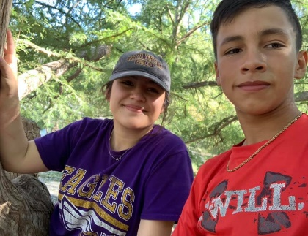
I am __(name)______ and I am planning to go to Mexico with Al Gains in his mission work with Kids at the Casa. We serve at an orphanage where we seek to help the orphans by creating personal relationships with the kids, providing labor work to repair the facility, deliver different messages of the bible each night, and on occasion take the kids out to explore their city as they rarely are allowed to go outside of the facility. While we have made great strides, there is always more to accomplish. The trip will be __(date)_____. I will be ____(fundraiser)____ on ____(date)_________ where donations will be accepted as well.

My cost for this trip is $_________.

Would you consider financially supporting this mission trip? The casa has a list of needs (I have also enclosed the needs list) if you have anything you want to donate to the casa. Mostly I would appreciate prayer. If you have any questions, I would be happy to provide you with more information about how you can help support or be a part of this mission. To learn more about our mission, check out https://kidsatthecasa.com/. If you wish to contribute checks can be made out to _____(name)_________. If you want to support the organization instead, checks can be made out to Kids at the Casa. Please join us if you feel called!
Sincerely,
__(sign name)_____
__(print name)_____
____(number)____________
____(email)____________
