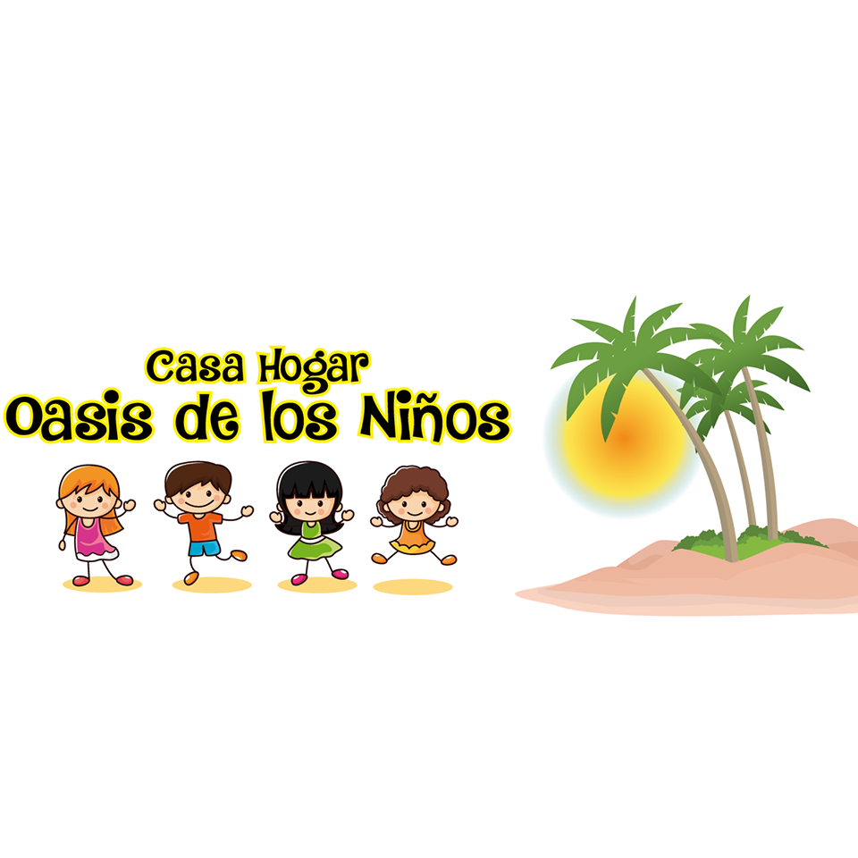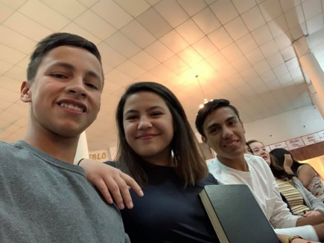

**[Insert Photo of Self]**

**[Insert Phone Number]**

**[Insert Email]**

**http://kidsatthecasa.com**

**What do we do?**

* Create connections with the kids
  + These kids are so used to people leaving them. It is important to me that these kids know that they are loved and wanted.
* Give nightly messages from the Bible
  + Most importantly, these kids need to know that they are loved by God.
* Labor work around the facility
  + The directors work tirelessly everyday to care for the kids. Our labor work keeps the facility up to date and helps the directors take a little break.
* Provide financial, spiritual, and physical support

**About Me…**

My name is [Insert Name] and I am [Insert Age] years old.

[Insert information about yourself]

[Include why you want to take this trip]

Thank you in advance for any support!