2021 Vision & Goal Setting
2021 Vision
Vision is God-given, while ambition is man-made
Habakkuk 2:2
“And the Lord answered me, and said, Write the vision, and make it plain upon tablets, that he may run that readeth it. For the vision is yet for an appointed time, but at the end it shall speak, and not lie: though it tarry, wait for it, because it will surely come, it will not tarry.” ~KJV
A vision board is simply a tool you can use to help keep your vision in front of you. It is any sort of board (a note book, poster board, computer, iPad etc) on which you display images, pictures, quotes, scriptures etc that represent whatever God has called you to be, do or have in your life. In addition to this or incorporated within your vision board, you will want to write your vision out to review periodically.
Year in Review 2020:
1. What accomplishments did you see in 2020?

2. What new skills or good habits did you acquire?

3. Looking back over the past 12 months what do you feel good about?

4. What has been your most significant learning in 2020?

5. What would you have done differently?

Whole Life Prosperity – Write Your Personal Goals for 2021
Goal setting is a helpful way to build the life you want. By setting objectives and creating a clear roadmap for how you’ll reach your intended target, you can decide how to apply your time and resources to make progress. Without goals, it can be difficult to determine how to get a certain job, promotion or other milestones you want to achieve.
When you set an objective for yourself, you should include each step necessary for success. To help, you can use a framework called SMART goals. Here’s how SMART goals work and a few tips and examples to assist you in your goal-setting effort

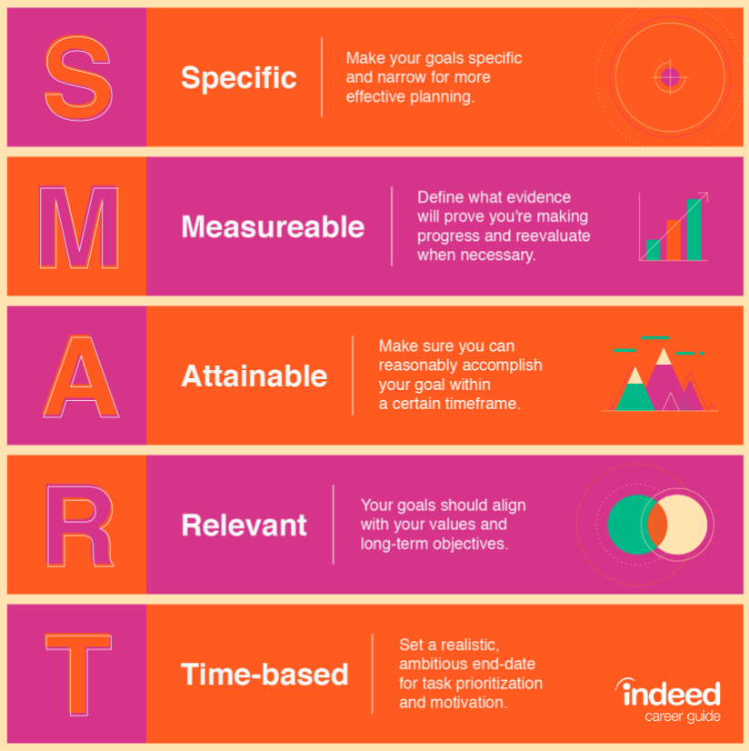

Whole Life Prosperity – Write Your Personal Goals for 2021

• Spiritual – Your spiritual life touched EVERY part of your life. Attend religious services, read religious publications, meditate and pray more, more effort in loving and serving others

• Soul – Mind, Will and emotions: Life follows your most dominant thoughts and imaginations. Personal Development, Reading, writing, improve vocabulary

• Physical – Our health is our wealth. Sports skill, different weight, eating right, exercise schedule

• Family – Balance your life and build healthy relations. Quality time, relationship with spouse, parents, relatives, new family activity

• Financial – Wealth is like a strong city and poverty is destructive. Retirement savings, Investment, Education Fund, Business Capital

• Social - Make new friends, dress & look your best, club activities,New Recreational pursuits

• Professional - Continuing Skills or Education, Management Promotion

• Community Support - Service Organizations, volunteer Work, Civic Office or Committees

How Do You Accomplish Your Goal?
- Define the goal.
- If your goal is long term, set shorter “sub-goals” that will help you accomplish it.
- Identify small steps to achieve each sub-goal.
- Consider the possible obstacles to your goals and brainstorm solutions to each.
- Take time to reassess your goal periodically. Be resilient! Modify your goal if necessary.

Key Steps to Achieve Your Goals in 2021
- Renew your mind – Beliefs make up your self-image
- Guard your mouth – Confessions of your mouth come to pass
- Walk in love – Faith works by love, business is about relationships
- Be a giver not a taker – what you sow, you shall reap
- Be accountable
- You success is wrapped up in your daily successful activities
Visualizing Your Business
Form a clear mental picture of your successful SURGE365 business, and hold this picture in your thoughts with fixed PURPOSE to get what you want, and unwavering FAITH that YOU DO get what you want…Whatever the mind can conceive and believe—it can achieve!
6 Ways to Turn Desires into Gold – Refer to Think and Grow Rich - Napoleon Hill
1st Fix in your mind the exact amount of money you desire.

2nd Determine exactly what you desire to give in return for the money you desire.
3rd Establish a definite date when you intend to possess the money you desire.
4th Create a definite plan for carrying out your desire. Begin at once.
5th Write out a clear, concise statement.
6th Read your written statement aloud twice daily.

How to Set and Obtain Spiritual Goals
Pastor Cho in his book "The 4th Dimension," talks about steps to creative goal setting:
STEP 1: Set a faith goal. A clear-cut objective - write it down and see it clearly.
Your heart should skip a beat when you read it.
STEP 2: Passionately pursue the desire. See it, live it, sleep it, walk it...
Know that the Lord will satisfy the desires of your heart.
STEP 3: Pray and believe for the Assurance. Pray until your receive the assurance.
With the assurance, your faith will reach out and grab hold of your objective.
STEP 4: Command and speak it. Claim it and give the Word.
When you speak it the Word goes out to create it. Signs and wonders shall follow.
Surge365 S.M.A.R.T SBA Business Goal for 2021 – helping others by helping others help others
- Team Builder – 3 personal sales, require 6 sales if over 30 days
- Regional Builder – Five (5) $1,000 Team Builder Bonuses
- National Builder – Fifteen (15) $1,000 Team Builder Bonuses
- Level 1 Marketing Director (250)
- Level 2 Marketing Director (500)
- Level 3 Marketing Director (2000)
- Level 4 Marketing Director (5000)
- Level 5 Marketing Director (10,000)
- Level 6 Marketing Director (25,000)
- Level 7 Marketing Director (50,000)
- Level 8 Marketing Director (100,000)

Also plan and establish S.M.A.R.T goals as a Referring Travel Agent (RTA), based on your desires in travel.

5-Step SURGE365 Success Process - Sharing & Recruiting is your LIFE BLOOD!
- Make Your List (Memory Jogger at www.ettc-cs.com)
- Contact and Pique Interest
- Invite to see a Money & Marketing Seminar (LIVE or On-Demand)
- Follow Up/3-way/Edify Up-line & Close
- Duplicate-Teach Team to do steps 1-5

Close The Sale (ABC – Always Be Closing)
- What did you like best about what you saw?
- Do you see the VALUE this brings?
- What would you like to have happen next?
- What would stop you from partnering with me tonight? OR What would stop you from opening your business right now? (close the sale)
- What is your timeline?

Write Your Personal Affirmations for 2021
What Is An Affirmation?
- Affirmation is a declaration that something is true
- Self-talk or inner dialogue
- A reflection of our inner truth or beliefs—True or False
- An affirmation is a carefully formatted statement that should be repeated to one's self and written down frequently.

Applying Affirmations
- You can use "Positive Affirmations", which are usually short positive statements targeted at a specific subconscious set of beliefs, to challenge and undermine negative beliefs and to replace them with positive self-nurturing beliefs.
- It is a kind of "brainwashing" only you get to choose which negative beliefs to wash away.

Why Affirmations Work
- Reprogramming the subconscious
- The mind is instinctively responds to something it believes to be true
- Continually repeating affirmations with conviction and passion will chip away at even the strongest resistance.
- 7 Days to form a habit and complete transformation in 2 years!

Writing Affirmations
- For an affirmation to be effective, it needs to be…
  - Present tense, Positive, Personal, and Specific.

How to create your own affirmations
- Start by taking some time to think about areas in your life you would like to improve and how you might want your life to be.
- Write the most important ones down in a list.
- Now look at each item on the list and write out a few positive statements for each. They must be positive and in the present tense, focus on what you do want, not on what you don't want.
- Creating your own affirmations is the perfect way to get the right affirmations for you.

The New You
- Because affirmations actually reprogram your thought patterns, they change the way you think and feel about things, and because you have replaced dysfunctional beliefs with your own new positive beliefs, positive change comes easily and naturally.

