DEPRESSION

Depression can happen to anyone - and does happen to one in four of us over our lifetimes. Different factors that make it more likely to happen include biological make-up, upbringing, or reaction to life events. What keeps it going though, is how we deal with those things. The way we think and what we do affects the way we feel. Depression is often accompanied by other feelings such as guilt, shame, anger and anxiety.
Thoughts

People who are depressed tend to think very negatively about themselves, the future and the world around them. It can be like seeing life through “gloomy specs”.
- Everything is hopeless - nothing can change
- I'm useless, worthless
- It's all my fault
- The world is a terrible place - everything goes wrong
We can dwell on these thoughts repeatedly, mulling over things, asking ourselves why, thinking regretful things about the past, what we should or shouldn't have done.
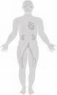
Physical Sensations
- Tiredness, fatigue, lethargy
- Difficulty concentrating or remembering
- Sleep changes (sleep more or less)
- Eating changes (eat more or less)
- Lose interest in hobbies, activities, sex
Behaviours
Because of the tiredness, difficulty sleeping and eating, and negative style of thinking, we tend to do less and less. We stop doing the things we used to do and enjoy. It could get so bad that we can't even go to work, or do things at home. We want to stay in bed, or stay at home doing very little. We might isolate ourselves from friends and family.

Vicious Cycle of Depression
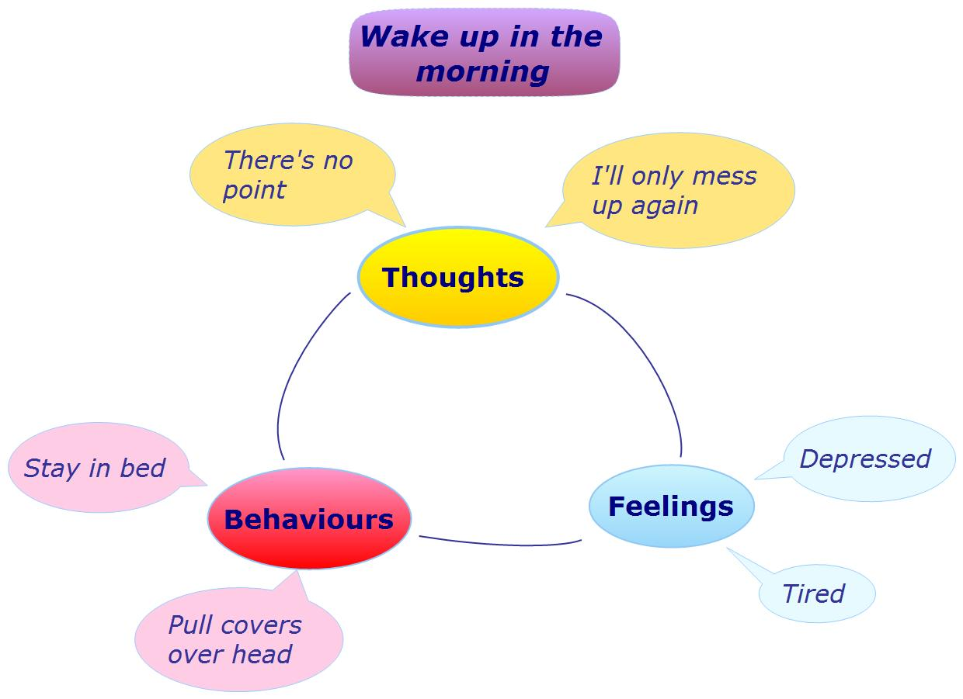
Breaking the cycle:


Activity & Physical Exercise
When we’re feeling depressed, we tend to do less and less because of the tiredness, difficulty sleeping and eating, and negative style of thinking. We stop doing the things we used to do and enjoy. It could get so bad that we can't even go to work, or do things at home. We want to stay in bed, or stay at home doing very little, and we might isolate ourselves from friends and family.

Just increasing our activity and exercise levels can make an enormous impact on our mood by:
- Making us feel better about ourselves
- Making us feel less tired
- Motivating us to do more
- Improving our ability to think more clearly
- Helping us think about something other than focussing on our unhelpful thoughts
- Using up the adrenaline resources created by anxiety and anger

- Increasing motivation
- Giving us a sense of achievement
- Enjoyment
- Being with other people
- Stimulating the body to produce natural anti-depressants
- Making us generally more healthy
- Stimulating our appetite
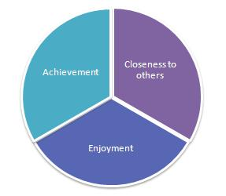
Healthy Balance - Schedule activities each day which give you a sense of:
- Achievement
- Closeness to others
- Enjoyment

- Use an Activity Diary or the ACE Log
www.getselfhelp.co.uk/ccount/click.php?id=14 www.getselfhelp.co.uk/ccount/click.php?id=15
- It's important to get a healthy balance of activities which give you a sense of achievement, enjoyment and being close to others. Choose activities which are important to you, have positive meanings, or are purposeful, and you might want to plan rest periods too.
- Keep your goals realistic – set achievable limits. For example: aim to walk for 15 minutes rather than a half-marathon, or wash the dishes rather than spring clean the whole house. Don’t set yourself up to fail! You can build up your activity over time.

Doing things differently

If lack of activity and tiredness is helping to maintain our negative thinking, and therefore keeping us depressed, then doing more (in spite of feeling tired and depressed) will help us feel better.
- Do something different (to what you normally do)
- Pause, take a breath

- Mindfulness - learn Mindful Breathing
- Focus your attention fully on another activity - Mindful activity
- Relaxation techniques - try lots and find one that works for you
- Put on some music - sing and dance along, or just listen attentively (use music that is likely to help you feel your desired emotion - avoid sad songs if you're depressed)
- Meditation or Prayer

- Help others
- Be with others - contact a friend, visit family
- Talk to someone
- Grounding techniques - look around you, what do you see, hear, smell, sense? Hold a comforting object.
- Physical exercise - walk, swim, go to the gym, cycle

- Engage in a hobby or other interest - if you don't have one, find one! What have you enjoyed in the past? What have you sometimes thought about doing but not got around to?
- Write down your thoughts and feelings - get them out of your head
- Just take one step at a time - don't plan too far ahead
- Pamper yourself - do something you really enjoy, or do something relaxing

- Positive self-talk - encourage yourself, tell yourself: I can do this, I am strong and capable - find an affirmation that works for you (even if you don't believe it at first!). Write it down and memorise it for when you need it. See Affirmations
- Do something creative - make a box of items that remind you to use the techniques that help, or put photos on paper, or write and decorate a list
- Use Safe Place Imagery
- Tell yourself: "This will pass, it's only temporary". "I've got through this before, I can do it now". When we're going through a tunnel and become fearful of being trapped, there's no point in stopping - we just have to carry on in order to reach the end of the tunnel. That light is there, and waiting!
- Visualise yourself doing the things you used to enjoy doing, or would like to enjoy doing, and successfully doing what you need to do.

Thinking differently
- STOPP! Pause, take a breath
- Ask yourself:
- What am I reacting to? What have I been thinking about here?
- Is this fact or opinion?
- Am I getting things out of proportion?
- How important is this really? How important will it be in 6 months time?
- Am I expecting something from this person or situation that is unrealistic?
- What's the worst (and best) that could happen? What's most likely to happen?
- Am I using that negative filter? Those gloomy specs? Is there another way of looking at it?
- What advice would I give to someone else in this situation?
- Am I spending time ruminating about the past or worrying about the future? What could I do right now that would help me feel better?
- Am I putting more pressure on myself, setting up expectations of myself that are almost impossible? What would be more realistic?
- Am I jumping to conclusions about what this person meant? Am I mis-reading between the lines? Is it possible that they didn't mean that?
- What do I want or need from this person or situation? What do they want or need from me? Is there a compromise?

- Am I just focusing on the worst possible thing that could happen? What would be more realistic?
- Is there another way of looking at this?
- Am I exaggerating the good aspects of others, and putting myself down? Or am I exaggerating the negative and minimising the positives? How would someone else see it? What’s the bigger picture?
- Things aren’t either totally white or totally black – there are shades of grey. Where is this on the spectrum?
- This is just a reminder of the past. That was then, and this is now. Even though this memory makes me feel upset, it’s not actually happening again right now.
- What would be the consequences of doing what I normally do?
- Is there another way of dealing with this? What would be the most helpful and effective action to take? (for me, for the situation, for the other person)
- Visualisation: Breathe in orange (for positive energy) and breathe out blue/black.

