[[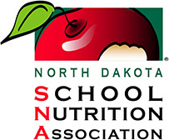](https://northdakotasna.com/index.php)](https://northdakotasna.com/index.php)

Certificate of Completion

*This Certifies that*

*______________*

SNA #_______

*’ Has successfully completed:*

**2025 NDSNA Annual State Conference**

NOURISH. BALANCE. THRIVE.

Bismarck Hotel & Conference Center, Bismarck, North Dakota

Number of CEUs Earned: ______

October 16th-17th, 2025 *Cindy Wall*

*Date of Completion Professional Development Chair*