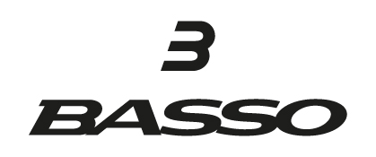

WHAT IS A MARGIN GUARANTEE AND WHY IS IT IMPORTANT?

Our margin guarantee is not just a sales pitch its a firm commitment to your profitability.
What is a margin guarantee?
A margin guarantee is comprised of three key elements.
Element # 1 - NO additional costs
NO additional or hidden costs are charged in addition to the wholesale price. Many brands will offer an above-average margin only to charge freight or alternately "discount" a portion of freight for volume. The margin is not the margin until all direct costs to get the box into the door are deducted. The margin we offer includes all costs on a door-to-door basis with NO additional or hidden costs.
Element # 2 - Sell through MSRP's
When setting MSRP's for our products we do a comparative analysis to similar products sold by brands with stable pricing policies. Offering an MSRP of X% means nothing if the MSRP needs to be discounted to get the bike out of the door.

We provide comparative analysis charts by product to assist in upselling and sell through on the shop floor. We are confident there is no need to discount our products to sell though - hence our NO discounting policy.

Element # 3 – NO Discounting

In order to ensure that you retain full margin we ask dealer partners not to discount any product. Presentation of comparative analysis schedules to customers are provided to assist you in explaining the value proposition for the customer.
Why is a margin guarantee important?
A margin guarantee is important because you bank dollars NOT margin. We want our partners to be profitable. In addition, we do not compete with our partners by selling directly to consumers.
Is there any additional margin or tier pricing?
YES – Obtain an additional 2% discount on all invoices by joining the NBDA.

We do not offer “Tier pricing” based on volume. Our objective is to offer all our partners the best possible service, support, and pricing.

What are the standard margins?

Complete bikes – 35%
Frames – 38%

Additional 2% discount for NBDA members.

LEARN MORE ABOUT BASSO:
Brand history podcast.
https://podcasts.apple.com/us/podcast/the-business-of-cycling/id1678035217?i=1000641002663
Brand website:
www.bassobikes.com

