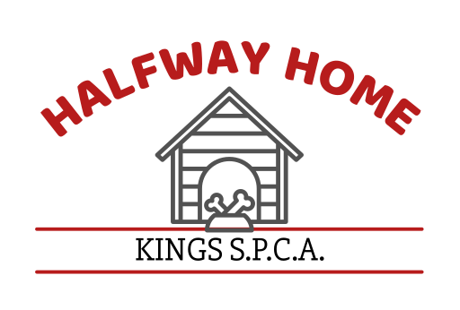

**Foster Care Application**

**Our foster parents provide temporary care for cats, kittens, dogs and puppies. By offering your time, energy, and home to an animal in need, you help prepare the animal for adoption into a permanent home as well as help prevent overcrowding in our shelter.**

Date: _______________

Please check the following animal(s) you are interested in fostering.

____ litter of puppies ____ orphaned puppies ____ adult dog(s) _____ puppy _____ kitten

Name of puppy/kitten__________________

**\*\*\* All applicants must provide the Kings SPCA with a valid government issued form of identification w/picture and two (2) utility bills/billing statements with same name and address as person applying to provide foster care.**

Name: __________________________________________________________________________________

Address: ____________________________________ City: ________________ State: ____ Zip: _________

Cell #: ______________________ Work#: ______________________ Message #: ____________________

Employer: _________________________________________________ Phone# ______________________

How long have you been employed with this Company? __________________

1. Please tell us why you would like to foster? ______________________________________________

_________________________________________________________________________________

1. Are you part of any animal organization? Yes _____ No _____

If yes, which one? __________________________________________________________________

1. Do you live in a: ___ Condo/Townhouse ___ Apartment ___ Duplex

___ Mobile Home ___ House

1. Do you: ______ Rent/Lease _____ Own

Name of complex and/or association: __________________________________________________

Name and phone# of landlord or owner: _______________________________________________

Pet Policy: ___ Yes ____ No

**(If you are renting/leasing you will need to provide the Kings SPCA with a letter from your landlord stating that it is okay for you to foster an animal and the amount of animals and type of animals that will be allowed.)**

How long have you lived at this address? _______________________________________________

1. Are there any children in your home? ____ Yes ____ No

If yes, how many and what are their ages? ______________________________________________

1. Would there be anyone home during the day? ____ Yes ____ No

If yes, who? ______________________________________________________________________

If no, where will the foster animal(s) be kept? ___________________________________________

1. Where will the foster animal(s) sleep? _________________________________________________
2. Name of Veterinarian you use? __________________________________ Phone# ______________

Reason for last visit? _______________________________________________________________

1. Do you have any dogs/cats at home now? ____ Yes ____ No
2. Age ____ Breed ______________ Sex ___ Name _______________ Licensed: __ Yes __ No
3. Age ____ Breed ______________ Sex ___ Name _______________ Licensed: __ Yes __ No
4. Age ____ Breed ______________ Sex ___ Name _______________ Licensed: __ Yes __ No
5. Age ____ Breed ______________ Sex ___ Name _______________ Licensed: __ Yes __ No

**(*You must provide the Kings SPCA with copies of the above listed pet(s) vaccination/rabies records)***

**I agree to the following conditions: (Please read each section carefully and initial)**

_____1) I agree that all the information which I have provided above is correct as written and I authorize the Kings SPCA to verify any and all information.

_____ 2) I agree to provide a Foster Home Report within two weeks of getting the foster animal.

_____ 3) I agree to provide updated reports when there are significant changes with the animal(s) being

fostered.

_____4) I certify that my own pets are currently licensed and up to date on all vaccinations, including rabies.

_____5) I agree to keep my pets separate from the foster animal for at least (7) seven days. If the foster

animal(s) is incubating any diseases this separation will minimize the chance of my pets becoming ill.

If the foster animal becomes ill, I agree to keep the animal at my home (in quarantine) until directed

otherwise by Kings SPCA staff.

_____6) I agree to keep the foster animal indoors at all times unless accompanied outside by myself on a

leash or in a well fenced back yard.

_____7) Should the foster animal(s) become injured/ill while in my care, I agree to notify the Kings SPCA

**immediately** and to take the foster animal to a veterinarian. Any injuries/sickness to the foster

animal due to fosters neglect/abuse will result in foster paying any/all charges accrued. If no private

vet is available the Kings SPCA will provide an appointment to have the foster animal evaluated.

_____8) I fully understand that the foster animal is the property of the Kings SPCA and that I will follow any

decision made by the Shelter Manager regarding the return and/or disposition of the foster animal(s).

_____9) I also fully understand that if for some reason an animal dies under my care I am to return the remains to the Kings SPCA immediately! **No Exceptions!**

_____10) I understand that the Kings SPCA is not responsible for any property damage and/or injuries that may

occur. Any damages and/or injuries will be my responsibility.

_____11) I understand that the Kings SPCA is held harmless should any animal(s) become ill from a foster

animal(s). I further agree to pay any veterinarian expenses incurred for my own animal(s).

_____12) I understand that the Kings SPCA has the right to perform home checks to ensure the safety, health,

and well-being of all fostered animals.

_____13) I have received a copy of the Foster Home Responsibilities and Guidelines handout.

\*\****Welcome to our family!! If you have any questions or concerns now is the time to ask. We here at the Kings SPCA***

***want this to be a very positive opportunity for all involved. If any questions or concerns should arise please don’t***

***hesitate to contact us; we want this foster to be a success!!***

___________________________________________ ___________________________

Printed Name of Foster Care Giver Date

__________________________________________

Signature of Foster Care Giver

__________________________________________ ___________________________

Signature of Authorized Kings SPCA Representative Date