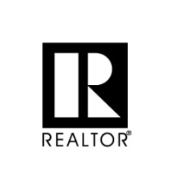
Lenawee County Association of REALTORS®
4125 Occidental Hwy · P.O. Box 425 · Adrian, Michigan 49221
Phone: (517) 263-0325 · www.LCARlive.com
“To serve, support, and inspire excellence” _____________________________________________________________________________

Broker must join as a Secondary Member – Proof of primary board membership is required
(Letter of Good-Standing)
Prorated 2019 Dues:
One-time office MLS Application fee of $200
*
Primary Membership (includes, MAR & NAR Dues)
Prorated 2019 Dues & App. Fee:
2020 Dues – due December 31, 2019
*
Monthly MLS fee per user is $65.00
*
Forms:
- Secondary Membership Application
- MLS Office Application
- Membership Application Checklist for Agents
- Association of Prices
- Application for Membership

