Pre-Ceremony Questions

Type of Ceremony
- Marriage Ceremony
- Package Selected Bronze / Silver / Gold / Platinum
- Emcee Duties @ Reception
Client Details
Your Name ____________________________________________
Phone & Email ____________________________________________
Partner’s Name ____________________________________________
Phone & Email ____________________________________________


Ceremony Details
Date ___________________________________________
Anticipate Time ___________________________________________
Venue Name ___________________________________________
Address ___________________________________________
Alt. Venue ___________________________________________
Your prep site ___________________________________________
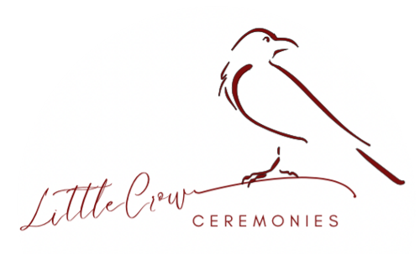
Emergency Contact __________________________________________

Marriage Ceremony
Is the venue booked Audience Size ____________?
Photographer _________________________________________
Style of Ceremony _________________________________________
Theme/Colours ________________________________________
Readings ________________________________________
Rituals ________________________________________
People to Acknowledge ____________________________________
________________________________________________________
Who else will be involved in the ceremony?
Bridal Party ________________________________________
________________________________________
Witnesses (2) ________________________________________
Flowers/Ring Bearer_______________________________________
How will you enter? _______________________________________
Personal Vows? __________________________________________
Ring exchange? ________________________________________
Sealed with a Kiss? _______________________________________
How do you want to be presented after the marriage is formalized? (e.g. Mr & Mrs; William & Catherine) __________________________________

Music
Processional ____________________________________________
Signing ____________________________________________
Conclusion ____________________________________________
Music Manager _________________________________________
Specific Client Details – Fill out separately
Name _________________________________________________________
How did you meet? ____________________________________________
________________________________________________________________
________________________________________________________________
First date/trips/events? ____________________________________________
________________________________________________________________
________________________________________________________________
How did the proposal happen? When? ________________________________
________________________________________________________________
________________________________________________________________
Special Moments/Events ______________________________________
________________________________________________________________
________________________________________________________________
What makes your partner special? ____________________________________
________________________________________________________________
________________________________________________________________
________________________________________________________________
Your Favourite Things
Music _________________________________________________
Books/Authors _________________________________________________
Movies _________________________________________________
TV Shows _________________________________________________
Food/Restaurant _________________________________________________
Hobbies/Sport _________________________________________________
Other _________________________________________________
Specific Client Details – Fill out separately
Name _________________________________________________________
How did you meet? ____________________________________________
________________________________________________________________
________________________________________________________________
First date/trips/events? ____________________________________________
________________________________________________________________
________________________________________________________________
How did the proposal happen? When? ________________________________
________________________________________________________________
________________________________________________________________
Special Moments/Events ______________________________________
________________________________________________________________
________________________________________________________________
What makes your partner special? ____________________________________
________________________________________________________________
________________________________________________________________
________________________________________________________________
Your Favourite Things
Music _________________________________________________
Books/Authors _________________________________________________
Movies _________________________________________________
TV Shows _________________________________________________
Food/Restaurant _________________________________________________
Hobbies/Sport _________________________________________________
Other _________________________________________________

