**NPA Working Group: NPA Framework Comment Submission Due January 29**

On behalf of (company/organization name): **HEETlabs**

Submitted by (name and email):**Audrey Schulman, Audrey@HEETlabs.org**

Date: **Jan 29, 2025**

Reference ID (to be filled in by Apex):

## High Level Comments

* **Rightsizing the gas system:** According to the Commonwealth’s [Clean Energy and Climate Plan](https://www.mass.gov/doc/2050-clean-energy-and-climate-plan/download), within 25 years more than 80% of all buildings[1] need to be on heat pumps for the vast majority of their energy needs. The gas utilities cannot maintain financial viability for 21,000 miles of gas infrastructure across the state while reducing their customer base and overall throughput that much. They need to rightsize their system proactively to meet the future demand.

<https://www.mass.gov/doc/2050-clean-energy-and-climate-plan/download>, pg xiii

* **Phased and street-segment-based coordinated gas and electric planning:** To enable this sort of massive thermal transition of our energy infrastructure to relying less on gas and more on electricity, we need comprehensive coordinated gas and electric system planning that is phased and granular to the street-segment level. We cannot have the gas system on Smith Street turned off before the electric system is ready to deliver the needed electricity and the buildings on the street are retrofitted for that electricity. Each overlapping gas and electric utility must coordinate the transition of the energy needs over the next 25 years to meet the Department’s mandates (affordability, reliability, emissions, equity, safety and security).
* **Need at least 5 years advance notice per non-gas-pipe alternative (NPA).** This type of thermal transition planning will be hard to do given the interplay of utilities, municipalities, residents and other stakeholders.The MA Gas System Enhancement Plan (GSEP) is made public by street-segment for 5 years in advance. The thermal transition planning will be much more complicated:
  + Involving 2 utilities rather than just the gas utility
  + Necessitating more complicated engineering and procurement if involving thermal networks or other less familiar technologies
  + Requiring thoughtful customer education and timing, etc.

As such, the opportunity of an NPA should be announced at least 5 years in advance of the needed installation.

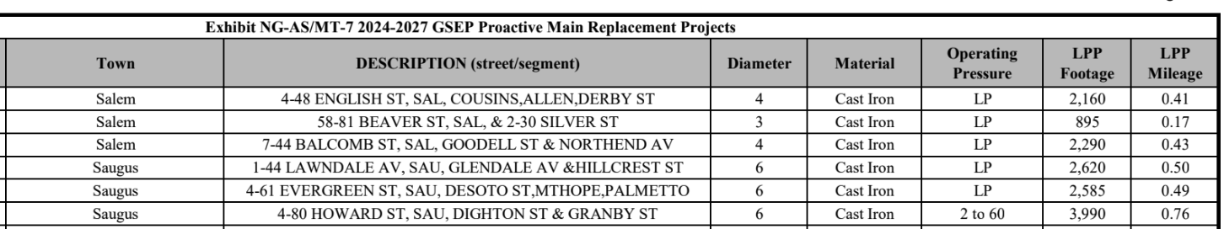

A sample GSEP showing future gas main replacements by street segment for 5 years into the future

* **Transparency of information**: To allow for the greatest number of potential NPAs to be installed, all predicted gas and electric infrastructure upgrades, to be installed from now until 2050, should be made public by street segment in the same manner that GSEP leakprone gas pipe locations, costs and reasons are made public, years before they are replaced. Transparency creates trust, gets engagement, and allows many minds to work together to solve potential problems. This energy transition will cost many billions of customer dollars. The customers deserve the information.
* **Avoided costs from synergies should be moved to building retrofits.** Mass Save alone will not be able to pay for all the building retrofits needed to move over 80% of all buildings to electricity for everything. A r[ecent analysis by Building Electrification Institute](https://static1.squarespace.com/static/5b6a482db27e39e8fcf65bbf/t/65ef4488c1d0827259981000/1710179465284/BEI-Boston+Funding+Gap+Analysis_Feb2024.pdf) finds a post-rebates funding gap of $21 to $77k per residential unit in Boston. The vast majority of customers in the state will not be able to afford those retrofits. Thermal networks, district heating and other non-emitting methods of supplying thermal energy to buildings through pipes can radically reduce the strain on the local electric system from building electrification. In the coordinated gas and electric utility planning, the local electric utility could suggest areas to the local gas utility where the electric system was quite constrained and there were higher than average system upgrade costs. The gas utility could then examine those areas for the financial viability of installing thermal networks or other non-emitting thermal energy infrastructure. Anywhere they did manage to do so, the Department could calculate the electric system avoided costs and transfer a portion of those avoided costs to Mass Save to pay for the local building retrofits so that those buildings can interconnect to reduce the electric peak. Low and moderate income customers can be prioritized.
* **Creating a Thermal Marketplace**: If the gas utilities don’t want to install boreholes, they should issue an RFP for non-emitting thermal energy that can be met by anyone, such as data centers and ice rinks. A single ice rink in the Boston area can provide enough heat to keep ~50 homes warm through the winter.
* **State-owned boreholes:** If the gas utilities issue an RFP for thermal energy, the state installing the boreholes on state or municipal land would radically reduce the cost of capital since the state can issue bonds for less than half the weighted average cost of capital of the gas utilities. For every $1 million of infrastructure installed by gas utilities, the gas customers pay $1.5 million additional in interest payments over time. Having the state install boreholes on government land through state bonds would reduce those payments on the same infrastructure to $0.7 M million.The state could get paid back by selling the resulting thermal energy. The savings on capital costs over time could be moved to either paying for local building retrofits so the buildings can interconnect, or the DPU could ensure that the savings made the customer bills lower.

*So sorry but the framework for comments doesn’t allow for cross-cutting measures. Thus I was not sure where to put these comments in your rubric.*

1. <https://www.mass.gov/doc/2050-clean-energy-and-climate-plan/download>, page xiii