NPA Working Group: NPA Framework Comment Submission Due January 29
On behalf of (company/organization name): Acadia Center
Submitted by (name and email): bbutterworth@acadiacenter.org
Date: 1/27/25
Reference ID (to be filled in by Apex):

Instructions for comment submissions:
- Categorize your comments by topic aligned with the LDC presentation, see bullet list below and headers in rest of template. If not tied directly to a topic below, please use “Other: (Please Specify).”
  - Comments will be tagged within the matrix by the above “Reference ID” so reviewers can easily navigate to the details of each comment when addressing. Provide your narrative text of your comments under the key point.
  - Complete raw comments will be compiled as an attachment to the report delivered to the D.P.U.
- Under each header, provide a key point/summary statement in bold that provides the key point of that section. This summary statement will be used to collate similar comments, to be used within a matrix for an attachment to the report and for synthesis of feedback.
  - Stakeholders can customize/update the template to remove topics if not needed (i.e., commenting on each section is not required)
  - Stakeholders can customize the number of key points per section, feel free to add or delete subheaders based on your comments.
  - Please include any comments on the “NPA Identification Requirements” into the relevant topic rather than as a stand-alone section.
  - The matrix of summarized key points will also be an attachment to the report.
- Please return a copy of your comments as a Word document by Jan 29 to npaworkinggroup@apexanalyticsllc.com
- These instructions in gray italics can be deleted
NPA Framework Topics:
- High level Comments
- Project Identification
- Initial Viability Testing
- Gas System Feasibility Review, Electric System Feasibility Review
- Benefit Cost Analysis
- Project Authorization and Project Prioritization
- Customer Education, Engagement and Commitment
- Impacts to Project Implementation
- Framework Updating
- Other (please specify)

High Level Comments

Key proposal strengths: Summary statement of high-level (executive summary-type) strengths of proposal
Insert text here

Key proposal challenges: Summary statement of high-level (executive summary-type) challenges of proposal, including cross-cutting concerns
Key challenges include 1) Short Window for Comments on Draft NPA Framework Presents Logistical Challenges for Stakeholder 2) Concerns with Community Engagement Approach 3) Some Elements of Benefit Cost Analysis Proposed by LDCs May Not Be Well Suited For Evaluation of NPAs 4) Relatively Narrow Scope of NPA Framework Highlights Need for More Holistic Framework For Assessing Gas System Investments 5) Concerns Regarding NPA Review Process for New Customer Requests 6) Concerns Regarding ‘Emergent’ and ‘Other Reliability’ Programs Not Undergoing NPA Review

Project Identification

Key Point #1: Concerns Regarding NPA Review Process for New Customer Requests
Table 1a) “Types of Capital Projects” presented at the January 22nd Technical Subcommittee meeting identifies which programs will and will not be subject to the NPA review process as part of the proposed Draft Framework. Currently, this table indicates that new customer service and main extensions will be subject to the NPA review process, but based on additional context provided by the LDCs during the meeting, this framing does not seem entirely accurate.
While other programs (e.g., GSEP, Reliability-Capacity, Reliability-Replacement) will be subject to the full NPA review process under the Draft Framework, it appears the LDCs are currently planning for a more limited review of new customer requests. For example – while these new customer requests would undergo a BCA analysis, this BCA analysis would not include consideration of the social cost of carbon, as is considered by projects undergoing the full NPA review. Additionally, the approach to new customer requests articulated in the Draft Framework appears to be in line with the current status quo approach that involves providing potential new customers with basic information on their energy options, alerting customers to the existence of the MassSave program, and requiring customers to sign an attestation that they have reviewed the information and made a decision based on the information provided to them. During the January 22nd Technical Subcommittee meeting, the LDCs did acknowledge that the simple “Yes” on Table 1a (indicating the new customer service and main extensions will be subject to NPA review) was overly simplified and that this framing will be corrected, but these comments serve as a reminder to the importance of following through on that correction.
The approach to new customers described by the LDCs also raises questions regarding whether LDCs could take a more proactive approach in articulating the benefits of electrification over natural gas for a customer considering a new natural gas connection given the intent of 20-80, the NPA Framework, and the building sector GHG sublimits. The Draft Framework’s proposed approach for potential new gas customers appears to be a continuation of the largely “box checking” exercise currently utilized by the LDCs that does little to reduce future stranded asset risk associated with the gas system and places the onus of pursuing electrification options on the customer, opposed to proactively supporting the customer in the pursuit of electrification options. Acadia Center urges both the LDCs and the Department to consider how these more proactive approaches could be integrated into the NPA Framework.

Key Point #2: Concerns Regarding ‘Emergent’ and ‘Other Reliability’ Programs Not Undergoing NPA Review
The “Emergent” and “Other Reliability” programs are two of the five programs flagged as not being subject to NPA review in the proposed Draft Framework. While Acadia Center acknowledges that certain projects within those categories represent immediate safety concerns which require a rapid response that does not fit within the NPA review process timeline, the definitions of the Emergent and Other Reliability programs are very high-level in the Draft Framework, leaving significant ambiguity as to the range of projects that fall within each program. More granular definitions of the programs and the types of projects that fall within them would help to ensure that all projects categorized under these two programs truly do require a time-sensitive response that does not allow for NPA review. Without more granular definitions and careful oversight of these programs, there could potentially be a perverse incentive for LDCs to inappropriately categorizing projects within these programs as a means of bypassing NPA review.

Key Point #3: Relatively Narrow Scope of NPA Framework Highlights Need for More Holistic Framework For Assessing Gas System Investments
One topic that has come up repeatedly at NPA Working Group meetings is the desire among many stakeholders to take a more holistic look at the gas system to evaluate the potential of NPAs in reducing gas system investments and stranded assets, opposed to the relatively narrow, project-specific reactive focus currently underpinning the Draft NPA Framework. For example, a more holistic framework could consider the entire cohort of leak-prone pipes in the GSEP case and prioritize NPAs through a proactive, top-down approach. As another example, if a project to replace a 100 yard section of main on a single block fails BCA review within the NPA Framework, what happens to that same project if the scope of the NPA project analysis is extended to include the five neighboring blocks?
This approach described above is in contrast to the Draft NPA Framework which considers NPAs at a more rigid individual project level in a more reactionary manner. While the Department may not see the NPA Framework as the appropriate mechanism for considering this more holistic approach to gas system planning, Acadia Center nonetheless would like to highlight the critical importance of this more holistic, proactive gas system planning approach. If this approach remains absent from the NPA Draft Framework, Acadia Center would strongly encourage it to be a central theme of the forthcoming LDC individual Climate Compliance Plans. Acadia Center sees this more holistic and proactive approach to avoided stranded assets on the gas system critical to cost-effectively achieving the building sector sublimits.

Initial Viability Testing

Key Point #1: Key point for Excel matrix of comments
Insert detailed comments here

Key Point #2:
Text

Key Point #N:
Text

Gas System Feasibility Review and Electric System Feasibility Review

Key Point #1: Key point for Excel matrix of comments
Insert detailed comments here

Key Point #2:
Text

Key Point #N:
Text

Benefit Cost Analysis

Key Point #1: Some Elements of Benefit Cost Analysis Proposed by LDCs May Not Be Well Suited For Evaluation of NPAs
Acadia Center is concerned the benefit cost analysis (BCA) proposed in the Draft Framework may not be well suited for addressing the urgency inherent in the Massachusetts Building Sector GHG sublimits of 49% below 1990 levels by 2030 and 94% below 1990 levels by 2050 established in the Massachusetts Clean Energy and Climate Plan for 2025 and 2030. While the NPA Framework on its own clearly is not capable of achieving the building sector sublimits, it should be designed in such a way to meaningfully contribute to the rapid decarbonization of the state’s building stock at the speed and scale necessary to achieve the sublimits.
Based on initial review of the four BCA tests being proposed as part of the Draft Framework, Acadia Center is concerned the Draft Framework, as currently proposed, could screen out too many potential NPAs that would be instrumental in helping to achieve the binding Building Sector sublimits. Given the information provided to stakeholders to date, it is extremely difficult to estimate how many future gas projects will be deemed non-viable or viable for NPAs under the proposed Draft Framework. However, it is clear the choice of BCA tests and decisions regarding how scores from those tests are weighted will be an instrumental component of the NPA screening process. The scale of potential avoided gas system investment in the coming years achievable via the currently proposed Draft Framework would have been made more tangible to stakeholders if the LDCs provided concrete examples of potential projects, applied the proposed BCA tests to those projects, articulated how the BCA test results inform the decision to deem a potential NPA viable or non-viable, and fostered discussion among stakeholders on the relative strengths and weaknesses of the BCA application in the context of a specific project. However, to date, no real world or hypothetical examples of applying the Draft Framework’s BCA analysis to potential projects have been presented to stakeholders, making the topic challenging to comment on in detail.
That being said, Acadia Center is highly concerned with the use of gas rate impact test (“gas RIM test”) in assessing the viability of NPAs as is currently proposed in the Draft Framework. Specifically, we are concerned with how the gas RIM test treats lost revenue to the gas utility as a cost and the potential ramifications this BCA design choice could have on the evaluation of NPAs. Historically, the gas RIM test has been utilized in energy efficiency proceedings because energy efficiency measures have the potential to reduce gas sales. While the gas RIM test may me appropriate in this more traditional analysis of energy efficiency investments, it seems less appropriate in the overarching context of the 20-80 Order – which the development of the NPA Framework in direct response to. Given the larger context of the 20-80 Order, building sector GHG sublimits, and cornerstone building decarbonization policies currently in development (e.g., Clean Heat Standard) it seems reasonable to assume that other state policies, outside of the NPA process, will be driving down natural gas consumption (and associated gas revenue) in the building sector in coming years.
Thus, in many cases, one could view the loss of future gas revenue as not truly attributable to an NPA – as the results of the gas RIM test in the context of the NPA Framework would suggest - but more so attributable to the broader climate and energy policy trajectory of the Commonwealth which necessitates declining gas sales. In other words, it is Acadia Center’s understanding that the development of the NPA process is a direct response to anticipated future lost gas revenues as result of the state’s overarching climate policies and the intent of the NPA process is to protect gas customers by right-sizing gas investments, avoiding stranded assets, and reducing overall gas system cost both in the near and long term. The impact of NPAs on declining gas sales and associated revenue and relatively small compared to, for example, a Clean Heat Standard designed to achieve the 2030 and 2050 subsector GHG targets, as is currently proposed in the CHS Draft Framework. Utilization of the gas RIM test within the NPA Framework takes the opposite approach – it frames NPAs as the core driver of declining gas sales and gas revenue in the context of an individual project, while essentially ignoring the broader policy context.
One potential solution to the conundrum described above is to replace the gas RIM test with the utility cost test in the BCA step of the NPA Draft Framework. The utility cost test shares several key similarities to the gas RIM test, but, notably, eliminates the consideration of lost revenues to gas utilities. The utility cost test would still be effective in quantifying the impacts of NPAs on the overall costs and benefits to utilities and ratepayers, but would do so in a way that does not inappropriately include lost gas revenue as a cost. Additionally, the Total Resource Cost (TRC) Test was one of the four cost tests proposed for inclusion in the Draft Framework – Acadia Center supports continued inclusion of this cost tests because it is, by design, more holistic than the other cost tests and accounts for benefits that are deemed important with respect to current Commonwealth policy. Furthermore, the TRC test has been in practice for energy efficiency for many years and that experience is valuable. That being said, the TRC test does require a supplemental approach to ensure equity and environmental justice as part of the overall NPA screening process.

Key Point #2:
Text

Key Point #N:
Text

Project Authorization and Prioritization

Key Point #1: Key point for Excel matrix of comments
Insert detailed comments here

Key Point #2:
Text

Key Point #N:
Text

Project Execution

Key Point #1: Key point for Excel matrix of comments
Insert detailed comments here

Key Point #2:
Text

Key Point #N:
Text

Customer Education, Engagement and Commitment

Key Point #1: Concerns with Community Engagement Approach
The NPA Working Group was presented with a Community Engagement Progress Update presentation on January 15th. The in-home interviews with 13 EJ households in four LDC territories conducted over the January 7-9 time period are a valuable contribution to the Draft NPA Framework process, but Acadia Center has concerns with the groups of citizens that were not involved in this process and the subject matter of the questions asked to participants.
The questions appeared to be focused on the respondents understanding of electrification technologies, benefits, and costs. The January 15th presentation described the “Why” of the in-home interviews as: “In-depth opinion on value of electrification benefits, attitude towards increased utility costs, understanding of electric heat technologies, aspects of an offer to electrify they find compelling, willingness to accept an electrification offer, feedback on sample electrification brochure”
Additionally, for a second set of EJ household interviews scheduled to be conducted on February 11th, the questions again appeared to center on similar topics. They “Why” for those February 11th interviews was described as: “High-level feedback on value of electrification benefits, attitude towards increased utility costs, understanding of electric heat technologies, willingness to accept an electrification offer”
While it’s valuable to get feedback from EJ households on these topics as part of the NPA Framework development, it’s notable that none of the questions focused on how the current gas system in the Commonwealth is negatively impacting certain EJ communities. This seems like an oversight given that one of the core goals of NPAs is to minimize negative impacts inflicted by the gas system on EJ communities as the Commonwealth decarbonizes the building sector.
For example, based on the information provided at the January 15th presentation, it does not appear that any residents living in close proximity to the National Grid LNG facility in Salem, Massachusetts or the Eversource LNG facility in Hopkinton, MA were interviewed – notably, both facilities are located in direct proximity to a number of homes within census blocks classified as EJ populations according to the Massachusetts 2020 Environmental Justice Populations mapping tool. It also appears that no EJ households living in close proximity to the 2018 Merrimack Valley gas explosions that impacted neighborhoods in Lawrence, Andover, and North Andover were interviewed – the majority of census blocks directly impacted by that tragedy are also categorized as EJ populations according to the Massachusetts 2020 Environmental Justice Populations Mapping tool. Not interviewing anyone from these communities – or similar communities negatively impacted by natural gas infrastructure – is a significant oversight that limits the breadth of responses used to inform the NPA Framework development process.
Figure 1. Google Earth Screenshot Highlighting Proximity of National Grid LNG Facility in Salem, MA
to Homes Located in Block Groups Identified as EJ Populations
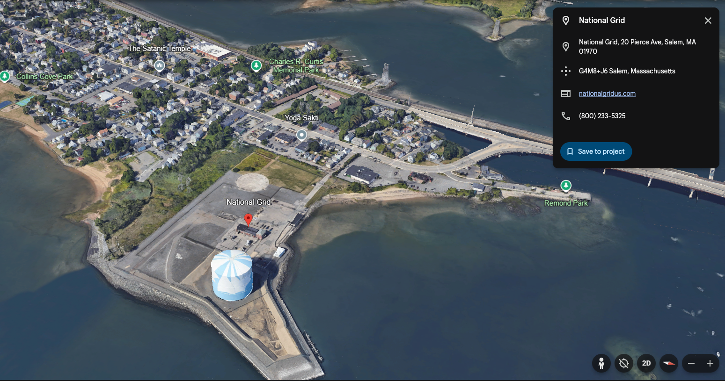
Source: Google Earth
Figure 2. Google Maps Screenshot Highlighting Proximity of Eversource LNG Facility in Hopkinton, MA
to Homes Located in Block Groups Identified as EJ Populations
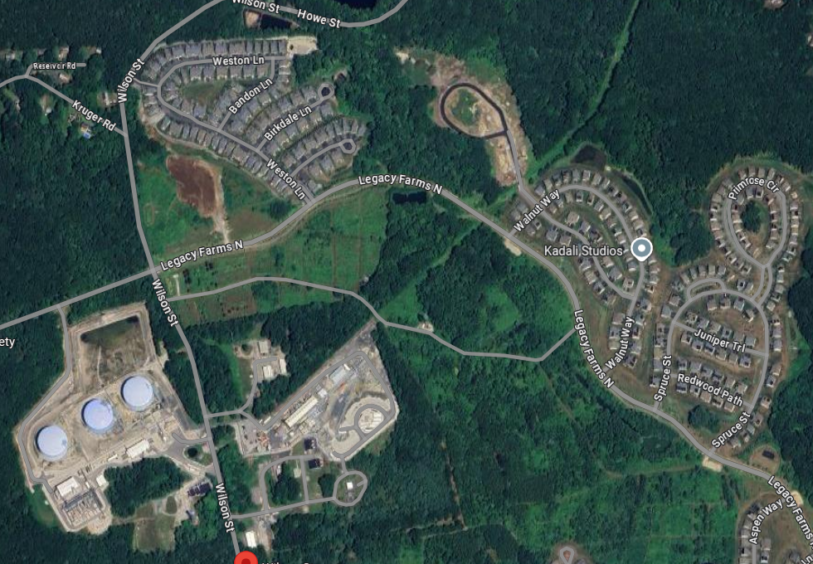
Source: Google Maps

Key Point #2:
Text

Key Point #N:
Text

Impacts to Project Implementation

Key Point #1: Key point for Excel matrix of comments
Insert detailed comments here

Key Point #2:
Text

Key Point #N:
Text

Framework Updating

Key Point #1: Key point for Excel matrix of comments
Insert detailed comments here

Key Point #2:
Text

Key Point #N:
Text

Other (please specify)

Key Point #1: Short Window for Comments on Draft NPA Framework Presents Logistical Challenges for Stakeholder
The most recent Technical Subcommittee meeting reviewing the Draft Framework was held on January 22nd and stakeholder comments in response to the Draft Framework are due on January 29th, giving stakeholders only five full working days to finalize comments on a highly technical and complex topic. For this reason, the comments below do not necessarily go into the level of depth that Acadia Center would have explored if we were granted more time to respond. Future stakeholder processes should make every effort to provide stakeholders with more time to formulate comments. With that being stated up front, the below comments represent are best effort to articulate key concerns with Draft NPA Framework given the quick turnaround time.

Key Point #2:
Text

Key Point #N:
Text

Massachusetts Clean Energy and Climate Plan for 2025 and 2030, Table 3.1, page 23, https://www.mass.gov/doc/clean-energy-and-climate-plan-for-2025-and-2030/download and Massachusetts Clean Energy and Climate Plan for 2050, Table 3-2, page 19 https://www.mass.gov/doc/2050-clean-energy-and-climate-plan/download

