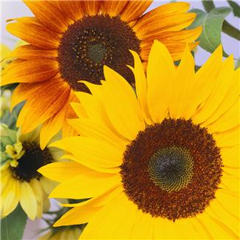 | Hope and Wellness  "Good for your Physical, Mental & Spiritual Health"
Reflexology Intake Form

Name:_______________________________________________DOB:_____________________________
Street Address: _______________________________________________________________________
__________________________________________________Phone:_______________________________
Email:_____________________ Occupation:___________________Referred by:_____________________

Health Questions
Have you ever had professional reflexology? | Yes |  | No | Do you suffer frequently from stress? | Yes | No
Do you experience frequent headaches? | Yes |  | No | Have you had any broken bones in the last 2 years? | Yes | No
Are you pregnant? | Yes |  | No | Do you have tension or soreness in a specific area? | Yes | No
Are you wearing contact lenses? | Yes |  | No | Do you have cardiac or circulatory problems? | Yes | No
Are you diabetic | Yes |  | No | Do you suffer from back pain? | Yes | No
Do you have high blood pressure? | Yes |  | No | Do you have numbness or stabbing pain anywhere? | Yes | No
Do you suffer from seizure disorders? | Yes |  | No | Are you sensitive to touch/pressure in any area? | Yes | No
Please list any surgeries:
Please list any other health problems/concerns:
Please list all medications you are taking:

Acknowledgement and Informed Consent Statement
I understand that Hope Charette is an educated Reflexologist and Natural Health advisor/teacher. She deals strictly with helping people to improve their general health and fitness through Nutrition, Vitamins, Ion Cleansing, Reflexology, improving lifestyles and health habits and positive mental attitudes.
I understand that the services provided should not be construed as a substitute for medical examination, diagnoses or treatment and that I should consult a physician, chiropractor, or other qualified medical specialist for any mental or physical ailment that I am aware of. Hope Charette is not a licensed physician and is not qualified to perform spinal or skeletal adjustments, diagnose disease, prescribe drugs, treat any physical or mental illness or recommend treatments for specific diseases.
I have answered all health questions honestly and am not intentionally withholding information about my health. I agree to keep you updated as to any changes in my medical profile and understand that there shall be no liability should I neglect to do so. The decisions I make regarding my health care are my responsibility and I will not hold her responsible or accountable for any consequences of my decisions.

Signature: _________________________________________________________Date: _______/_______/20_______

Signature of Parent, if under 18:_______________________________________________________________________
Patient Name:_________________
Date:
Notes

Date:
Notes

Date:
Notes

Date:
Notes

Date:
Notes

Date:
Notes

