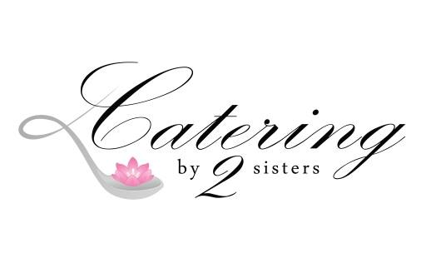
Continental: $9.99 per person
Mini bagels, whipped butter, cream cheese, fresh pastries, yogurt, coffee, bottled water or orange juice (choose two)
Executive Breakfast: $13.99 per person
Fresh fruit platter, scrambled eggs, sausage, bacon, home fries, coffee, bottled water or orange juice (choose two)
Breakfast Wraps Box: $9.99 per person
Wrap (choice of wheat or white),, scrambled eggs, choice of bacon or sausage, cheddar cheese, fruit cup and bottled water

Brunch: $17.99 per person
- Breakfast Casserole: scrambled eggs, sausage, ham or bacon, cheddar cheese
- Home fries:: diced red potatoes, butter, parsley and seasoned salt
- Fresh Fruit: watermelon, cantaloupe, honeydew, pineapple, and grapes
- Stuffed French toast casserole: Brioche bread, fresh blueberries, cream cheese baked to perfection
- Fresh pastries
- Coffee, tea and orange juice

The Perfect Shower: $15.99 per person
- Assorted Tea Sandwiches:
– Smoked Salmon with Herbed Cream Cheese, Capers + Red Onion
– Tuna Salad with Cucumbers
– Fresh Egg Salad with Dill Relish
– Chicken Salad with pineapple
- Chef Salad with Carrots, Cucumbers, Croutons, Tomatoes, Ranch + Balsamic Dressings
or
Caesar Salad with Asiago Cheese, Croutons, Homemade dressing
Choose 2
- Penne pasta with mozzarella, grape tomatoes in olive oil with Italian seasoning
- Broccoli Salad, broccoli, bacon, raisins, red onion, cheddar cheese with sweet mayo vinaigrette
- Fresh Fruit Cantaloupe, Honeydew, Pineapple, Fresh
Berries

Bottomless Mimosas: Fresh orange juice, champagne and fresh raspberries
$5.99 per person

All packages include disposable plates, napkins, utensils and serving utensils. Minimum of 25 people3

Catering By Two Sisters
1693 Quaker Rd
Barker, NY 14012
716-572-3528
Cateringby2sisters.com

