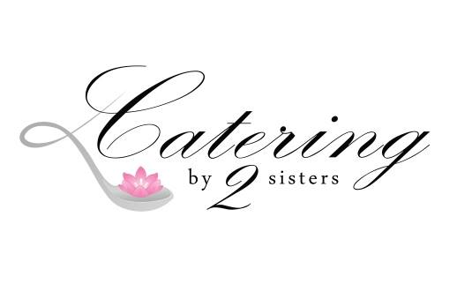
1693 Quaker Rd. Barker, NY 14012
716-572-3528
www.cateringby2sisters.com
Party 2 Go!
$17.99 per person (50 person minimum)
Additional Side + $2.25 per person
Additional Entree + $2.99 per person
All packages include disposable plates, utensils, napkins, and serving utensils.
**Disposable Chafers with Fuel Available for $10.00 each

Choose 2 Choose 2
Roasted Turkey Three Cheese Baked Ziti
Panko Crusted Chicken w/ Vidalia dressing Fettuccini Alfredo
Chicken Parmesan Macaroni Salad
Beef on Weck* Potato Salad
BBQ Pulled Pork* Broccoli Salad
Italian Sausage Peppers & onions* Pasta Salad
Crispy Fried Chicken Macaroni & Cheese
All packages include disposable plates, utensils, napkins, and serving utensils.
**Disposable Chafers with Fuel Available for $10.00 each
*Condiments and rolls accompanied where indicated
Desserts (serves 24)
Brownies tray $39.99
Cookies tray $29.99
Dessert Bar tray 39.99
Assorted dessert tray (includes all of above)
$49.99
**This pricing is pick up only

