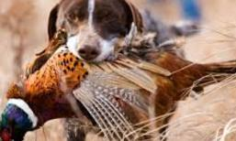

2020-2021 Rules
- Entrees accepted 11/14/2020 to 01/31/2021 for Adults
- Entrees accepted 11/07/2020 and 01/31/2021 for Youth
- No cost to enter…must be over 18 years of age to win the gun.
(Does NOT have to be a Kansas Resident)
- Youth must be between 11 and 17 years of age and be a Kansas resident who has taken Hunter Safety
- All State and Federal Firearms Regulations Apply
- Ringneck Pheasants Only. Tailfeather must be intact and removed at the entry location.
- Feathers will not be returned to hunters.
- Entry locations are:
  - Schwartz Auto -- 221 Main Street Jetmore, KS 67854
  - Best Western North Edge Inn – 404 West Frontview, Dodge City, KS 67801
- Feathers will be measured against one another…judges rulings are final.
- Adult Winner is to receive a Winchester SuperX Pump 12 Guage Shotgun
- Youth Winner is to receive a Lifetime Kansas Hunting License
- Birds must be shot in Hodgeman County OR Ford County, KS
- Adult Hunters MUST show a valid hunting license and Youth Hunters between the ages of 11 and 17 must show a valid Hunters Ed Certification.
Good Luck to Everyone! Winners will be announced in February 2021
2020LTFCFullRules.docx

