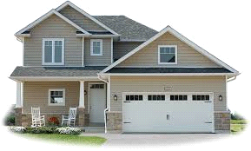

Hodgeman County and City of Jetmore
New Home Incentive Program

In an effort to spur new construction and community growth, Hodgeman County and the City of Jetmore have authorized a new incentive program designed to provide cash contributions to incent new home construction in Hodgeman County.

The program will run until program funds are expended, or until ended by an official announcement. Applications will be taken on a first-come, first-serve basis. We look forward to welcoming our new neighbors and growing our community!

Please see the official program guidelines for eligibility requirements and other program details.

Incentive checks must be claimed within 18 months of approval. Incentives may be claimed by either the builder or the homeowner, and this selection will be made at the time of application.

