Arizona
Knights of Columbus
Charity Raffle
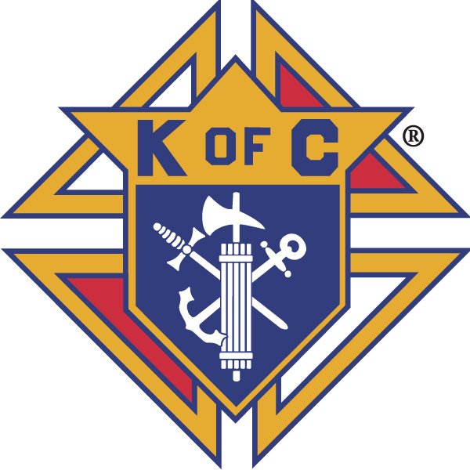
2019 Charity Raffle Guide
A Win-Win Program
Information for a successful CHARITY Raffle

Table of Content

Letter from the Charity Raffle Director 2
Executive Summary 2
Time Line at a Glance 4
Sample Letter to Council Members 5
Raffle Check List 6
Final Report must include 6
2019 State Council Charity Raffle Sales Report 7
Century Report [$100] 8
Millennium [$1,000] Report 8
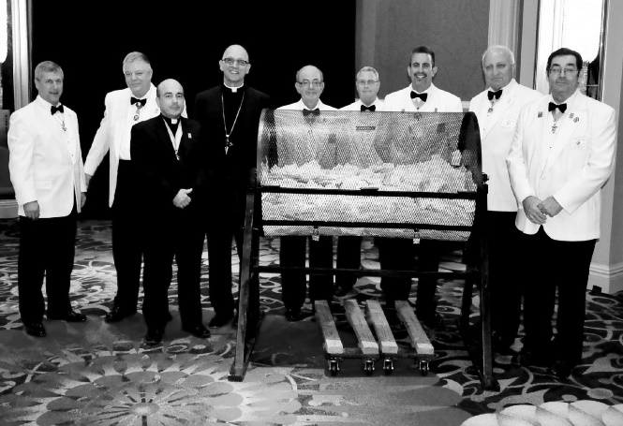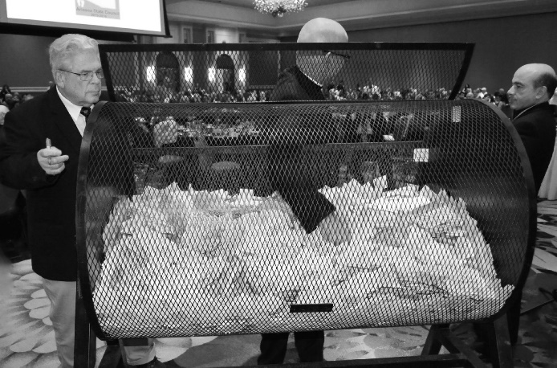

Mid-Winter Meeting
December 1, 2019

Brothers,

Our goal for 2019 is $355,000, and if every Arizona Knight buys just $20 worth of tickets, we will reach and exceed that goal. We have done a great job in the past with the raffle and want to make this year another successful year. Our goal is attainable with everyone's help. We are strongest when everyone works together!

Charity is our primary goal and this project enhances charity programs at both the local and state levels. Jesus primary mission was a mission of charity.

2018 AZ State Charity Raffle results:
- Total Sales: $343,782
- Council Charity Dollars: $171,891
- Bonus dollars earned by the councils: $12,853.82
- Councils participating: 114
- Average sales per council: $3,015.63
- Average sales per member: $20.38
If you experience problems or have questions, please send an e-mail or call me.

A more detailed copy of this guide with additional suggestions and ideas for a successful raffle sale is on the State Website at http://www.KofC-AZ.org . We will also send e-mails to the raffle committee throughout the campaign to provide all councils with the most updated raffle information. A voice over powerpoint training module as well as a training video are being developed and will be available on the state website. Please note an important change in the incentive plan. Good luck selling tickets and reaching your council’s Charity goal.

Vivat Jesus!
Dennis Sullivan Richard Armanini
Dennis Sullivan Richard Armanini
AZ State Charity Raffle Director AZ State Charity Raffle Co- Director
denpsulli@aol.com richard.armanini@gmail.com
480-201-5556 480-818-1774

Executive Summary 2019
- Grand Knight to identify Charity Raffle Chairman, create raffle committee, and advise the Arizona State Council Charity Raffle Director of chairman’s contact information by 1/31/19. See state website at www.KofC-AZ.org for sales success webinars.
- Set a sales goal, for example: At least 10% above last year’s results.
- Grand Knight or Charity Raffle Chairman to make sure that tickets are on hand for your council by mid-January 2019. If you did not receive them, contact State Charity Raffle Director (denpsulli@aol.com or Phone: 480-201-5556).
- Charity Raffle Chairman and committee to determine “Council Marketing” effort.
  - Make sure to discuss your council’s plan with council leadership and Pastor.
  - Note: See full 22-page Charity Raffle Manual for helpful hints on successful campaigns and tips used by Brother Knights. (on state website at www.KofC-AZ.org).
- Grand Knight and Charity Raffle Chairman to determine charity(s) to receive council share (MUST BE A 501c3) organization. This MUST be done before the 2019 State Convention as NO CHANGES will be allowed after the State Convention.
- Recommendation is to distribute a minimum of 3 books to all members. In Arizona, fraternal organizations may mail tickets to members but not to other unsolicited individuals.
- Winners must be 21 years of age or older by May 18, 2019.
- Charity Raffle Chairman should collect ticket stubs and monies often and maintain a running log of sales $$ to update council on progress toward goal. Promote raffle at EVERY meeting and council event – esp. Fish Fries, Pancake Breakfasts and after every Mass (with Pastor’s permission).
- Charity Raffle Chairman oversees distribution of tickets to all members, promotes the raffle, weekly records and turns in all raffle monies and checks to the Financial Secretary. Charity Raffle committee prepares ticket stubs by marking council number on reverse side of ticket stubs, removing staple and separating tickets.
- Complete paperwork (2 pages) that MUST be turned in at the 2019 State Convention or mailed (to be received no later than May 13th), to Dennis Sullivan at 16832 S. 1st Drive, Phoenix, AZ 85045 with a single council check for the total amount collected through the campaign. The council check must be written to the AZ Knights of Columbus Charities, Inc. Bring ticket stubs, completed paperwork and council check to the state convention.
- Council receives 50% of their sales returned for their charity(s). State will issue a check(s) that will be sent to Financial Secretary following the convention in the name of the charity(s) and the $ amount.
- IMPORTANT CHANGE FOR 2019 INCENTIVE – The bonus is to be calculated from the State’s half of total sales (the state’s 50%) and can be used to help councils with their expenses, cover assessments and/or recognition of individual efforts (shirts, hats, plaques, certificates, etc.). No cash may be given to any individual or individuals. The bonus check of 10% of charity dollars is mailed to the council Financial Secretary. The incentive plan requires a minimum council sales of $1,000 and is structured as follows:
Council with 2018 sales from:
  - $1,000 to $5,000 must increase by 10% to earn the 10% charity $ bonus
  - $5,001 to $10,000 must increase by 7.5% to earn the 10% charity $ bonus
  - $10,001 to $15,000 must increase by 5% to earn the 10% charity $ bonus
  - $15,001 and above must increase by 2.5% to earn the 10% charity $ bonus
- Council receives 50% of its total sales for its 501(c)3 named charities.

- As in the past several years, the program remains 5 tickets for $20, and 6 books for $100, which gives the ticket buyer an extra book of tickets.
- For additional copies of the posters, CHECK OUT THE STATE WEBSITE FOR PRINTABLE COPIES at www.KofC-AZ.org.

Time Line at a Glance

December 1, 2018 – Tickets, posters and sales guides delivered to District Deputies. He should deliver to assigned councils within the next month – no later than Jan 31, 2019.

December, 2018 - January, 2019 –Select Charity Raffle Chairman and a Charity Raffle Committee. This committee can help plan the sales campaign, stuff envelopes for each council member, select the charity or charities who will benefit. The committee can also give you support with sales and promoting Charity Raffle at the council meetings and events.

February, 2019 (or sooner) – Mail or give members their tickets and START SELLING! Promote the State Raffle at every meeting and at every event – especially Fish Fries, Pancake Breakfast and after every Mass ( with Pastor’s permission). Remember, tickets MUST be sold to persons 21 years or older. Tickets sold to anyone under 21 will be disqualified and not paid to any other member of the family.

Mid- May, 2019 –Wrap up your sales, collect ticket stubs, and money. This is a good time to hold a committee meeting so that members can help write or stamp your council number on the back of the ticket stubs. The ticket stubs need separation. You will need to bring a Council Check to the convention. If your Treasurer is scheduling a fishing trip to Alaska in May, make sure he gives you a check before he leaves. Remember – Please bring only council checks. Please do not send or bring personal checks or cash to the convention. If someone other than you turns in the tickets make sure they understand the program. Better yet, assign the Raffle Chairman as an alternate delegate and have him deliver the raffle material to the convention.

May 17-18, 2019 - You can turn in your raffle ticket stubs, council check, and Raffle Sales Report, Century Report, and Individual Knights Sales over $1,000 at the State Council Convention.

May 18, 2019 at 12:00 noon – is the deadline for turning in raffle materials. This gives us time to prepare a Raffle Report for the convention delegates.

After the State Council convention [2 - 4 weeks] – Check(s) are made out to your council’s designated 501c3 charity(s) and are mailed to your Financial Secretary for councils who turned in tickets, council check, and State Report listing eligible charities. No changes can be made to your selection of charities after the 2019 State Convention. Remind the Financial Secretary to watch for the check(s) from the State Council.

  - Information about the Prizes

- The prizes are drawn from 1st prize to the 10th prize. Two alternate tickets are drawn in case we cannot locate or must disqualify any of the ten winners.
- Winners must confirm their acceptance of the prize within 14 days of being notified by returning a copy of the letter sent to them requiring a signature and their social security number. Winners must be 21 years or older to participate and collect the prizes.
- The unconfirmed winners list is posted on the web site as soon as possible. The list is updated after all winners are confirmed. This may take up to six [6] weeks.
- The original winners are responsible for all taxes and will receive a 1099 form for income tax purposes.

Sample Letter to Council Members only
<Date>

Name
Address
City, State, Zip

Brother <First Name>,

It is again time for the Annual Knights of Columbus Arizona State Charity Raffle. All prizes are cash again this year. They are 1st prize - $10,000, 2nd prize - $7,000, 3rd prize - $5,000, 4th Prize – $3,000, 5th prize - $2,000, 6th prize - $1,000, 7th prize - $500, 8th prize - $500, 9th prize - $500, and 10th prize - $500. The total is $30,000!

Our Council goal for 2019 is _______. Our charity is <Name charities> will receive half the proceeds from the sale of the raffle tickets. Last year our council gave <name charity> a check for <amount of check>.

Enclosed are three books of five [5] tickets each for you to sell or purchase. The tickets are $5 each or $20 for each book—or a total of $60.00. Each book sold is $20 toward our goal and $10 for <name charity>. You can return all ticket stubs and money through the church office, collection basket, or directly after Mass to the Knight’s table. Make checks payable to the Knights of Columbus Council <number>. Please return the ticket stubs, money or check in an envelope with your name on it to identify you as the seller. Please do not separate the tickets stubs and do not mail cash.

The deadline for returning tickets and money is [pick a date early in May].

This is your opportunity to support a council project and help raise money for <charity>. If you do not believe in selling or buying Charity Raffle tickets to support charity, then please make a donation in any amount. Additional tickets are available.

Thank you for your help with this very important charity project.

<Your name>

2019 Council Charity Raffle Chairman
Phone:
E-mail:

Enclosed three books of State Charity Raffle tickets

Note: send the letter using mail merge and window envelops for this project. If you do not know how to use mail merge, recruit a member who does and have him do the letters for you. Use electronic signature or fancy type for the name and provide contact information in the footer of the letter. Consider copying sales hints / tips onto the back of your council letter from the 22 page manual posted on the website.

Raffle Check List:

  - Planning phase [December and January]

- Grand Knight selects Council Raffle Chairman. (Date _____)

- Send Council Chairman's name and e-mail address to Raffle Director Dennis Sullivan at
denpsulli@aol.com or Phone: 480-201-5556. (Date _____)

- Name a 501(c)3 eligible charity[s] as recipients for the council share of the ticket sales so everyone knows who will receive the proceeds of the ticket sales. Name of charity[s]_________________ (Date _____)

- Set a council goal for the sales campaign of at least a 10% increase over 2018 council sales. [We will sell as many tickets as possible is not a goal]. A goal is a dollar figures based on a percent (at least 10%+) over last year's sales] our goal is $________. (Date _____)

  - Sales phase [January, February, March, April]

- Distribute tickets to council members including a letter describing why you are selling raffle tickets. (Date _____)

- Suggest/develop new/other ways for the council to sell tickets. (Date _____)

- Communicate progress to the council and parish. (Date _____)

  - Wrap-up [May]

- Collect money and ticket stubs. (Date _____)

- Review tickets for complete details, remove the end tab to separate tickets and stamp or write the council number on the back of each ticket stub. (Date _____)

- Deposit all money and checks in your council account. (Date _____)

- Write a Council check to the Arizona Knights of Columbus Charity, Inc. (Date _____)

- Fill out the 2019 Arizona State Council Charity Raffle Sales, Millennium, and Century Sales Reports, Bring all three reports with ticket stubs, and Council check to the 2019 Arizona State Convention before 12:00 noon, May 18, 2019. (Date _____)

Final report must include:

____ 2019 State Council Charity Raffle Sales Report completed with charity(s) listed.

_____ Millennium [$1,000] Report completed, if none mark NA and your name.

_____ Century Sales [$100] Report completed, if none mark NA and your name.

_____ Council check for the total amount of ticket sales. [Council # on the check]
_____ Ticket stubs separated and council number printed or written on the back.

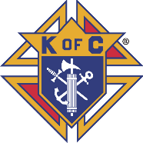
Arizona State Council
Date Rec: _________________
Time Rec:_________________
Rec By: _________________
Council

#__________
Knights of Columbus
2019 Arizona State Council Charity Raffle Sales Report
Total Ticket Sales $ $ $ $
50% of Sales: $ $ $ $

(Total Disbursement must equal 50% of Gross Sales)
Official Use Only
Check
# Amount

__________ __________

__________ __________

___________ __________

Total $_________

Attach Council Checks only.
Approved Charities - [501(c) (3) document not required]:
Arizona Right to Life $
Arizona Special Olympics $
Parish [Name] $

Ministry__________________________ $

St Joseph Youth Camp $______________

Parish St. Vincent de Paul $_______________
(Name)______________________
All Other Charities: [Must attach current 501(c) (3) IRS letter] Attached IRS Letter
YES Used Previous
$

$

STOP did you name your charity?

NOTE: IRS Laws and State Knights of Council Bylaws require the charity recipients of the raffle proceeds be a 501(c) (3) organization.

Council Information: (Print Clearly)

Raffle Chairman: Council #

Telephone: E-Mail:

Address:

City: Zip:

Tickets turned in by: Phone:

Signatures: GK ___________________ Raffle Chair______________________

WRITE OR STAMP YOUR COUNCIL NUMBER ON THE BACK OF TICKETS - separate stubs
DO NOT BRING CASH OR PERSONAL CHECKS!
Make check payable to: AZ Knights of Columbus Charities, Inc
Century Sales [$100] Individual Knights $1,000 Sales Report 2019

The sale of raffle tickets is a team effort among Brother Knights and councils. We also want to recognize individual councils and Knights that do an outstanding job of selling Charity Raffle tickets by listing them on the Knights web site. In order to recognize one or both, please fill out this report even if you have already told me about their achievements.

Century [$100 or more] Sales]:
A century sale is one Knight selling one person $100 worth of tickets which is six books to one person at one time. They can put one name on all 30 tickets or put different name on them such as family members. If someone buys $200, report it as one sale and $200 in the Total Sales column. Report only totals. DO NOT SEND THE LIST OF NAMES WHO PURCHASED $100 OR MORE TICKETS. Keep them for your records.

Report for your councils Century Sales of $100 or more:

 | Council # | City | # Century Sales | Total Century Sales | Average per sale
Example 1 | 00001 | Any Town | 2 | $300 | $150
Example 2 | 00002 | Any City | 5 | $500 | $100
Your Council

Individual Knights Sales of $1,000 or more [PLEASE PRINT USING CAPITAL LETTERS]

Print the information for all Knights with total sales over $1,000.
Count | Council # | City | Knight’s Full Names | Phone Number | Total Sales
1
2
3
4
5
6
7
8
9
10

Report Submitted by:__ _______________________________ Council Number: _________
Note: A composite Millennium and Century Sales Report will be posted on K of C web site.

