**Knights of Columbus**

Fourth Degree

John H. Reddin Province

PO Box 3392

Sierra Vista, AZ 85636-3392

10 October 2019

Dear Worthy Officers and Brothers All,

**Please actively recruit new members into the Fourth Degree by distribution of this entire packet to all.**

The primary purpose of the Fourth Degree is to foster the spirit of patriotism by promoting responsible citizenship and a love of and loyalty to the Knights' respective countries through active membership in local Fourth Degree groups called assemblies.

Each ‘degree’ of the Knights of Columbus is associated with a particular virtue, the fourth being “Patriotism”. Consequently, the 4th Degree is often known as ‘The Patriotic Degree’.

The requirements for joining the 4th are that a brother Knight must be a third-degree member in good standing, be an exemplary Catholic, and be of sound citizenship of his country.

The Fourth Degree is frequently regarded as an honorary title but should rather be thought of in terms of service to church and country, and the goals of the Fourth Degree may be summarized as the promotion of the ideals of Catholicism and Patriotism side by side.

The next scheduled Exemplification of the Fourth Degree will be in Tucson Arizona on Saturday, 16 November 2019, hosted by Archbishop Daniel J. Gercke, Assembly 16. The ceremonial will be held at 1330 S Mountain View Ave, Tucson, AZ 85711.

One of the top Exemplification Teams in the entire order will present the degree ceremony. The Exemplification will start at **10:00 AM**. Following the ceremony, there will be a reenactment of the Knighting Ceremony for those who want to take photographs.

Enclosed in this packet are the agendas for the Saturdays Exemplification activities: General Instructions and the Registration Form.

**Please reproduce this entire packet and ensure that every candidate has a copy.**

This letter; all forms and instructions; and additional information are available on the Arizona State Council Web Site: <http://kofc-az.org/patriotic-degree>

Sincerely and Fraternally,

Bryant Sayers

Arizona District Master

**Knights of Columbus**

Fourth Degree

John H. Reddin Province

PO Box 3392

Sierra Vista, AZ 85636-3392

10 October 2019

**Fourth Degree Exemplification**

**LETTER OF INSTRUCTION**

1. **Mandatory Dress**

The mandatory dress for the exemplification for Candidates and Sir Knights will be one the following:

1. A **Dark Suit** (black, dark grey or dark blue), white shirt, black shoes and a conservative tie.
2. **Black Tuxedo** pleated white shirt, black shoes, black bow tie and black cummerbund. The shirt must have a PLAIN LAY DOWN COLLAR ONLY as shown in the picture. NO WING TIP COLLARS, VESTS, OR WAIST COATS ARE ALLOWED.

Members of the Armed Forces, Police, Firefighters & Border Patrol may wear their full-dress uniform in lieu of a tuxedo. Priests may wear Clerical Garb with Collar.

Dress for the luncheon guests will be church attire suitable for the occasion.

**2. Recruitment**

Faithful Navigators are encouraged to visit councils and start recruiting as many Third-Degree Knights as possible or that will have their Third Degree by the suspense date. At every council meeting, there is time set aside for a Fourth-Degree report. Grand Knights should allow the Faithful Navigator or a representative of the Assembly to speak and recruit at this time.

The Faithful Navigator or representative should walk the candidate through the registration process and hand this packet in its’ entirety to the candidate to complete along with a Form 4.

**3. Candidates Membership Application (Form 4)**

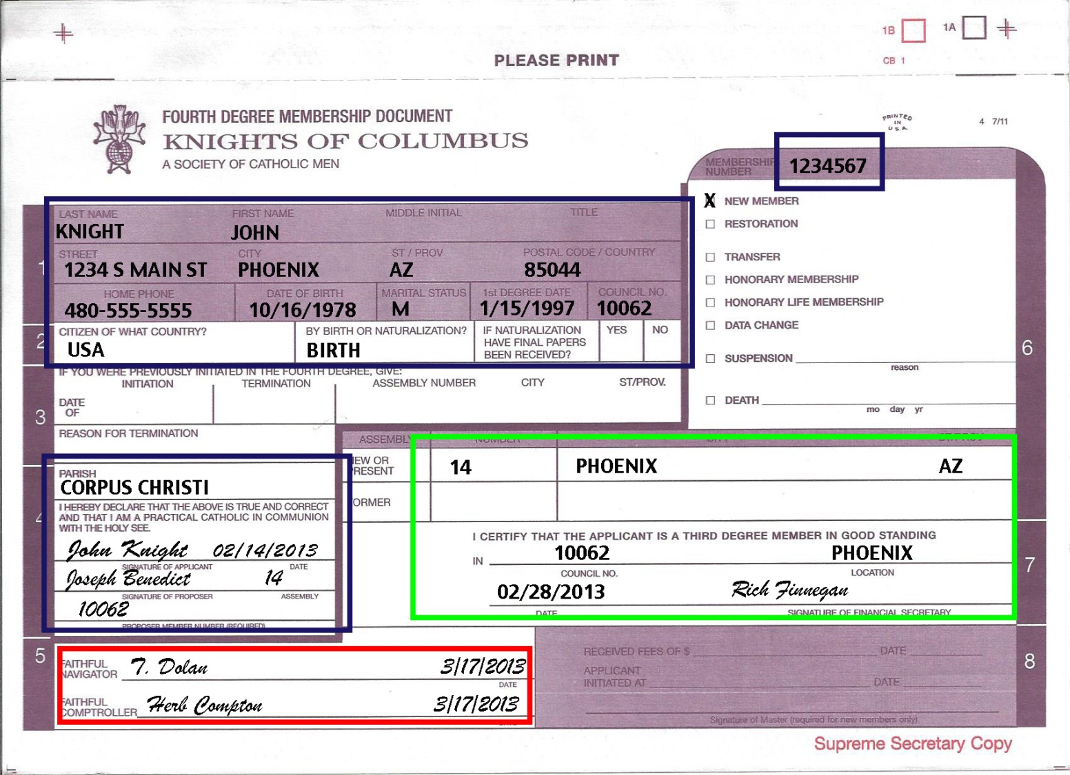

**Example of properly filled out Form 4**

All Form 4’s must be filled out properly. Be sure the form has the candidate’s **membership number** (top right-hand corner) and **personal information**. Ensure all blocks requiring signatures (**Applicant, Sponsor**, **Council** **Financial Secretary**, **Faithful Navigator**, and **Faithful Comptroller**) are completed. Rank or Title is for Priests or Military only. Please type or print legibly in **ALL** **CAPITAL** letters.

The gaining Assembly Comptroller will detach the Assembly’s copy of the completed Form 4 for their file and detach the Council’s copy and provide it to the candidate’s Financial Secretary’s for their file. Mail all remaining copies (Supreme & Master) with candidate registration form and fees paid via checks made payable to *District Master Knights of Columbus*, shown on the Registration Form. All checks must be sent to arrive **NO LATER THAN 6 NOVEMBER 2019**

Candidate Fees are **$70.00** which includes one banquet ticket (mandatory and not refundable), a Social Baldric, and a Fourth Degree Lapel Pin. Fees for Priest Candidates are **$50.00** whichalso including the above items. The Assemblies are requested to pay for Priest Fees and accommodations.

**NOTE: Incomplete forms will need to be corrected ASAP.**

**4. Mass**

Mass will be celebrated at 12:00 Noon. Everyone is invited to Mass. Priests who would like to concelebrate Mass should bring Alb & Stole, and inform the Arizona District Master in advance, at email [arizonadistrictmaster@gmail.com](mailto:arizonadistrictmaster@gmail.com) or his Executive Secretary for the 4th Degree at email [azjhrpeecsec@gmail.com](mailto:azjhrpeecsec@gmail.com).

**5. Registration Form**

Registration forms may also be brought the day of the Exemplification. Please mark special needs access (wheelchair/walker) and/or dietary needs in the *Other Special Needs* box.

**6. GENERAL INFORMATION:**

Make additional copies of all Forms as needed. All documents included with this packet are available on-line at the Arizona State Council Wed Site: <http://kofc-az.org/patriotic-degree>. These forms can be downloaded, printed, and manually completed and may also be completed on-line using required publishing software. Instructions for electronically completing the Registration Form are posted to the web site.

**NOTE: THERE WILL BE NO REFUND OF ANY PAYMENTS FOR ANY REASON AFTER**

**11 NOVEMBER 2019.**

**7. TENTATIVE AGENDA – 16 November 2019 Exemplification**

Saturday

8:00AM to 9:00 AM Registration of Sir Knights and Candidates.

9:15 AM Candidates report to candidates’ room to sign the registration log

9:45 AM Candidates Process to main ballroom with Honor Guard (Sir Knights in Ballroom)

10:00 AM Exemplification Fourth Degree

Following Exemplification Knighting Re-enactment Photo Session immediately following the ceremony

12:00 Noon Mass will be celebrated and all Priests in attendance are welcome to concelebrate.

Following Mass Luncheon

**Knights of Columbus**

Fourth Degree

John H. Reddin Province

PO Box 3392

Sierra Vista, AZ 85636-3392

10 October 2019

**How to Register for the Fourth Degree Exemplification 16 November 2019, hosted by Archbishop Daniel J. Gercke, Assembly 16. The ceremonial will be held at 1330 S Mountain View Ave, Tucson, AZ 85711.**

Please read and follow the below instructions carefully.

**Third Degree Candidate Instructions**

1. **Form 4** - You must have a completed & approved Form 4 processed through your gaining Assembly. Contact your gaining Assembly’s Officers to ensure this has been done.
2. **Registration Form** - Complete the registration information to include personal data including special dietary needs and accessibility (wheelchair or walker).
   1. Your banquet meal, and only yours, is included in the Candidate Registration Fee ($70 for Candidates, $50 for Priest Candidates).
   2. Total all the charges and enter on the Grand Total Line.
3. **Payment**
   1. If you are paying your Assembly to have them send payment on your behalf, you must make a copy of this completed form and give it to your Assembly. Enter ASSEMBLY WILL PAY in the block for Check Number on the original Registration Form sent to the Registration Chairman.
   2. If you are paying directly, make your check payable to *District Master Knights of Columbus*. Write the check number in the “Check Number” block.
   3. **Assemblies should pay all fees for their Priest Candidates**!
4. **Mail** - Mail your Form 4, the completed Registration Form, and check (if paying directly) as noted on registration form

Registered Candidates will get a confirmation if they provide an email address that accepts email from [azjhrpexecsec@gmail.com](mailto:azjhrpexecsec@gmail.com). DO NOT assume that you are registered. If you do not receive a confirmation, please call 520.234.4120 or email the Arizona District Master Executive Secretary, for confirmation.

**Sir Knight Instructions**

1. **Registration Form -** Complete the registration information to include personal data including special dietary needs and accessibility (wheelchair or walker).
2. **Payment –** ALL SIR KNIGHTS ARE REQUIRED TO PAY THE $10 REGISTRATION FEE!
   1. If you are paying your Assembly to have them send payment on your behalf, you must make a copy of this completed form and give it to your Assembly. Enter ASSEMBLY WILL PAY in the block for Check Number on the original Registration Form sent to the Registration Chairman.
   2. If you are paying directly, make your check payable to *District Master Knights of Columbus*. Write the check number in the “Check Number” block.
3. **Mail** - Mail the completed Registration Form, and check (if paying directly) as noted on registration form.

Registered Sir Knights will get a confirmation if they provide an email address that accepts email from [azjhrpexecsec@gmail.com](mailto:azjhrpexecsec@gmail.com). DO NOT assume that you are registered. If you do not receive a confirmation, please call 520.234.4120 or email the Arizona District Master Executive Secretary, for confirmation.