The purpose of this publication is to provide accurate current information about actions of government at the city, county, state and federal levels which affect citizens of Davis County Utah. We welcome the free sharing of our articles by all readers on any media so long as the publication and author are recognized. If you would like to volunteer to report on an organization of government, please email our editor at DavisCorrespondence@outlook.com.
Click to Contents
Government This Month –
- What About the Process?
- Artificial Intelligence and Privacy
Opinion – A Sobering Day in Utah
Upcoming Events
Recent Events
Platform Plank of the Month
Constitutional Clip of the Month -

What About the Process?
Jack Barrington
Focus with me on a broad statewide issue that obviously affects Davis County as well.
We have an overall process issue at the Capitol. For many years now policy has been made between lobbyists, NGOs (non-governmental organizations), P3s (public-private partnerships) and our intended representative public servants. The “stakeholders” are not the people but rather local, foreign, and national lobbyists and big business.
As a state, and a country frankly, the “why” has been lost. To be elected as a representative of your fellow men and women bestows a sacred trust upon that representative. That trust should be treated with the utmost loyal care. Frequently, it is not. This happens with national, state, county and even down to our local city representatives. Before you assume I mean elected officials are nefarious evil doers, let me clarify. I do not. Rather the process by which those in these positions function currently is broken.
In Utah we have had special sessions in which more than 17 bills were voted on in one day. Representatives are voting on bills which they have not read. That is a complete dereliction of duty. If time was not permitted for our elected representatives to read it, the people surely could not have had time to give their input to their representatives. This a common issue!
The current process does not provide for a strict constitutional review. I do not mean a review by activists taught in a biased system at universities, nor by lawyers hired by the interested parties. I suggest a thorough, line by line, constitutional comparison by those who have a deep understanding of both national and state constitutions.
Can the populace at large read bills under consideration? Can they find and read historical code? Is that taught in grade school and up? Do voters at large have any knowledge of who their representatives are? Do they know the responsibilities of a county recorder?
How is the public to hold the government in check when it has little understanding of what it is? There are many reasons for this lack of knowledge. Apathy is certainly part of it. However, I’d argue a larger issue is that government is overwhelming. It has intentionally become so big and so confusing that the public cannot or will not engage.
The lack of knowledge not only leads to rogue branches of government, of corruption and abuse, but it also results in the public accepting clearly unconstitutional initiatives or loss of rights without even knowing it.
The process in Utah must change. There must be greater transparency along with sufficient notice to read bills, especially if they are over 10 pages long. Our elected representatives owe it to us, at the bare minimum, to read bills that can greatly alter our lives for the better or worse.
Just this year alone there have been three large bills that the legislature passed and once the law was actually being enforced, they were horrified and had to do something to undo or stop it. Why? Because they did not read it.
They must stop just trusting one another, or the lawyers and lobbyists, on the details of a bill. No more circular trust. They should read it, and you should hold them accountable if they do not.
In closing, I ask that we require the following:
- Sufficient notice for both the legislature and public when special sessions are held. Holidays and weekends do NOT count in the number of days’ notice required.
- No more routinely voting to disregard the rules of procedure just to expedite passage of more billes. It’s for emergencies.
- LISTEN – Listen to the voters that lives in your district. Stop giving all your time to lobbyists, NGOs, and out of state activists.
- Require real Constitutional checks.
- No more mob rules. Legislative leaders should allow lawmakers to vote their conscience to benefit the people. No more threats to delay or to vote against their bills because they voted against yours.
- Kickbacks, back scratching, and the like at the public’s literal and figurative expense is not okay. Corruption of any kind is not what the public voted for.
- Stop giving funding to NGOs, programs, and systems that are destructive to America, our culture, and the family.
We hope to see some big changes so that trust can begin to be restored over time. Currently the public has little trust in the government. We need honesty, transparency and genuine engagement with the people (not with NGOs and lobbyists).
All elected officials are responsible to serve the best interests of their voters within the bounds of the constitution and under the oversight of our Creator.
Artificial Intelligence and Privacy
Dale Hawkins
Artificial Intelligence (AI) can be used for both good and bad. One's identity and privacy need to be protected. The risk of ID theft has been escalated with the advancement of AI. Therefore, to help minimize ID theft risk, and the harm that can result from such covert activity, one MUST protect against ID theft, OR someone taking out credit cards, loans, etc. in your name.
We all need to request that access to our credit report be frozen, nor allowed the issuance of credit in our name, via the three major credit reporting agencies. A call to EACH of the following credit reporting agencies, or going online to their individual website needs to be done TODAY, if you haven't already placed a freeze on your credit.
Equifax: 888-298-0045
Experian: 800-509-8495
TransUnion: 888-909-8872
Having one's spouse freeze their credit is also important since you are linked to your spouse's credit also, via marriage. Your credit and liability can be affected by covert activity against your spouse. One should also consider freezing the credit of your minor children.

It is highly recommended that you do NOT use a debit card for any transaction except getting cash from your financial institution directly. Use a credit card exclusively. Numerous people have found that their financial accounts have been compromised because they used a debit card instead of a credit card.
Most people are aware of the fact that when you use a debit card, there is an almost instantaneous withdrawal of funds from your financial institution, whereas a credit card allows at least several weeks of delay for payment. An unauthorized debit transaction instantaneous inflicts harm upon the account holder. Many times significant funds are withdrawn before the fraud is detected. Resolution of the fraud can take weeks to get resolved, and there's generally collateral damage, which the debit card holders incurs before the fradulent funds are credited back to one's account.
The financial institution who issued the debit card has little incentive to help you resolve the fraudulent debit card activity, whereas one can easily dispute an unauthorized charge related to a credit card. There's automatically a delay from the time the charges are placed until one is expected to pay for a charge. When there is a dispute over an authorized credit card transaction you have the VISA gorilla or the MasterCard monster who is willing to pursue the fraudulent activity because they have a vested interest. They want their money. Also, there are legal safeguards that you have with a credit card that do not exist with a debit card. A good credit card will reward you for using it. Use a credit card, make some reward money, and avoid exposure to unnecessary risk. Consider making payments on your credit card as soon as you make charges or even prepay for anticipated purchases to avoid possible late fees and interest payments.

OPINION
A Sobering Day in Utah
By Davis County Commissioner John Crofts
My heart has been heavy following the tragic and senseless shooting of police officers in Tremonton — ambushed and murdered with a high-powered rifle.
As someone who has spent much of my life in public service and now serves as an elected official, this tragedy hits especially close to home.
I’ve personally experienced threats in this role. I’ve had unhinged individuals show up at my home. I’ve seen firsthand the level of hostility that sometimes accompanies public service. I know I’m not alone in that experience — many others who serve their communities do so under a quiet but persistent weight of concern for their safety and their families.
To see public servants gunned down in cold blood is more than heartbreaking — it’s infuriating. It’s unthinkable. Whether you're wearing a badge, running for office, or simply stepping up to serve your community, no one should face the threat of violence just for trying to make a difference.
My deepest gratitude goes out to the brave officers who put their lives on the line every single day. I also extend that same appreciation to the elected officials across our state and country who continue to lead in this difficult environment. It takes courage.
Even here in Davis County, we’ve had our own close calls — serious threats against public officials that the media doesn’t report, not because they don’t matter, but because we often choose not to publicize them. But make no mistake: those of us in public service feel it. We live it.
To the families of the fallen officers in Tremonton: my heart goes out to you. Your loss is unimaginable. Your loved ones are heroes.
And in quiet moments, after the cameras are gone, I find myself asking a painful but honest question:
Who’s next?
It is a sobering time in America. Let’s honor those who serve. Let’s refuse to look away.

Upcoming Events
County Commission Meetings –10/21, 10/28, 11/2, 11/18 2025 at 10:00 AM
Commission Chambers Room 303 – 61 S. Main St. Farmington
Davis School Board Meetings – Tuesday 10/21 at 4:00 pm Board Workshop
Tuesday 11/18 at 6:00 pm Board Meeting
Tuesday 11/18 at 4:00 pm Board Workshop
Auditorium at 45 E State Street, Farmington, Utah
Davis County Conservatives Community Forum –


Recent Events
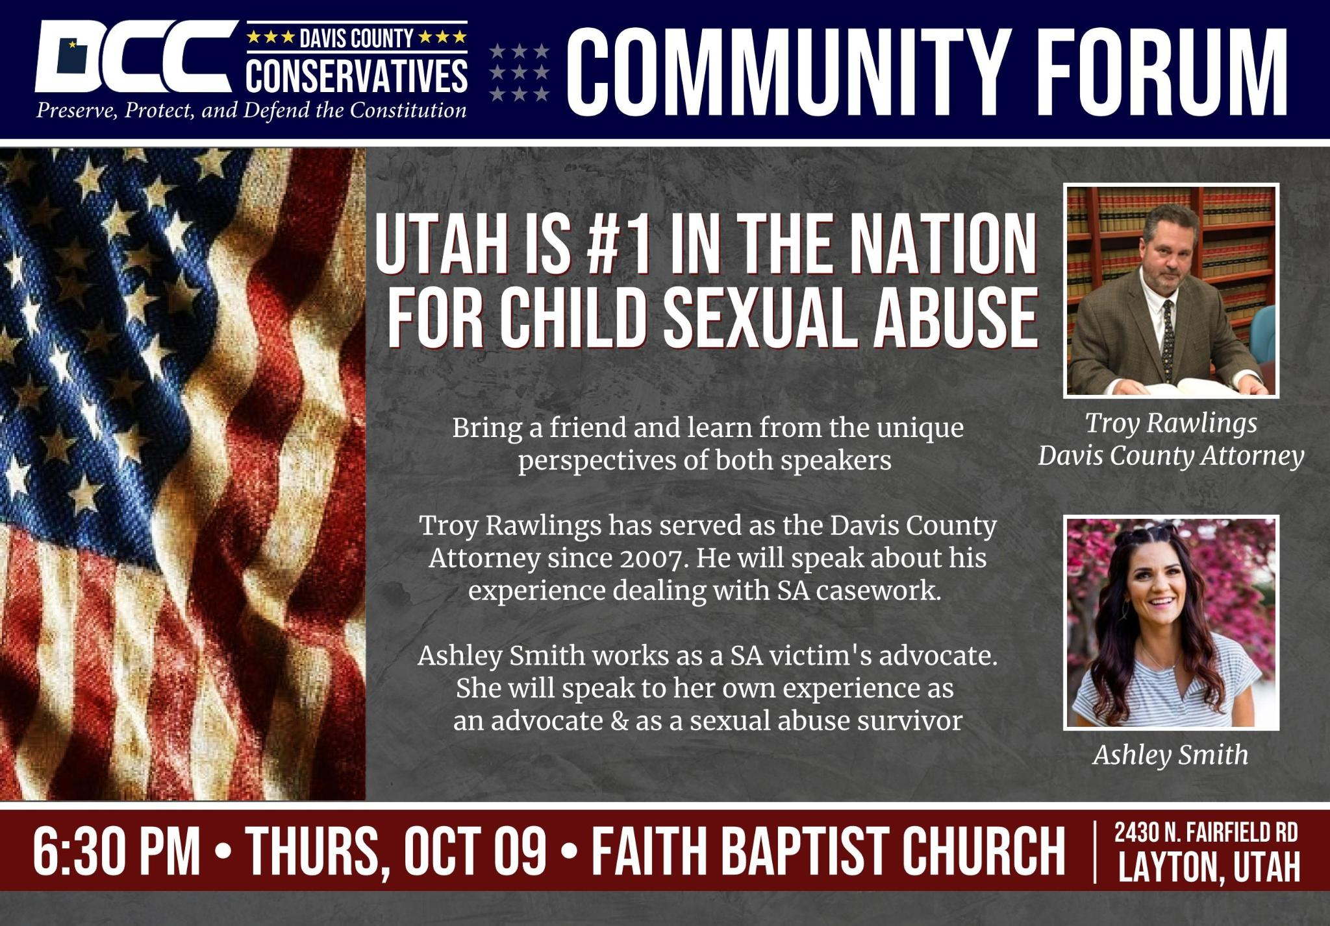
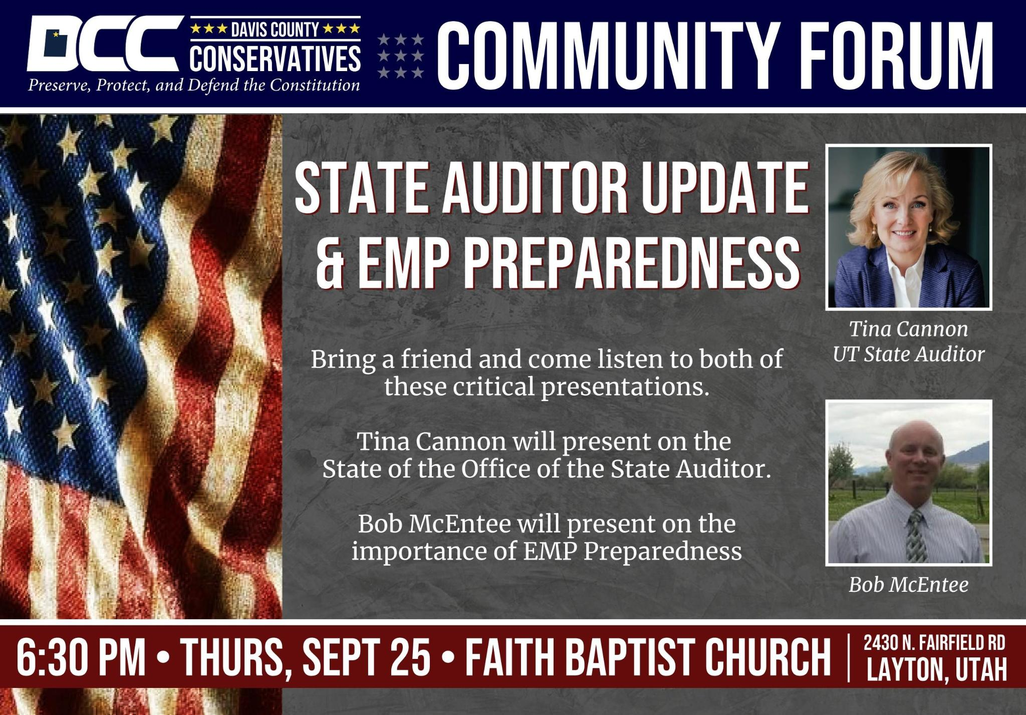
Platform Plank of the Month
Private Property
We recognize the rights of the individual to own property. We resist any effort by government to take private property without both an overwhelming need for public use and just compensation.
Reaffirmation of States’ Rights
We oppose congressional, judicial, and administrative abrogation of the principle that and powers not delegated to the central government of the United States of America by said Constitution, nor prohibited by said Constitution to the states, are reserved to the states respectively or to the people.
We demand that Federal law and administration be amended to require that administrative law fully comply with unalienable individual rights guaranteed under the Constitution. We are persuaded that government actions under administrative law have not ensured the basic constitutional rights of the citizens. Legislative action is essential to require government agencies to formulate rules and regulations that are consistent with unalienable individual constitutional rights.
To assist in balancing the federal budget, we demand an independent, outside policy, operational and financial audit of the Federal Reserve System, or by the General Accounting Office, similar to H.R. 1468, a bill in the 102nd Congress. We proclaim the constitutional right of any state to require such an audit. (1) We encourage Utah’s Attorney General to initiate an audit by proceeding directly before the United States Supreme Court under a state’s right of original jurisdiction. (2) Article I, Section 9, paragraph 7, of the Constitution of the United States. Article III, Section 2, paragraph 2, of the Constitution of the United States.
Davis County Republican Party Platform

Constitutional Clip of the Month
Article IV Section 4
Section 4
The United States shall guarantee to every State in this Union a Republican Form of Government, and shall protect each of them against Invasion; and on Application of the Legislature, or of the Executive (when the Legislature cannot be convened) against domestic Violence.

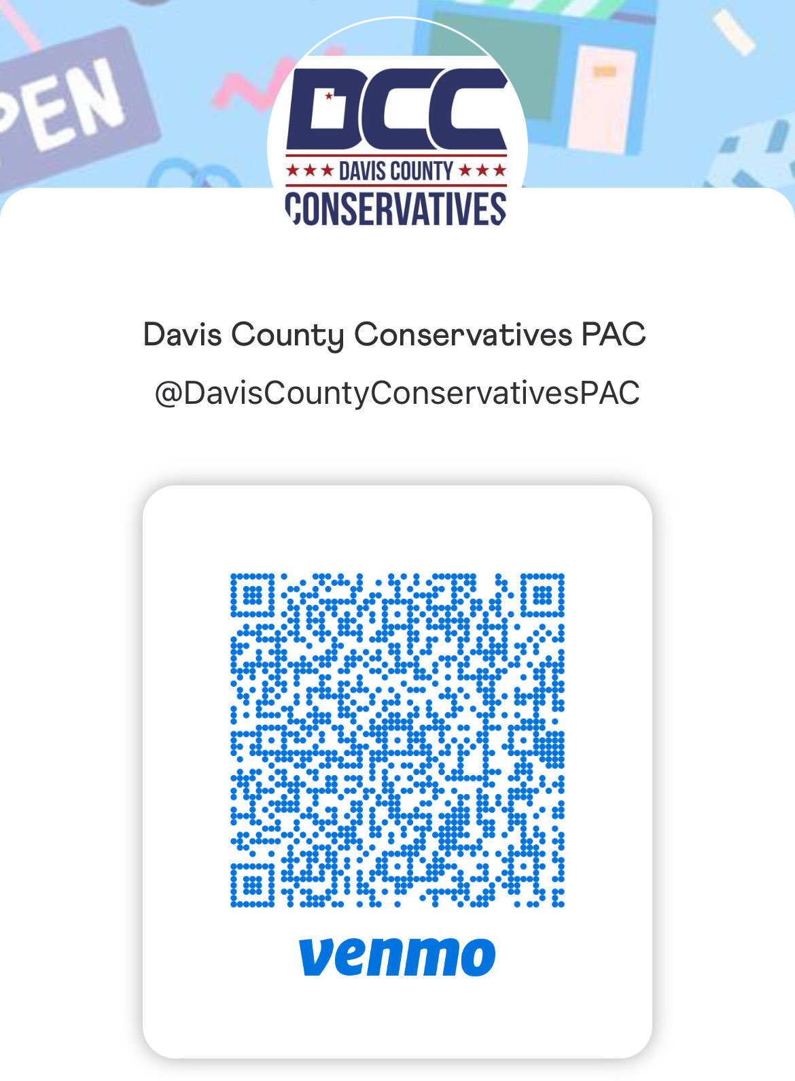
Subscriptions
We do not charge a subscription fee even though we do have modest expenses. We welcome your donations at davisconservatives.com or through the QR code at the right.
Subscribe or unsubscribe by emailing your name and email address to daviscorrespondence@outlook.com.
Advertising
We reserve the right to accept or reject advertising. All proceeds will be used to support the creation and circulation of the newsletter. Please submit proposals for advertising to daviscorrespondence@outlook.com.

