ST. PETRI EVANGELICAL
LUTHERAN CHURCH



20th Sunday after Pentecost
October 11, 2026
Welcome to St. Petri!
Worship is both in person and online today.
If joining us in person, please observe all health and distancing policies!

Interested in Church Membership? Contact the office at 419-385-4639
3120 S. Byrne Road, Toledo Ohio 43614
stpetritoledo1@gmail.com ● www.StPetriToledo.org ● facebook.com/StPetriToledo

Welcome to worship at St. Petri! If you're worshiping with us online, please say hello. If more than one person is watching with you, let us know how many are gathered with you. We'd love to know who's part of our online congregation today.

20th Sunday after Pentecost October 11, 2026

GATHERING
The Holy Spirit calls us together as the people of God

FOR THOSE IN THE CONGREGATION: IF YOU HAVE PROBLEMS STANDING, PLEASE FEEL FREE TO REMAIN SEATED THROUGHOUT THE SERVICE.

WELCOME & ANNOUNCEMENTS

Rejoice in the Lord always! Again I say, rejoice!
Let your gentleness be known to everyone, for the Lord is near.
Today we choose to rejoice. We come to worship and give thanks to God.

Do not be anxious about anything, but in every situation,
through prayer and petition with thanksgiving, present your requests to God.
We lay down our worries and place our trust in the Lord.

And the peace of God, which goes far beyond all human understanding,
will guard our hearts and our minds in Christ Jesus.
We open our hearts to God’s peace.
Whatever is true, honorable, just, pure, lovely, and commendable,
we fix our thoughts on these things and worship our God! Amen

CONFESSION and FORGIVENESS

Blessed be the holy Trinity, ☩ one God,
who pours love into our hearts
and healing upon the earth.
Amen.

Confident that God justifies us by grace through faith,
let us confess our sin.

Compassionate God,
we confess that we struggle to embody your goodness
in the world and in our own hearts.
Creation groans from overuse.
Jealousy and bitterness strain our relationships.
Indifference keeps us from seeking justice.
Divisions disrupt your call to show genuine love to others.
Turn our hearts back to you.
Restore our world and reconcile us to one another.
Renew us to live as your holy people,
following the way of Jesus Christ.
Amen.

Hear this good news:
We have peace with God through ☩ Jesus Christ,
in whom there is no condemnation,
but only forgiveness and the promise of eternal life.
Receive freely this healing gift of grace.
Amen.

¶ GATHERING HYMN Immortal, Invisible, God Only Wise
Congregation sings verses 1, ,2, 3 and 4

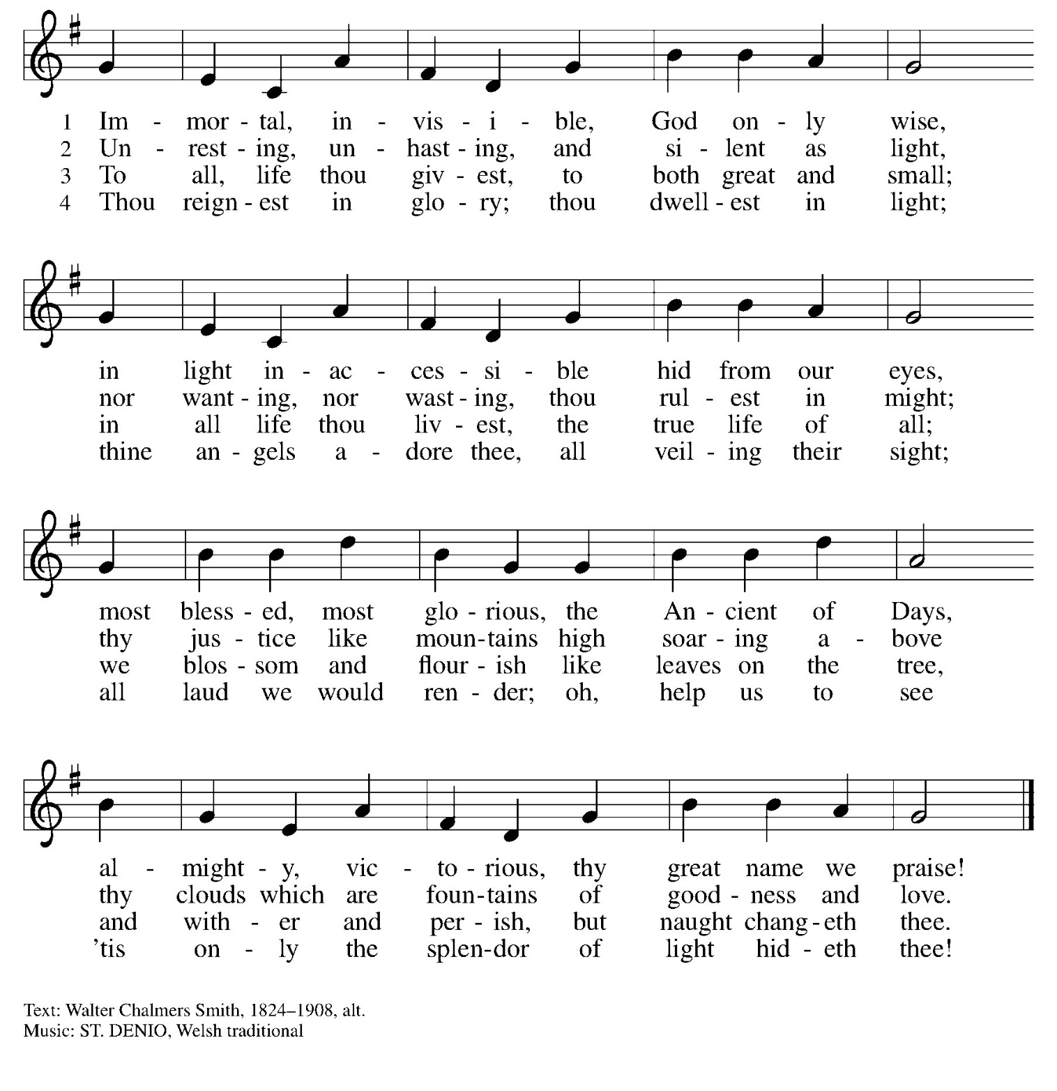
PRAYER OF THE DAY

Lord God,
Thank you for your nearness today. When anxiety tries to take over, help us to stop and bring everything to you with a thankful heart. Fill us with your joy and grant us your perfect peace which passes all understanding to guard our hearts and minds in Christ Jesus. Cleanse our thoughts today, and help us focus on what is true, pure, lovely, and good. Give us the strength to put your word into practice so that your presence stays with us in all that we do.
Amen.

WORD

READING: Isaiah 5:1-9
L: A reading from the book of Isaiah

¹ O Lord, you are my God;
I will exalt you; I will praise your name,
for you have done wonderful things,
plans formed of old, faithful and sure.
² For you have made the city a heap,
the fortified city a ruin;
the palace of foreigners is a city no more;
it will never be rebuilt.
³ Therefore strong peoples will glorify you;
cities of ruthless nations will fear you.
⁴ For you have been a refuge to the poor,
a refuge to the needy in their distress,
a shelter from the rainstorm and a shade from the heat.
When the blast of the ruthless was like a winter rainstorm,
⁵ the noise of foreigners like heat in a dry place,
you subdued the heat with the shade of clouds;
the song of the ruthless was stilled.
⁶ On this mountain the Lord of hosts will make for all peoples
a feast of rich food, a feast of well-aged wines,
of rich food filled with marrow, of well-aged wines strained clear.
⁷ And he will destroy on this mountain
the shroud that is cast over all peoples,
the covering that is spread over all nations;
⁸ he will swallow up death forever.
Then the Lord God will wipe away the tears from all faces,
and the disgrace of his people he will take away from all the earth,
for the Lord has spoken.
⁹ It will be said on that day,
“See, this is our God; we have waited for him, so that he might save us.
This is the Lord for whom we have waited;
let us be glad and rejoice in his salvation.”

The Word of the Lord
Thanks be to God.

READING: Psalm 23 (Read the Psalm responsively)

¹ The Lord is my shepherd;
I shall not be in want.
² The Lord makes me lie down in green pastures
and leads me beside still waters.
³ You restore my soul, O Lord,
and guide me along right pathways for your name’s sake.
⁴ Though I walk through the valley of the shadow of death, I shall fear no evil;
for you are with me; your rod and your staff, they comfort me.
⁵ You prepare a table before me in the presence of my enemies;
you anoint my head with oil, and my cup is running over.
⁶ Surely goodness and mercy shall follow me all the days of my life,
and I will dwell in the house of the Lord forever.

FOCUS TEXT READING: Philippians 4:1-9

¹ My brothers and sisters, whom I love and long for, my joy and crown, stand firm in the Lord in this way, my beloved.
² I urge Euodia and I urge Syntyche to be of the same mind in the Lord. ³ Yes, and I ask you also, my loyal companion, help these women, for they have struggled beside me in the work of the gospel, together with Clement and the rest of my coworkers, whose names are in the book of life.
⁴ Rejoice in the Lord always; again I will say, Rejoice. ⁵ Let your gentleness be known to everyone. The Lord is near. ⁶ Do not be anxious about anything, but in everything by prayer and supplication with thanksgiving let your requests be made known to God. ⁷ And the peace of God, which surpasses all understanding, will guard your hearts and your minds in Christ Jesus.
⁸ Finally, brothers and sisters, whatever is true, whatever is honorable, whatever is just, whatever is pure, whatever is pleasing, whatever is commendable, if there is any excellence and if there is anything worthy of praise, think about these things. ⁹ As for the things that you have learned and received and heard and noticed in me, do them, and the God of peace will be with you.
The Word of the Lord
Thanks be to God.

GOSPEL ACCLAMATION

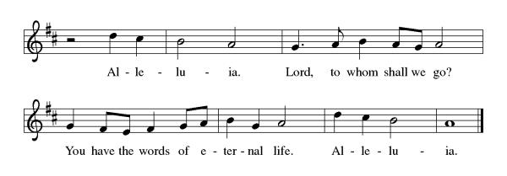

GOSPEL: Matthew 22:1-14

The Holy Gospel according to Matthew, the 22nd chapter.
Glory to you, O Lord.

¹ Once more Jesus spoke to them in parables, saying: ² “The kingdom of heaven may be compared to a king who gave a wedding banquet for his son. ³ He sent his slaves to call those who had been invited to the wedding banquet, but they would not come. ⁴ Again he sent other slaves, saying, ‘Tell those who have been invited: Look, I have prepared my dinner, my oxen and my fat calves have been slaughtered, and everything is ready; come to the wedding banquet.’ ⁵ But they made light of it and went away, one to his farm, another to his business, ⁶ while the rest seized his slaves, mistreated them, and killed them. ⁷ The king was enraged. He sent his troops, destroyed those murderers, and burned their city. ⁸ Then he said to his slaves, ‘The wedding is ready, but those invited were not worthy. ⁹ Go therefore into the main streets, and invite everyone you find to the wedding banquet.’ ¹⁰ Those slaves went out into the streets and gathered all whom they found, both good and bad, so the wedding hall was filled with guests.
¹¹ “But when the king came in to see the guests, he noticed a man there who was not wearing a wedding robe, ¹² and he said to him, ‘Friend, how did you get in here without a wedding robe?’ And he was speechless. ¹³ Then the king said to the attendants, ‘Bind him hand and foot, and throw him into the outer darkness, where there will be weeping and gnashing of teeth.’ ¹⁴ For many are called, but few are chosen.”
The Gospel of the Lord.
Praise to you, O Christ.

CHILDREN’S SERMON

SERMON Pastor Adam Bohland



HYMN OF THE DAY My Life Flows On in Endless Song
Congregation sings verses 1,2,3 and 4

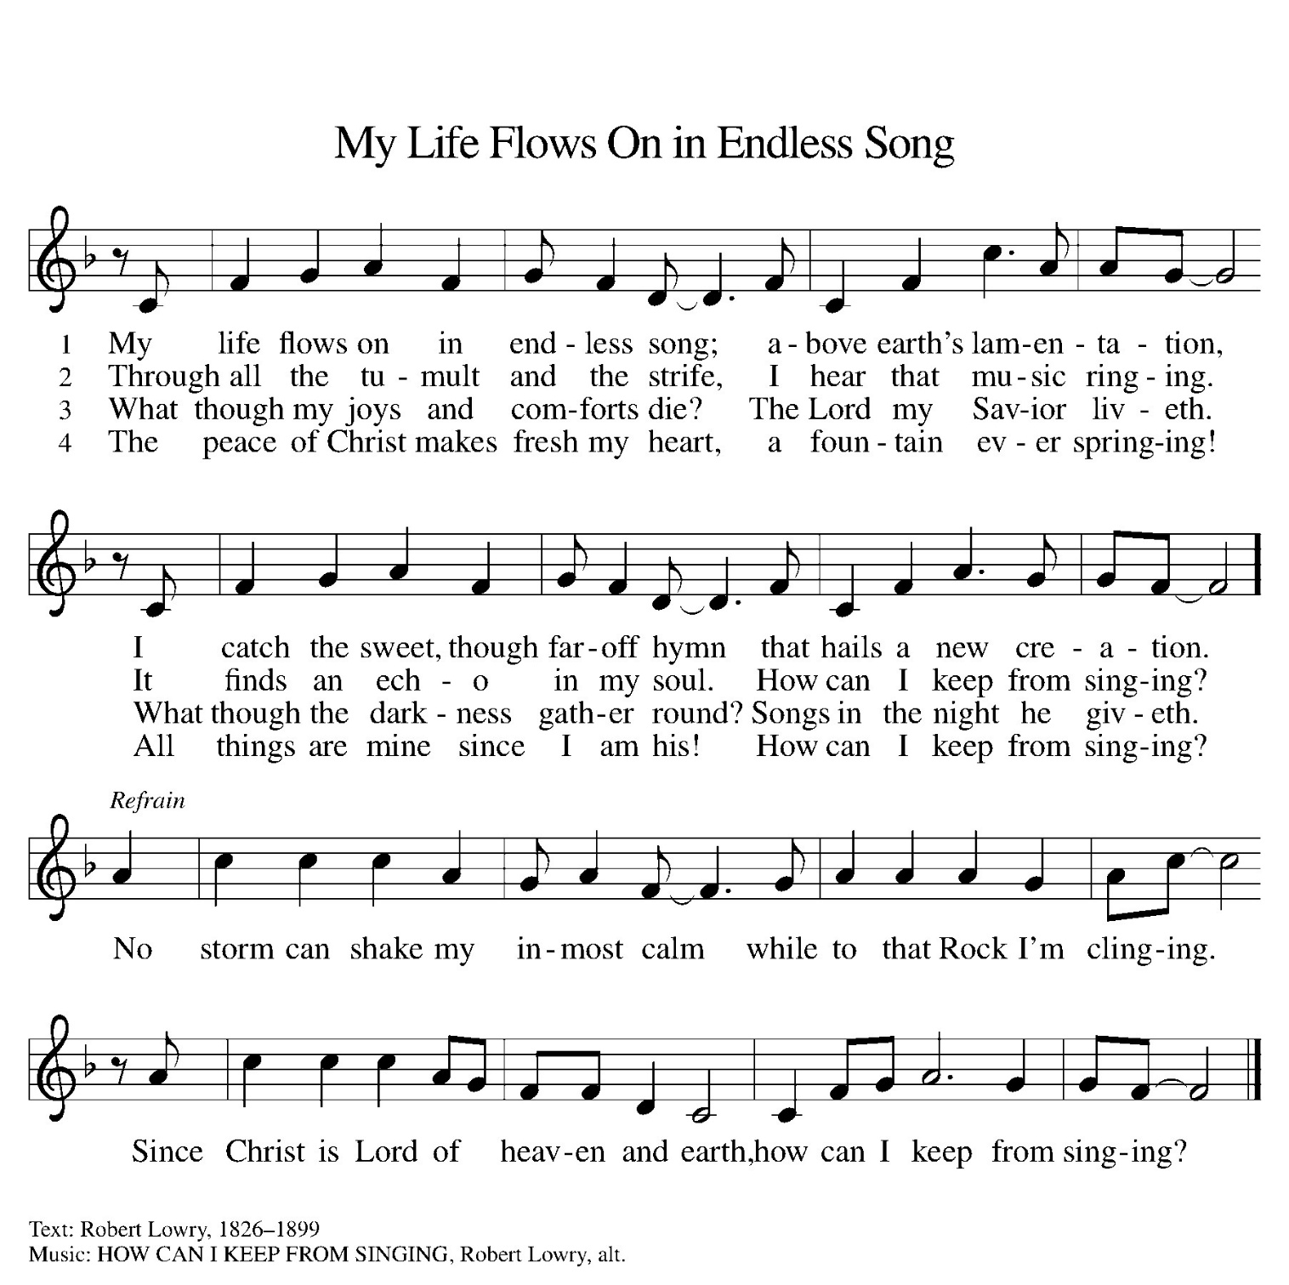


APOSTLE’S CREED
I believe in God the Father Almighty, Creator of heaven and earth.
I believe in Jesus Christ, His only Son, our Lord. He was conceived by the Holy Spirit, and born of the virgin Mary. He suffered under Pontius Pilate, was crucified, died and was buried. He descended in hell. On the third day He rose again, He ascended into heaven and is seated at the right hand of the Father. He will come again to judge the living and the dead.
I believe in the Holy Spirit, the holy catholic Church, the communion of saints, the forgiveness of sins, the resurrection of the body, and the life everlasting. Amen.

PRAYERS OF THE PEOPLE

L: Seeking the Spirit of God who makes all things new, we pray for the church and the world…
A brief silence.

L: Holy God, we remember your promise of unity on your holy mountain. Empower the World Council of Churches and all those working across religious differences, that the world may know your undivided love. Hear us, O God.
C: Your mercy is great.

L: We remember your promise of green pastures and quiet waters. Preserve all places of natural beauty and restore our relationship with the land. Hear us, O God.
C: Your mercy is great.

L: We remember your promise not to abandon us amid the storms of life. Renew all communities facing disasters and give your courage to those leading relief efforts. Hear us, O God.
C: Your mercy is great.

L: We remember your promise to wipe away every tear. Heal and console all who are sick or suffering (especially those we now name aloud or in the quiet of our hearts). Hear us, O God.
C: Your mercy is great.

L: We remember your promise of a banquet open to all people. Challenge this congregation to reach out to our neighbors with your good news and welcome everyone to the table. Hear us, O God.
C: Your mercy is great.

L: We remember your promise to swallow up death forever. We give thanks for those who have gone before us (especially those we now name aloud or in the quiet of our hearts). Hear us, O God.
C: Your mercy is great.

L: God of Mercy, today we pray for our local Lutheran congregation: Bethel, while we pray globally for the
Lutheran World Federation. Hear us, O God.
C: Your mercy is great.

L: Bless our nation and those who guide it: our President, Congress and Courts; our state and local leaders; and for those who serve as police, first responders, and for all who serve in the military, especially those known to St Petri: Kurtis, Matthew, Matt and Pastor Adam. Hear us, O God.
C: Your mercy is great.

C: Trusting in your boundless grace, O God, we lift up these spoken prayers and those in our hearts;
through Jesus Christ our Lord. Amen.

OFFERING
Choir Anthem I Will Sing, I Will Sing Dyer
St. Petri Choir

NOISY OFFERING

OFFERTORY
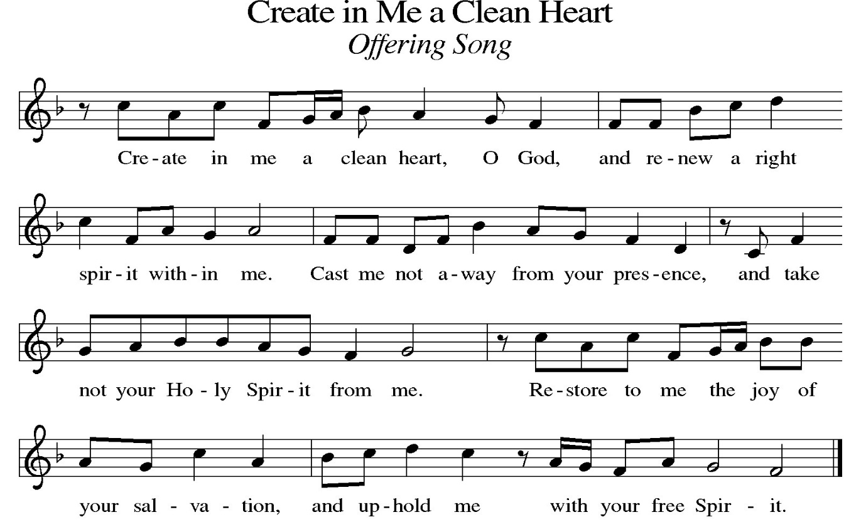

OFFERTORY PRAYER

God of Joy,
All blessings are from you; shape us into your people whose generosity is gentleness made visible, whose offerings declare we are on the side of our neighbors. Receive what we place in your hands and let it become courage, welcome, and hope.
Amen.

PLEASE STAND

¶ LORD’S PRAYER
P: According to your steadfast love, O Lord, hear these and all our prayers as we lift them up to you in the name of Jesus Christ our Lord, who taught us to pray:
C: Our Father, who art in heaven, hallowed be thy name, thy kingdom come, thy will be done, on earth as it is in heaven. Give us this day our daily bread; and forgive us our trespasses, as we forgive those who trespass against us; and lead us not into temptation, but deliver us from evil. For thine is the kingdom, and the power, and the glory, forever and ever. Amen.

BLESSING

Go forth into the world in peace, standing firm in the Lord and not anxious about anything.
As you leave this place, may the peace of God, which surpasses all understanding, guard your hearts and your minds in Christ Jesus.
Amen.



SENDING HYMN I’ve Got the Joy, Joy, Joy
Congregation sings verses 1 and 2

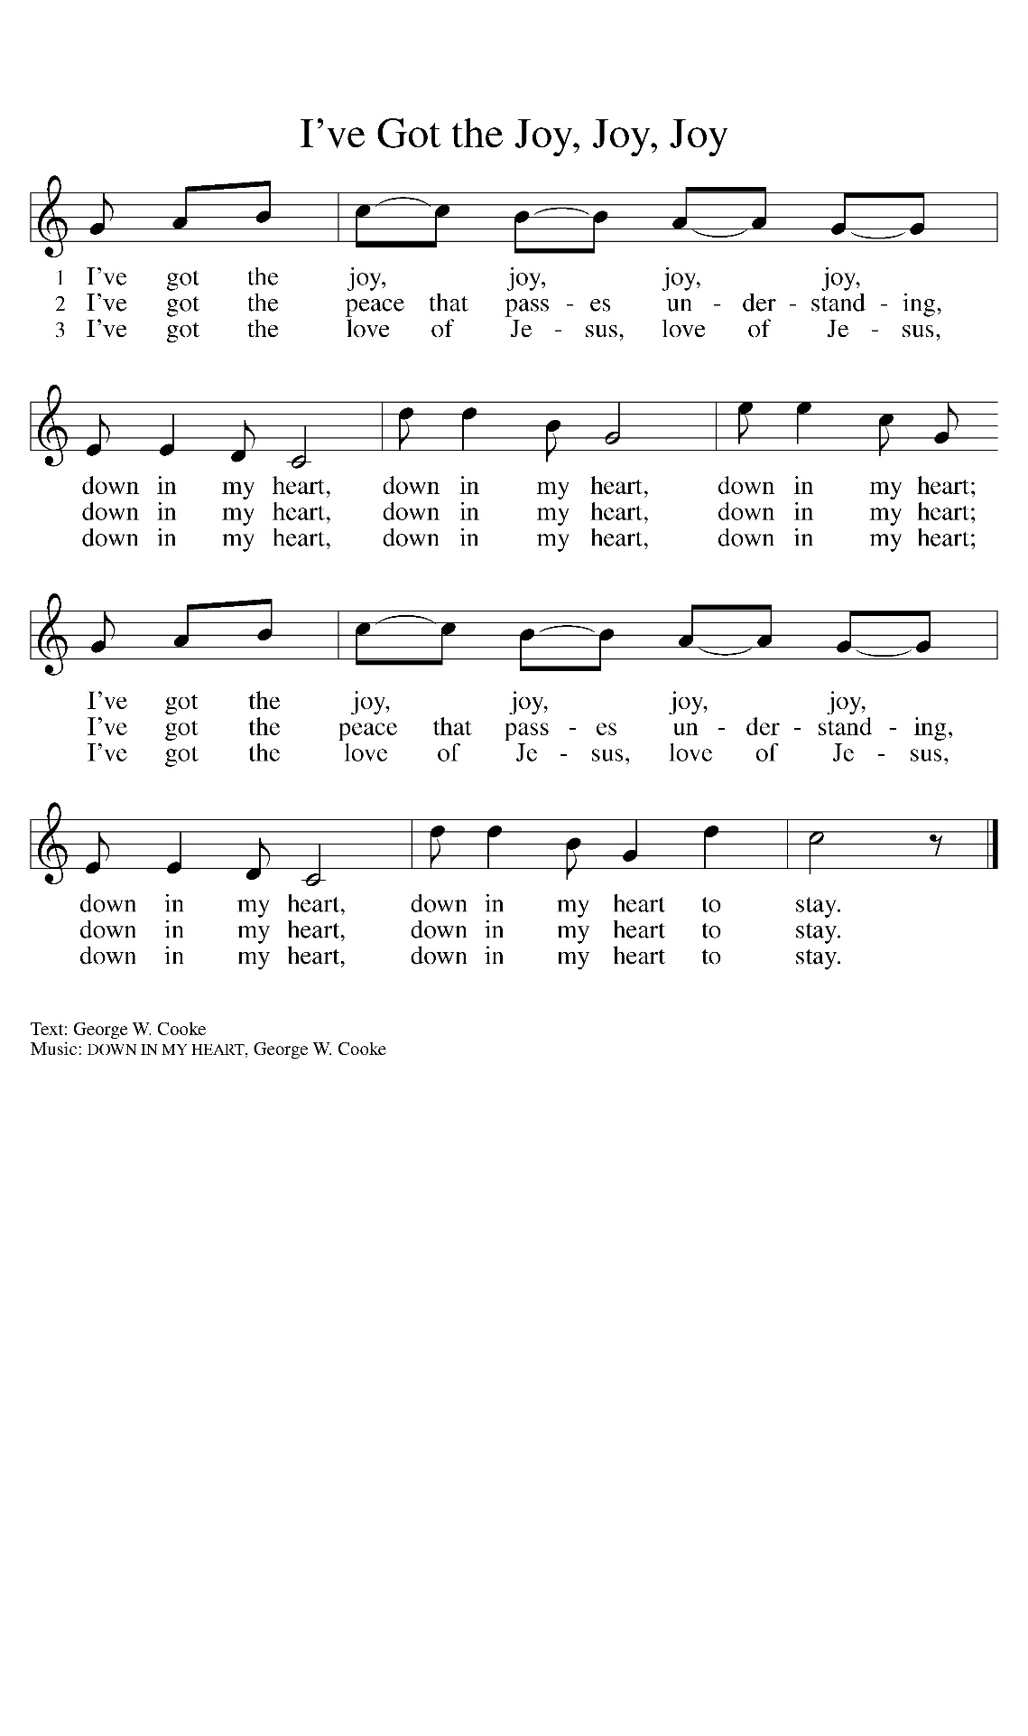

DISMISSAL
Go out in joy. Be led forth in peace.
Thanks be to God.

Copyright © 2026 Augsburg Fortress. All rights reserved. Reprinted by permission under Augsburg Fortress Liturgies Annual License #SAS028047. New Revised Standard Version Bible, copyright © 1989, Division of Christian Education of the National Council of the Churches of Christ in the United States of America. Used by permission. All rights reserved.
Leading Worship Today |  | St. Petri Staff and Worship Chairs
Presiding Minister | Pastor Adam Bohland | Pastor | Rev. Adam Bohland
Organist | Martha Amstutz | Director of Music | Martha Amstutz
Lector | Kelly Colley | Office Manager | Shelly Savory
Cantor  Lead Usher | Carrie George  John Colley | Altar Guild  Head Elder | Sandy Seelman  Terry Francis
Altar Care | Sue Mead | Worship Cmte. | Cindy Kuhman
Camera Operator | Cindy Kuhman | Custodian | Tonya Roberts
Greeter Mary & Doug Barris

THANK YOU FOR WORSHIPING WITH US TODAY! If you do not know a hymn or song, feel free to speak the words rather than sing. Please notice that congregational responses are in bold. The congregation may stand as they are able for the parts of the Service marked ¶.

RESTROOMS are located on each side of the outside entrance to the worship space.

FREE WiFi: Anyone may access “SPLC-Guest”. The password is: Troop200

SPECIAL WELCOME VISITORS: A special welcome to all visitors with us today. Please take a moment to sign the red guest book located in the Narthex. If you have any further questions we are happy to try and assist you.

SIP & SCRIPTURE: Join us on Thursday, October 15 from 6-7:30pm in the Gathering Room.. Join us for coffee, light refreshments a brief devotion and a simple craft. Suggested donation $15. Sign up on bulletin board in the Narthex or hallway.

St. Petri Store is now open. Check out catalog in Narthex or go online to https://stpetristore.itemorder.com/ and get your St. Petri gear, your way!

We Offer with Joy and Thanksgiving
~ ourselves, our time, our possessions ~

Attendance last Sunday: 47 in person 12 online

Giving last Sunday: | Current Offering Receipts: | $4,190.00
 | Received Month-to-Date: | $4,190.00
 | Budgeted Needs Monthly: | $12,964.00

Offerings for current expenses:
From Member Envelopes: | $3,980.00
From Other Sources | $210.00
Total Received: | $4,190.00
Offerings for Benevolence: |  | $5.00
Offerings for Project Fix-Up: |  | $535.00
General Memorial |  | $ 0.00
~ signs of God’s gracious love! ~

UPCOMING EVENTS

SUN [OCT 11]
9am Worship

MON [OCT 12]
5:30 pm Girl Scouts Meeting
7pm Dartball Practice

TUES [OCT 13]
9am Quilting

WED [OCT 14]
6:30pm Choir Rehearsal

THURS [OCT 15]
6pm Sip & Scripture
7pm Boy Scout Adult Committee Meeting

SUN [OCT 18]
9am Worship

MON [OCT 19]
5:30pm Girl Scouts Meeting
7pm Dartball – St. Mark @ St.
Petri

TUES [OCT 20]
9am Quilting

WED [OCT 21]
6:30pm Choir Rehearsal

SAT [OCT 24]
6pm Adult Night Out –
Golden Lily

REMEMBERING IN PRAYER
Members in Nursing Homes | Military | Members | Non-Members
Terrence Henricks, | Kurtis Grohowski | Norma Schrickel | Sam Saar
Ayden Healthcare  Dolores Jabs | Matthew Cass  Pastor Adam Bohland | Gene Daniels  Pam Michalski | Monica Matuszak  Mencia
The Gardens of St. | Matt Kelsey | David Michalski | Delores Jabs
Francis |  | Terry Henricks | Jeri Campbell
Marilyn Henricks |  | Sherri Leininger | Adrienne Perrault
Otterbein-Monclova |  | Marti  Huepenbecker  Chuck Dolt  Irene Daniels  Marilyn Henricks  Sydney Easton  Karen Snyder | Avery Monroe  Danielle Scott  Vivian McCarthy  Pastor Tim Rothfuss  Pastor Chuck Campbell  Melissa Haydock  Sue Brown
 |  | Gene Campbell  Pastor Denny King  Don Hughes  Donna Haskins  Daryl Bosh | Pat Shiple  Carol Dolt  Paul Klockowski  Jan and David Peterman
If you would like your name, the name of a friend or loved one added to the prayer list, please call the church office at 419.385.4639. To have your prayer added to St. Petri's Prayer Chain or to become a part of our Prayer Chain, please call Norma Schouten at 419.382.3301, or the church office.



