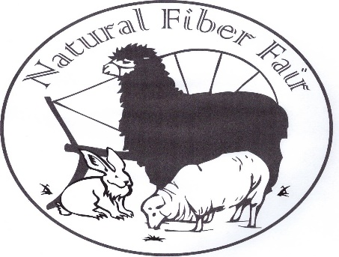
Natural Fiber Fair
PO Box 384
Blue Lake, CA 95525
Website: naturalfiberfair.com

Teaching the Community Sustainable Traditions

Natural Fiber Fair 2023
Exhibits, Classes, Workshops, Kid Zone, Fleece Market, Knitting, Spinning, Weaving,
Natural Dyes, Basketry, Spinning Circle, and so much more…
September 9th and 10th, 2023 held at Arcata Community Center in Arcata, CA
Saturday 10-5 and Sunday 10-4

Natural Fiber Fair Vendor Application
NAME: _________________________________________________________________
BUSINESS NAME: ________________________________________________________
ADDRESS: ______________________________________________________________
________________________________________________________________________
PHONE: ______________EMAIL: _____________________ WEBSITE: ______________________
Please provide a brief description of your merchandise as you would like it to appear in the program and on the web site. Please let us know if any of your contact information should not be included on the website. ** New vendors; Please describe your merchandise, display and include a photo of your booth.
Items to be sold must be fiber related. Our goal is to provide a great fair that supports our artisans and producers. You may sell items you make yourself or items manufactured from fiber you produce. Weaving supplies, tools, books, yarn and fabric are also allowed.
Imported finished goods are not allowed. These items include garments, scarves, hats, toys, gloves, hangings, placemats, bags, rugs and other finished items. An exception may be made for cooperatives that work directly with artisans from other countries, at the discretion of the Fiber Fair committee. We will ask you to remove items that are not allowed.

EDUCATION: Demonstrations and workshops are a major aspect of our fair. We strive to offer low cost workshops and free demonstrations to inspire the attendants. We ask all vendors to offer a minimum of one demonstration in the exhibit hall that. Please explain your demonstration as you would like it to appear on the web site and program. Include any material fee to be charged to participants. ^{Please add details here:}

Natural Fiber Fair Vendor Application
The City of Arcata requires a booth Business License. Please complete, sign and return the separate pdf form to NFF. The form link is on our website. If you already have a license, you may send details or a copy to skip this fee.
Please pay NFF directly for the license fee. (not Arcata) 2023 License fee is $24.00
BOOTH
VENDOR HALL:
10’ x 10’ booth - $130 20’ x 10’ booth - $260 30’x10’ booth- $390 Total $________
We figure out the booth map yearly by committee and won’t make any promises, but welcome your mapping requests.
30” x 6’ rectangular tables – we will have a limited quantity available.
Send in your application early to reserve up to two tables.
# requested: ZERO ONE TWO

Electricity
The hall has gymnasium lighting. Since most of us are selling “color” please bring additional lighting including a heavy duty extension cord.
OUTDOOR FLEECE MARKET SPACE
This outdoor market is for the sale of fleece, pelts or other items. $50 Total $_________
Vendors may bring other fiber related products along with their fleeces, fiber & pelts.

GRAND TOTAL DUE $_________

Please make one check payable to NATURAL FIBER FAIR and mail to:
Natural Fiber Fair
PO Box 384
Blue Lake, CA 95525

Paypal link for vendor booth payment is also available on our Applications & Forms page. http://www.naturalfiberfair.com/applications---forms.html

Forms, descriptions, photos and demonstration details can be mailed to the address above or emailed to nffchris@gmail.com.

Thank you, we anticipate another wonderful fair. We also appreciate your help in promoting our event! Please include any additional information or notes here or by email.

Vendor Coordinator: Chris Manhart, 707-616-8074 nffchris@gmail.com.

