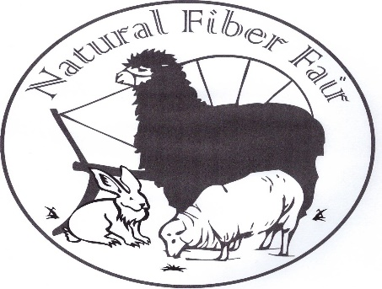

Natural Fiber Fair

PO Box 384

Blue Lake, CA 95525

Website: naturalfiberfair.com

Teaching the Community Sustainable Traditions

Natural Fiber Fair 2025

Exhibits, Classes, Workshops, Kid Zone, Fleece Market, Knitting, Spinning, Weaving,

Natural Dyes, Basketry, Spinning Circle, and so much more…September 6th and 7th, 2025 held at Arcata Community Center in Arcata, CA

Saturday 10-5 and Sunday 10-4

Vendor Information:

Please provide a brief description of your merchandise as you would like it to appear in the program and on the web site. Please let us know if any of your contact information should not be included on the website. ** New vendors; Please describe your merchandise, display and include a photo of your booth.

Items to be sold must be fiber related. Our goal is to provide a great fair that supports our artisans and producers. You may sell items you make yourself or items manufactured from fiber you produce.  Weaving supplies, tools, books, yarn and fabric are also allowed.  
  
Imported finished goods are not allowed. These items include garments, scarves, hats, toys, gloves, hangings, placemats, bags, rugs and other finished items.  An exception may be made for cooperatives that work directly with artisans from other countries, at the discretion of the Fiber Fair committee. We will ask you to remove items that are not allowed.

EDUCATION: Demonstrations and workshops are a major aspect of our fair. We strive to offer wonderful workshops and demonstrations to inspire the attendees. We ask all vendors to offer at least one demonstration in the exhibit hall. Please explain your demonstration as you would like it to appear on the web site and program. Include any material fee to be charged to participants.

We also ask that vendors donate small items for door prize drawings during the fair weekend. Participating vendors are entered into their own drawing for a free booth space in the following year.

Vendors are welcome to teach workshops – please see the workshop details and form on the website.

Please return page 2

Natural Fiber Fair Vendor Application 2025 dates September 6th & 7th NAME: _________________________________________________________________BUSINESS NAME: ________________________________________________________

ADDRESS: ___________________________________________________include on website? ______

PHONE: ______________EMAIL: _____________________ WEBSITE: ______________________

Brief description of your merchandise: _________________________________________________

same as last year? _____ Demonstration:___________________________________________

The City requires a booth Business License. Please complete, sign and return the separate pdf form to NFF. The form link is on our website. If you already have a license, you may send details or a copy to skip this fee.

**Please pay NFF directly for the license fee.** **2025 License fee is $24.00** **BOOTH**

**VENDOR HALL:** 10’ x 10’ booth - $130 20’ x 10’ booth - $260 30’x10’ booth- $390 **Total    $________**

We figure out the booth map yearly by committee and won’t make any promises, but welcome your mapping requests.

30” x 6’ rectangular tables – we will have a limited quantity available.

Send in your application early to reserve up to two tables. **# requested: ZERO ONE TWO**

**Electricity**

The hall has gymnasium lighting. Since most of us are selling “color” please bring additional lighting including a heavy duty extension cord.

**OUTDOOR FLEECE MARKET SPACE**

This outdoor market is for the sale of fleece, pelts or other items. $50 **Total    $_________**

Vendors may bring other fiber related products along with their fleeces, fiber & pelts.

GRAND TOTAL DUE $_________

If there is enough interest – we can arrange group room rates from a local hotel.

Are you interested in a discounted local hotel for the weekend? _____________

Please make one check payable to NATURAL FIBER FAIR and mail to:

Natural Fiber Fair

PO Box 384

Blue Lake, CA 95525

The link for booth payments is available on our Workshop Enrollment page on naturalfiberfair.com

Forms, descriptions, photos and demonstration details can be mailed to the address above or emailed to [nffchris@gmail.com](mailto:nffchris@gmail.com).

Thank you, we anticipate another wonderful fair. We also appreciate your help in promoting our event! Please include any additional information or notes here or by email.

Vendor Coordinator: Chris Manhart, 707-616-8074 [nffchris@gmail.com](mailto:nffchris@gmail.com).