Overhead Squat Evaluation

Name____________________________________________________________Date________________

Anterior Deviations | Lateral Deviations | Posterior Deviations
Knees initiate outwards | Arms forward | Shoulder elevation
Knees initiate inwards | Head forward | Weight shift asymmetrical
Feet turn out | Excessive forward lean | Foot flattens
Feet turn in | Excessive lordosis | Heels rise
 | Rounding of low back

 |  |  | Corrections for Dysfunctional Movement
Position | Kinetic Chain Focus Point | Movement | Myofascial Release | Stretch | Strength
Anterior | Foot | Feet turn out | Gastrocnemius | Standing calf | Bridge (ball)
 |  | Feet turn in | Peroneals | Stability ball bridge | Squat (band around knees)
 |  | Knees initiate outwards | Piriformis | Supine piriformis | Romanian deadlift (one leg)
 |  | Knees initiate inwards | Adductors | Adductor (ball) | Lateral walking with band
Lateral | Lumbar-Pelvis-Hip-Complex (LPHC) | Excessive forward lean | TFL / IT band | Standing psoas | Step-up balance
 |  | Excessive lordosis | TFL / IT band | Kneeling hip flexor | Posterior pelvic tilt
 |  | Rounding of low back | Hamstrings | Supine hamstring | Cobra (ball)
 | Torso | Arms forward | Latissimus Dorsi | Standing lat | Standing lat balance
 | Head | Head forward | Sternocleidomastoid |  | Cobra, neck roll
Posterior | Foot | Foot flattens | Peroneals | Standing calf | Squat (band around knees)
 |  | Heels rise | Gastrocnemius | Standing calf | Supine bridge
 | LPHD | Weight shift asymmetrical | TFI / IT band | Lunge, piriformis | Squat (ball)
 | Torso | Shoulder elevation |  | Levator Scapulae | Superman

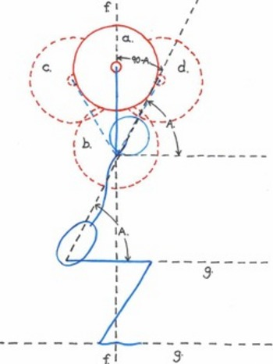
Notes:
- Be aware of orthopedic concerns
- Mark areas that need work
- Evaluate from all angles
- Listen and note client’s comments
- Re-evaluate when needed
- Remember this is only one assessment tool

