**This week please remember the following people in prayer:**  Jim & Joan Eubanks, Jeff, Amy, Emma, and Nolan Eubanks

**Pray for those dealing** **with from medical** **issues:** Dick Yoder, Oliver Yutzy, LaVonne Friesen (Ardell Kliewer’s sister), Gerhard Luitjens (Nathan’s dad), Gerry Widmer, Victor Barrera (Victoria Perez’s father), and Maddy Yeager.

**Mennonite Mission Network** Marisa Smucker, who has been working for Mennonite Mission Network's Church Relations team, began serving as the Mennonite Voluntary Service program director in June. Pray that God will provide wisdom, energy and joy for Marisa as she serves in this capacity.

**Central Plains Mennonite Conference** We pray for Susan Janzen as she begins her time as the Conference Minister for Ministerial leadership in Central Plains. May God guide her work as she develops relationships with leaders across the conference.

**LAST SUNDAY**

**Attendance:** 113

**Offering:** Home Missions: $4,788.34 Missions: $100

**Furnace/Air Conditioner Fellowship Hall Project total-to-date:** Furnace/Air Conditioner fund total to date is $7,035.00. Our goal is to raise $15,000.00.

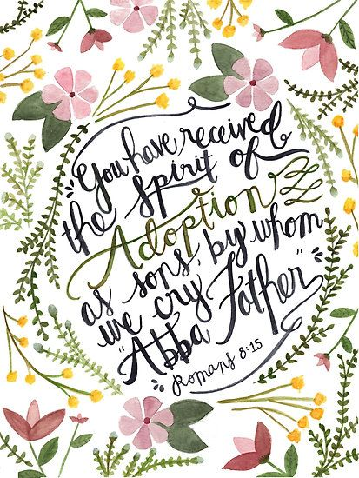

**August 4, 2019**

**SUGAR CREEK MENNONITE CHURCH**

**P.O. Box 146, Wayland IA 52654**

**Office/Answering machine/Fax Phone: 319-256-6061**

**Website: sugarcreekmennonitechurch.org**

**Email address:** **sugarcreekmc@gmail.com**

Pastors Nathan & Rachelle Luitjens Home 319-254-2479

Nathan Cell: 319-461-6505 (nathanluitjens@gmail.com)

Rachelle Cell: 319-537-1976 (rachelleluitjens@gmail.com)

Elders: Mike Roth: 319-750-0932 (mroth@farmtel.net)

Debbie Leichty: 319-750-1687 (leichtyd@farmtel.net)

Lowell Unruh: 319-759-1958 (lkunruh@gmail.com)

Office Hours: Tue-Thu, 9am-1pm

**August 4, 2019**

We welcome all to this place

for worship of God and for Christian fellowship.

Let us worship God in spirit and truth,

reaching out to one another in Christ’s love.

8:45 am: Prayer in the Prayer Room

9:15 am: Sunday School

10:10 am: Fellowship Time

10:30 am: Worship

Worship Leader: Reece Oswald

Song Leader: Wendy Scarff

Piano/Organ: Lori Graber

Welcome

Call to Worship

Opening Prayer

*WB70 Immortal, invisible, God only wise*

*WB306 In Christ there is no East or West*

Scripture: Psalm 139:1-12, 23-34 (OT p. 448)

& Romans 8:12-25 (NT p. 120)

Children’s Story with Joan Rodgers

Message: Joan Rodgers “I’m Adopted and I Have an Inheritance?”

*MH441 Rise Up, O Men of God*

Offering: Home Missions (8/11 Missions)

Announcements, Sharing & Prayers

Benediction

*The Lord Lift You Up*

Thank you to the Maretta Conrad for serving in the nursery today during Sunday School and Lisa & Brenna Graber for serving in the nursery today during church. The nursery is available during Sunday school and church for children 2 years of age and younger.**Annual Reports:** Once again it’s time to reflect on the past year and the plan for the upcoming year. The annual report deadline is August 27th. If you are a church representative, committee chair, superintendent, or Sunday School president, we want to hear from you! When your report is finished, please forward a copy to [sugarcreekmc@gmail.com](mailto:sugarcreekmc@gmail.com) or turn a copy in to the office. If you have any questions, please contact the church office.

**The Library Committee** has sorted through the books in our church library. There are two tables of books in the foyer for you to look through and take as many as you want. Books not taken by the last Sunday in August will be disposed of.

**AREA NEWS & ANNOUNCEMENTS**

**Crooked Creek Christian Camp** Thank you to several Sunday School classes and individuals for helping make our summer 2019 camping season a success. We’re grateful for the many volunteer hours in the kitchen, donated items such as candles, cereal, s’more materials, meat, fruit snacks and more! We’re privileged to be part of a giving community and are blessed by all the love, support and prayers given during camp.

**MENNONITE CHURCH USA**

**Find post-convention resources,** including worship speaker videos and worship songs: convention.mennoniteusa.org/post-convention-resources.

**At MennoCon19, delegates approved the addition of youth delegates and passed the Churchwide Statement on the Abuse of Child Migrants resolution.** Catch up on our compiled MennoCon19 news, photos and highlights at [mennoniteusa.org/kcsauce](https://mennoniteusa.us1.list-manage.com/track/click?u=97f16d9c230780d6354d01572&id=62f488d3bb&e=b0a26d3422).

**Pray for Allegheny Mennonite Conference and Mountain States Mennonite Conference** as they gather for their respective annual assemblies during the weekend of August 2-4.

We want to welcome and thank Joan Rodgers for bringing the message today.

**THIS WEEK**

**Wednesday, August 7:** Mennonite Women

**Sunday, August 11:** Message by Rachelle.

**MYF News**

**August 11:** MYF Welcome Party! 4pm at Tim & Lisa’s.

**SUGAR CREEK NEWS AND UPCOMING EVENTS**

**Nathan, Rachelle, and the boys are on vacation** until August 6th. Pray for safe travels and rest as they spend time with family and friends. If you have any pastoral needs during this time, please contact an Elder.

**Last week’s Affirmation Ballot** was affirmed unanimously. Please continue to be in prayer as the positions and committees transition. A list of all the church positions beginning in September will be published.

**Mennonite Women** will meet August 7th. Project: School kits. Devotions: Mark 14:3-9 Serve the Lord with Gladness. Lunch: sack lunch with dessert provided.

**MCC SCHOOL KITS** – Mennonite Women are asking the congregation to help make school kits that will be sent to MCC. We encourage you to begin donating the items now and we will be collecting the items through the month of August. **Each kit needs: 4 spiral or perforated notebooks (8 ½ x 10 ½ in – 70 pages each), 8 new unsharpened #2 pencils, 1 ruler (flat, good quality; must indicate 30 cm; inch markings optional), 12 colored pencils in packaging, 1 large eraser, & 2 new black or blue ink pens. Mennonite Women will provide the metal pencil sharpeners.**

**MARK YOUR CALENDARS!** August 18th is our annual worship service at CCCC! We will be having our morning worship service at the shelter at the pond. Feel free to bring your own lawn chair to sit on. **Note a change of lunch plans**: Due to limited electricity at the shelter, we will be having a finger food potluck. Sandwiches, drinks, and table service will be provided.Sermon Notes