**Township of Fairgrove**

**Minutes of a Special Planning Commission Meeting**

**Held on August 22, 2025 @ 10:00 a.m.**

A special meeting of the Fairgrove Township Planning Commission was conducted on August 22, 2025, commencing at 10:00 a.m., at the Fairgrove Township Hall.

**Call to Order:**

Chairperson Pike called the meeting to order at 10:00 a.m.

**Present were**:

Brian Pike – Chairperson

Garrett Goodchild

Craig Sherman

Any Grady

Mike Shannon

Justin Edward

**Absent**:

Marylin Grzemkowski

Also, present was Township Planner, Aruther Mullen; Township Attorney, Seth Koches; and, approximately twenty-eight (28) interested members of the public.

**NextEra Energy – Public Hearing – Including Comments from Warner Norcross, Wade Trim; and, Bauckham, Thall, Seeber, Kaufman & Koches, P.C.**

The next item on the agenda was the public hearing to consider the special land use application and site plan submitted by NextEra (“applicant”) to construct a battery energy storage system (“BESS”) within the Township. Township Attorney Seth Koches confirmed that the public hearing was properly notice in compliance with the Michigan Zoning Enabling Act, and the Open Meetings Act. Pike invited the applicant to discuss its project.

Brandon Wood addressed the Planning Commission on behalf of the applicant. Wood said that Tuscola Energy Storage, LLC is an indirect wholly owned subsidiary of NextEra Energy Resources, Inc., and proposes to construct a 100-MW BESS, within the Township. Wood introduced the NextEra team that was present to answer any questions of the Planning Commission. The project area will include approximately 5 acres of battery storage within a fenced-in area on a parcel that is approximately 32-acres in size, which is located in the Township’s “A-1” Agricultural District Zoning District Classification. Wood said that the subject property was selected for the BESS due to its proximity to electrical grid infrastructure.

Wood prepared a PowerPoint presentation to discuss the BESS project to the Planning Commissioners and those present at the meeting. The PowerPoint presentation is incorporated by reference into the record and the meeting minutes. Wood discussed the BESS components, noting the project will be monitored remotely from NextEra facilities in Florida. Wood discussed safety protocols, the landscaping plan, and, the fire response plan. Wood said that the BESS requires DC electric that is converted into the energy grid. Wood said the project is 100MW and can provide electricity for a 4-hour duration, and is expected to have the capacity to power 20,000 homes.

Wood discussed batteries and how batteries degrade over time, discussed augmentation and the sound study, and explained that the decommissioning plan included actual cost of decommissioning (salvage value was not considered). Wood discussed the site, which depicted the BESS and substation. Wood noted that the BESS project footprint is 5 acres and the laydown yard during construction is also 5 acres.

Wood discussed the standards contained in Section 7.6.a of the Township Zoning Ordinance, which states:

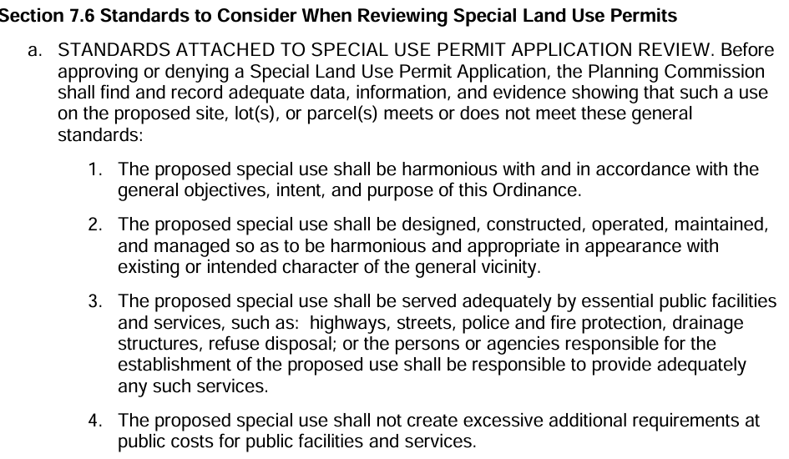

Wood said that the project is designed to be consistent with the objectives, intent and purpose of the Township Zoning Ordinance, as a BESS is a special land use regulated by Section 7.28 of the Township Zoning Ordinance, and that the site plan satisfied the standards contained in Section Chapter 9, titled, “Additional Site Plan Requirements.” Wood noted that Sections 9.4, 9.6 and 9.7 are all satisfied. Wood cited section 1.2 of the Township Zoning Ordinance, nothing that the project is consistent the purpose of the Zoning Ordinance because it encourages the use of lands and conserves natural resources [Section 1.2.b and 1.2.c].

Wood discussed Section 15 of Section 7.28, titled “Decommissioning,” noting that NextEra’s application [Appendix C] discussed decommissioning. The actual cost of decommissioning is projected to be $2.3 million in plant disassembly costs, which included estimates of $1.8 million in transportation costs, $348,000 in site reconstruction costs; and, $4 million in decommissioning costs. Wood discussed Section 17 of Section 7.28, titled, “Community Impacts Analysis” which include the EGLE grant of $5 million per MW for local approved renewable projects, including BESS. Wood said that the project will create temporary construction jobs and tax revenue for the Township and other applicable taxing authorities. Wood concluded his presentation to the Planning Commissions and offered to answer any questions.

Pike discussed the site plan and the size of the laydown yard. Pike confirmed that the weight of each battery is approximately 8,000 pounds. Goodchild and Wood discussed water runoff plans. Goodchild and Wood discussed the emergency plan. Wood noted that the expected fire response plan is approximately 30 minutes by the Bridgeport Fire Department. Wood discussed how each battery module is self-contained, which is designed to prevent the spread of a fire. Shannon discussed the safety design of the modules. Goodchild and Wood discussed NextEra’s ability to monitor the project remotely. Wood confirmed that the life expectancy of the batteries is approximately 25-30 years. Shannon and Wood discussed sound that is generated by the project. Wood confirmed that the sound study measured 55 decibels, which is in compliance with ordinance requirements. Wood said that noise is generated by a HVAC system that is used to cool the battery modules and run as needed. Grady and Wood discussed whether the project will be decommissioned at end of the project’s life. Wood said NextEra will evaluate whether to replace the batteries at that time. Shannon discussed the EGLE grant and NextEra’s land use attorney, Dan Ettinger, discussed the EGLE grant process. Shannon and Wood discussed providing first responder training for the Township’s fire department to learn about responding to an emergency at a BESS site. Wood confirmed that Next Era will offer annual training to the fire fighters.

Being that there were no additional questions from the Planning Commission, Pike invited the Township’s Planner, Arthur Mullen from the consulting firm Wade Trim to address the Planning Commission. Mullen prepared a memorandum, dated August 20, 2024, discussing the project, which is part of the record and incorporated by reference into these meeting minutes. Ettinger prepared a response letter to this memorandum, dated August 21, 2025, which is incorporated by reference into the record and into these meeting minutes. Mullen’s report included project application review, special land use standards analysis and site plan review. Koches discussed that the proposed project is also consistent with the Township Master Plan. Pike and Ettinger discussed the complaint resolution procedure and Shannon asked that the root cause of the complaint be identified, which Ettinger was willing to add into the procedure. Ettinger noted that part of the complaint resolution procedure includes an investigation into what caused the initial complaint.

Being that there were no further comments from Mullen and no additional questions for NextEra from the Planning Commission, Pike opened the public hearing at 10:30 a.m. and invited any interested party to submit public comment to the Commissioners.

Roger Keoshon asked how many complaints Next Era received on all their projects and expressed concern of the fire safety. Pike said that the Fire Chief toured another NextEra project and submitted a letter of support for the project. Wood confirmed that NextEra has over 50 projects within the United States. Wood said the most common complaint is connected to noise. Ettinger referenced Wage Trims staff report, which discussed landscaping/buffering and NextEra’s obligation to maintain the planting for the life of the project.

Nancy Lanskowski thanked Wade Trim for their staff report regarding safety concerns. Lanskowski asked the Planning Commission to re-schedule the public hearing to review Wade Trim’s reports and make the same available to the public. Lanskowski said it is important to see the specific details of the staff report. Lanskowski discussed the tax benefits of renewable projects, but noted four of the top eight local units that have these projects also have higher millages, so the tax benefit was minimal. Lanskowski generally discussed the sound plan.

Ettinger discussed the completeness of the project and asked the Planning Commission to proceed instead of re-scheduling the public hearing. The Commissioners and Next Era discussed the surety bond and the ability to update the same every 5 years during the life of the project to account for inflation. Koches said that this may be a condition of approval, which is authorized by the Township Zoning Ordinance.

John Geerhead discussed the “what ifs” of what may go wrong once the project is operational. Geerhead discussed the fire response plan and expressed concern over the 30-minute response time. John Costrua said that the Planning Commission had a tough decision to make.

Koches discussed the impact of PA 233 [preemption] upon local units throughout Michigan. Koches said that the Township does not have a compatible ordinance, but drafted a workable ordinance and NextEra worked within those parameters rather than going to the MPSC.

An unnamed individual asked whether the BESS would provide electricity locally. Pike said that the electricity will be transmitted into the grid and could go to residential homes. Another said that the public hearing should not have been held at 10:00 a.m. Pike said the Township is required to hold a public hearing and there is no specific time that works best for everyone.

Hearing no additional public comment, Pike closed the public hearing at 11:22 a.m. and the Commissioners entered into deliberations.

Mullen addressed the Planning Commission, discussing the special land use standards of review and the ability to add reasonable conditions that NextEra must satisfy as part of an approval. Mullen said that NextEra is required to provide a safety plan according to Section 7.26, which may include an evacuation plan if the Fire Chief felt that was necessary. Mullen said that the performance bond for decommissioning may be looped into other bonds that NextEra currently holds related the Pegasus wind project that is operational within the Township. Mullen agreed that NextEra should submit a list of annual complaints they receive to the Township. Mullen summarized his site plan review of the project, noting that storm water calculations will be submitted to the County Drain Commissioners and NextEra will provide the Township copies of all permits that are necessary for the project. Ettinger provided the Commissioners an updated site plan, which confirmed compliance with site plan standards. Pike confirmed that the project envelope was 5 acres on a 32-arces footprint, and a 5-acre laydown yard during construction. Mullen said that the Planning Commission is within their rights to proceed with making a decision regarding NextEra’s request for special land use and site plan approval for the proposed BESS.

Koches prepared a draft resolution that was provided to the Planning Commission and summarized it. Koches referenced Wade Trim’s staff report and summarized the special land use and site plan standards of review contained in Section 7.6 and Chapter 9 of the Township Zoning Ordinance. Koches and the Planning Commission discussed several conditions of approval that may be added into the resolution for consideration. The conditions were finalized and Koches memorialized the same within the resolution, which is incorporated by reference into the record and as part of these meeting minutes.

Upon motion by Sherman, supported by Shannon, the Planning Commission adopted the resolution, including the conditions approval, to approve the request of Tuscola II Energy Storage Project Special Land Use application and Site Plan dated July 9, 2025, for a 100 MW Battery Energy Storage System on an unaddressed parcel of land, within the Township, on W. Fairgrove Road (M-138) west of Kirk Road and north of the railroad tracks, being Parcel No. 010-019-000-0600-0; and, on property it owns addressed as 1765 N. Kirk Rd., being Parcel No. 010-019-000-0100-02, for the reasons cited within Resolution 2025-01 and Exhibit 1 and the hereby incorporated staff reports, satisfied the applicable provisions related to Special Land Use Permits and Site Plan regulations contained within Township Zoning Ordinance subject to the following conditions contained in Resolution 2025-01. The motion to adopt the resolution passed 6-0.

**Planning Commissioner Comments**

The Commissioners made some brief comments discussing NextEra’s application.

**Public Comment**

None.

**Adjournment**

Being that there was no further business to come before the Planning Commission, Pike adjourned meeting at 11:45 a.m. NextEra accepted personal service of the signed Resolution 2025-1 at the conclusion of the Planning Commission meeting.

**Synopsis of Action Taken:**

1. Approved Tuscola II Energy Storage’s request for special land use and site plan to operate a BESS, with conditions.

*s/ T. Seth Koches*

Seth Koches, Township Attorney