No person was ever honored for what he received. Honor has been the reward for what he gave.
– Calvin Coolidge

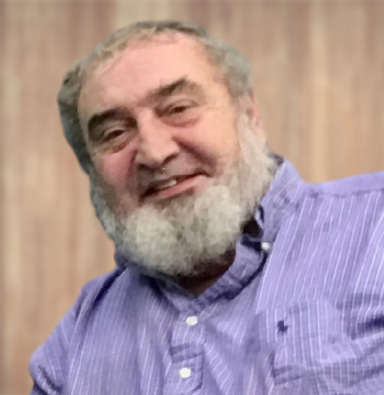

Carl L. Childs
February 2, 1949 – September 24, 2020

~ Dedication ~
It is with our sincere appreciation we dedicate this ordinance to the memory of Carl Childs and his committed and invaluable service to Fairgrove Township. As Planning Commission Chairman, Carl’s patient and skilled leadership was instrumental in the creation of this document. During the upcoming years, this ordinance will guide the Township in promoting growth and recognizing the rights of property owners, while protecting our citizens’ health, safety and welfare. And although Carl was unable to see this project through to final completion, his wisdom, intelligence, compassion, and understanding are woven throughout.

Fairgrove Township Board of Trustees Fairgrove Township Planning Commission
Keith Aeder, Supervisor Brian Pike, Chairman
Katie Gebhardt, Clerk Anne Leen, Secretary
Sarah Donovan, Treasurer Jeff Montei, Member
Dennis Hadeway, Trustee Douglas Shannon, Member
Justin Edwards, Trustee Marilyn Grzemkowski, Member
Kreg Sherman, Member
Board of Trustees Members emeritus Justin Edwards, Ex officio Member
Karen Goodchild
Michael Day
John McQuillan

