Welcome to Oaks
Oaks is a large pre-school room which has some continuous provision, role play, sensory exploration, loose parts, access to multiple small world and construction resources plus puzzles, fine motor activities and we also and have our very own covered area (our veranda) to explore.

Our Oaks staff will follow repetitive and consistent routines at nursery, making sure your child feels happy and secure during their time with us. We believe that maintaining familiar routines helps children to settle in more easily and supports their emotional well-being. Our dedicated and experienced team works closely with parents to understand each child's unique needs and preferences, ensuring that their time with us is both enjoyable and nurturing.

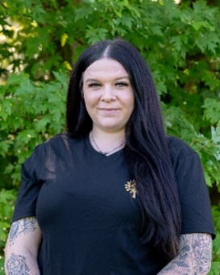
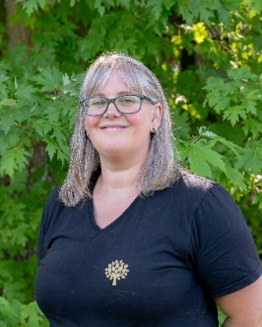
Oaks Staff
Introducing:
Hannah Watkins-Cave. Manager/ Room Lead/ SENCO/ DSL. Level 6
Kayleigh Davis. Room Lead. Level 6.
Amie Devine: Nursery Practitioner. Working towards Level 3.
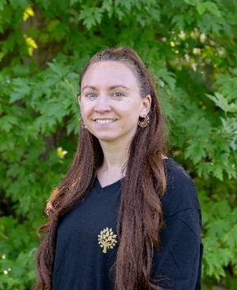
Curriculum
The Early Years Foundation Stage (EYFS) (2024) sets the standard for the learning, development and care of your child from birth to 5 years old.
All schools and Ofsted-registered early years providers must follow the EYFS, including childminders, pre-schools, nurseries and school reception classes.

7 Areas of learning.
Children’s learning is often like a winding pathway, so it is important to know that each child’s learning journey is unique to them. The EYFS has separated areas of learning into Prime Areas and Specific Areas.

The three Prime Areas are:
Communication and Language (C.L)
Personal, Social and Emotional Development (PSED)
Physical Development (PD)

The four Specific Areas are:
Literacy (L)
Mathematics (M)
Understanding the world (UW)
Expressive Arts and Design (EAD)

However, when a child learns these areas are often interconnected. For example, when a child is playing with water they may be filling and emptying containers. This is a mathematical learning as they learn about capacity. However, if they are playing with another child doing this, they are learning within PSED. Should they be having a conversation about what they are doing, both children are developing C.L. Your child should have play and learning experiences offered to them which cover all these interconnected areas of learning, whether they are a baby or 5 years old.

The Three I’s
The Three I’s framework is set by Ofsted to assess the quality of education in Early Years settings. The three I’s are: Intent, Implementation, and Impact. This framework helps ensure that the educational experiences provided are purposeful, well-delivered, and result in positive outcomes for children.
Intent – What do we want the children to learn?
Implementation – How do we want them to learn?
Impact – How does this help the child?
The three I’s are set at the beginning of a school year and assessed and updated if required at the end of every term.
Focus child
Once a term your child will be a ‘focus child’ during this period (normally a week) focused observations will take place on your child.
This information is then collated and then Next Steps will be planned accordingly to work on for the term until your child becomes the focus child again.

Assessments/Reports
At certain key points, assessments will be recorded to measure children’s progress and make sure their learning and development is on track to meet their developmental milestones. The government require children to have a check at 2 years old, which is made alongside a health check with your Health Visitor. Children have another assessment when they go into Reception. This is called the Reception Baseline Assessment. The final assessment children have in the EYFS is at the end of reception where their teacher looks at the Early Learning Goals, to assess their current development and aid transition to Year 1.

Key Person
The key person's role is crucial in creating a strong bond with your child, providing a consistent point of contact and continuity throughout their nursery experience. This dedicated approach not only fosters a sense of trust and belonging but also aids in the child's overall development and learning journey.

Food, Drinks and Milk
We provide a healthy snack in the morning session which will include a carbohydrate such as a rice cake or breadstick and some fruit and vegetables. We also have a small piece of cheese daily at the end of the snack to help cleanse the pallet from any natural sugars. In the afternoon each room takes a turn to bake something, the opportunity to bake can really help reluctant eaters to try new things plus baking has the potential to offer many areas of the EYFS – measuring the ingredients? (M). Turn taking? (PSED). Listening to instructions? Understanding (C.L). Kneading bread? (P). Snack and baked items are carefully considered to be heathy and with any allergy requirements in mind.
We have lunch at 12pm daily in Oaks. We ask for all small round’s foods such as grapes, strawberries, blueberries and tomatoes to be sliced into quarters. Food such as sausages, carrots, cheese and cucumber must be sliced into sticks, fruits such as apple or mango to be sliced rather than cut into chunks.
Please no peanuts or food which contain peanuts. We are a nut free nursery.
Children need to have access to their own water bottles during the day, please can you provide one of these for their time at nursery, these will be available at all times: we promote the drinking of just water at Wild Oaks.

Clothing
To ensure that children are comfortable and able to fully engage in all activities, we ask that they wear appropriate clothing suited for outdoor play. This includes items such as weather-appropriate jackets, hats, gloves, shoes and wellies. It is also helpful to label all clothing and personal items to avoid any mix-ups. We ask for spare clothing to be brought to nursery daily. We do ask for children to wear slippers or slipper socks while indoors, they move freely between carpet and hard flooring and also reduce noise, keep the setting clean and also allows the children to be prepared for fire drills/ emergency evacuation.

Communication with parents
Effective communication with parents is really important to us, you can contact staff via the Blossom app, phone and you can email us too. We send termly newsletters to keep you updated with what we have planned for the term ahead, important dates and reminders. We also plan stay and play sessions, where we welcome you to join us at nursery, this is a great opportunity for you to see how they explore, play alongside the other children and how they have developed lovely relationships with the staff.

Oaks Daily Routine
Routine in early years helps children feel safe, happy and secure in their environment. Establishing a consistent daily routine also aids in the development of self-discipline and time management skills, which are essential for their growth and learning. By knowing what to expect next, children can transition smoothly between activities and experience less anxiety and stress. Please find below our daily routine for the Oaks room.
8.00 – 9.00AM | Breakfast Club
9.00 -10.20AM | Circle Time | Adult Led Activities | Free Play | Sensory Tray
10.20 – 10.30AM | Story of the Week
10.30 - 10.50AM | Snack | Prepare for Outdoor Play
10.50 - 11.45AM | Outdoor Play
11.45 – 12.00PM | Circle time (2)
12.00 – 12.45PM | Lunch
12.45 – 1.15PM | Quiet Time
1.15 – 1:45PM | Afternoon club
1:45 – 2.30PM | Outdoor Play
 | Oaks Planning
In the Oaks Room we usually plan a theme for a whole term, this maybe for example ‘Bears.’ We will then choose a story of the week to help introduce, explain, extend and develop knowledge, language and understanding. Each session will have planned morning and afternoon circle time, an adult led activity, a sensory tray and an afternoon club. Hannah, Kayleigh and Amie share this responsibility across the week, and they all use the EYFS to develop their ideas and activities.
This approach gives the children access to diverse and interesting opportunities.

