Welcome to Acorns
Acorns is for children aged 18 months – 3 years. Acorns has a large room with designated areas for creative activities, a calming book corner, loose part resources, a home corner which includes an indoor slide, and they have access to sand and playdough continually available. We also have our carpet area which we use for circle time and story time. We have our very own Acorns Garden to explore, which is accessed down steps.
Our outdoor areas at Wild Oaks are numerous and include mud kitchens, playhouse, growing areas, a slide and a boat!
Our Acorn staff will make sure your child feels happy and secure during their time at nursery. We believe that maintaining familiar routines helps children to settle in more easily and supports their emotional well-being. Our dedicated and experienced team works closely with parents to understand each child's unique needs and preferences, ensuring that their time with us is both enjoyable and nurturing. We aim to encourage independence and autonomy such as putting on their own slippers, drinking from a cup and toilet training.
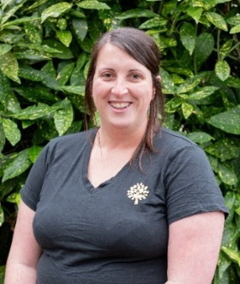
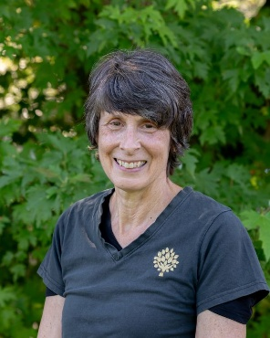
Amy Vizor Zoe Waite Fiona Hawes
Deputy/ Room Lead Deputy Nursery Practiotiner
Level 3 Level 4 Level 3

Curriculum

The early years foundation stage (EYFS) sets standards for the learning, development and care of your child from birth to 5 years old. All schools and Ofsted-registered early years providers must follow the EYFS, including childminders, preschools, nurseries and school reception classes.

7 Areas of learning.
Children’s learning is often like a winding pathway, so it is important to know that each child’s learning journey is unique to them. The EYFS has separated areas of learning into Prime areas and Specific areas.

The three Prime areas of learning which are:
Personal, Social and Emotional Development
Communication and Language
Physical Development

The four Specific areas of learning which are:
Literacy
Mathematics
Understanding the world
Expressive Arts and Design

However, when a child learns these areas are often interconnected. For example, when a child is playing with water they may be filling and emptying containers. This is mathematical learning as they learn about capacity. However, if they are playing with another child doing this, they are learning within the Personal, Social and Emotional prime area of development. Should they be having a conversation about what they are doing, both children are developing speech and language skills. Your child should have play and learning experiences offered to them which cover all these interconnected areas of learning, whether they are a baby or 5 years old.

The Three I’s
The Three I’s framework is set by Ofsted to assess the quality of education in early years settings. The three I’s are intent, implementation, and impact. This framework helps ensure that the educational experiences provided are purposeful, well-delivered and result in positive outcomes for children.
Intent – What do we want the children to learn?
Implementation – How do we want them to learn?
Impact – How does this help the child?
The three I’s are set at the beginning of a school year and assessed and updated if required at the end of every term.
Focus child
Once a term your child will be a ‘focus child’. During this period (normally a week) focused observations will take place on your child.
This information is then collated, and then next steps will be planned accordingly to work on for the term until your child becomes the focus child again.

Assessments/Reports
At certain key points, assessments will be recorded to measure children’s progress and make sure their learning and development is on track to meet their developmental milestones. The government require children to have a check at 2 years old, which is made alongside a health check with your Health Visitor. Children have another assessment when they go into Reception. This is called the Reception Baseline Assessment. The final assessment children have in the EYFS is at the end of reception where their teacher looks at the Early Learning Goals, to assess their current development and aid transition to Year 1.

Key Person
The key person's role is crucial in creating a strong bond with your child, providing a consistent point of contact and continuity throughout their nursery experience. This dedicated approach not only fosters a sense of trust and belonging but also aids in the child's overall development and learning journey.
Daily Diary
We keep our under 2 year olds parents informed about their child’s bottle, meal and sleep times, nappy changes and the different activities they have explored during the day, this includes photos too.
Food, Drinks and Milk
We have lunch at 12pm daily in Acorns. We ask for all small round’ foods such as grapes, strawberries and tomatoes to be sliced into quarters. Food such as carrots, cheese and cucumber must be sliced into sticks and fruits such as apple or mango to be sliced rather than cut into chunks. Please no nuts or food which contain nuts.
Children need to have access to their own water bottles during the day. Please can you provide one of these.
Clothing
To ensure that children are comfortable and able to fully engage in all activities, we ask that they wear appropriate clothing suited for outdoor play. This includes items such as weather-appropriate jackets, hats, gloves, shoes and wellies. If children are not walking as of yet then waterproof booties are great for keeping feet warm and dry. It is also helpful to label all clothing and personal items to avoid any mix-ups. We ask for spare clothing to be brought to nursery daily. We do ask for children to wear slippers or slipper socks while indoors as they move freely between carpet and hard flooring and provide extra grip for babies learning to walk.
Communication with parents
Effective communication with parents is really important to us, you can contact staff via the Tapestry app, phone and you can email us too. We send termly newsletters to keep you updated with what we have planned for the term ahead, important dates and reminders. We also plan stay and play sessions, where we welcome you to join us at nursery, this is a great opportunity for you to see how they explore Seedlings, play alongside the other children and how they have developed lovely relationships with the staff.
Acorns Daily Routine
Routine in early years helps children feel safe, happy and secure in their environment. Establishing a consistent daily routine also aids in the development of self-discipline and time management skills, which are essential for their growth and learning. By knowing what to expect next, children can transition smoothly between activities and experience less anxiety and stress. Please find below our daily routine for the Seedlings room, all details of what we have been exploring during the day is sent to you via the diary.

8.00 – 9.00 AM | Breakfast Club
9.05 - 9:10 AM  9:05 – 10:15 AM | Registration  Adult Led Activities | Free Play | Sensory Tray
10.15 – 10.30 AM | Circle Time
10.30 - 10.50 AM | Snack | Prepare for Outdoor Play
10.50 - 11.45 AM | Outdoor Play
11.45 – 12.00 PM | Story Time/ Group Activity (Home time for some)
12.00 – 12.45 PM | Lunch
12.45 – 1.45 PM | Quiet Time | Free Play | Sleep
1.45 – 2.30 PM | Outdoor Play
2.30 – 3.00PM | Snack
3.00 – 4.00pm | After School Club

