Food Safety Policy

Policy on food, allergies and cultural restrictions

Our Commitment
Wild Oaks ELC is committed to maintaining the highest standards of food hygiene and safety in line with statutory requirements and best practices. We are proud to have achieved and maintained a 5-star food hygiene rating at our settings, as awarded by an Environmental Health inspection.
We adhere to the guidance set out in the Food Standards Agency’s “Safer Food, Better Business” toolkit and ensure that all food safety procedures are fully embedded in our day-to-day operations. We also understand that from September 2025, we intend to include a new requirement in the safeguarding and welfare requirements of the EYFS that providers must have regard to this nutrition guidance.

Food Handling, Preparation, and Hygiene
We ensure all staff involved in food handling and preparation follow strict hygiene protocols, including:
- Staff exhibiting signs of illness are prohibited from handling food.
- All food preparation surfaces are cleaned before and after use with antibacterial spray and disposable cloths.
- Colour-coded chopping boards are used correctly (e.g., red for raw meat) to prevent cross-contamination.
- Chopping boards, utensils, and equipment are thoroughly cleaned and disinfected after each use.
- Hand hygiene is strictly observed — staff wash hands with antibacterial soap and warm water before and after food preparation, after toilet use, and after changing nappies.
- Cuts or sores are covered with a blue waterproof dressing.
- Food Hygiene training certificates are held by all relevant staff and regularly renewed.

Cleaning Procedures
Fridge and Freezer Maintenance:
- Fridges are cleaned weekly: all shelves, drawers, and seals are washed with warm soapy water and disinfectant.
- All items are checked for expiry dates; out-of-date items are discarded appropriately.
- Freezers (non-frost-free) are defrosted and deep cleaned termly.
- Fridge temperatures are checked daily and logged to ensure food is stored safely.
General Kitchen Cleaning:
- Worktops and food contact surfaces are cleaned before and after each use.
- Kitchen waste is disposed of promptly and hygienically.

Healthy Eating and Nutrition
At Wild Oaks ELC, we believe that a healthy, balanced diet is essential for a child’s physical and emotional development.
- We promote positive food experiences and educate children on the importance of nutritious meals.
- Children are provided with healthy, balanced snacks appropriate to their age and dietary needs.
- Fresh drinking water is available to children throughout the day.
- Cultural, religious, ethical, and medical dietary requirements are always respected and accommodated.
- Multicultural foods are included to ensure all children feel represented and to encourage an appreciation of global diets.

Parents are asked to inform us of any dietary requirements during registration. Where dietary preferences are based on non-medical needs, parents may be asked to supply suitable alternatives in sealed, labelled packaging.

Food Allergy and Intolerance Management
We take food allergies and intolerances extremely seriously and have comprehensive systems in place to manage risk:

View PDF (Allergen icon poster)
Common_allergens.pdf list of common allergens in foods.
- Allergy information is collected during registration and updated regularly.
- Individual health care plans are created for children with food allergies/intolerances.
- Clear visual indicators such as:
  - Children with allergies on display in each room as appropriate.
  - Dietary and allergy information updated on Blossom App which shows those in attendance per day and their dietary requirements and allergies for all staff to see.
Staff training includes:
- Recognising signs of allergic reactions and anaphylaxis
- Administering emergency medication (e.g., EpiPen)
- Reading food labels for allergens
- Cross-contamination prevention
Food allergen risk assessments and policies are reviewed regularly, and all allergy-related documentation is securely stored and accessible.

Safe Food Storage and Temperature Control
To prevent contamination and ensure food quality, we follow strict storage guidelines:
- Fridge temperatures are monitored daily and maintained at or below 5°C.
- Freezers are maintained at -18°C or lower.
- Dry foods are stored in cool, dry, pest-free areas in sealed containers.
- Cooked and raw foods are stored separately.
- All food is labelled and dated upon receipt and opening.

Feeding Babies and Weaning Guidelines
We work closely with parents to support safe, responsive feeding routines for infants, including baby-led weaning.
Questions we ask parents:
- Have lumps been introduced at home?
- Is your child following baby-led weaning or spoon-feeding?
- What foods have already been introduced?

Safety measures for infant feeding:
- Babies are always seated upright and supervised while eating.
- Avoid choking hazards:
  - Round, hard, or sticky foods (e.g., whole grapes) are cut lengthwise or omitted.
  - Cylindrical foods are cut into strips.
  - Meats are sliced across the grain and into small pieces.
  - No foods larger than half an inch in any direction.
- Commercial white bread is limited to avoid “pasty globs”.
- Only a few pieces of food are served at a time to prevent overloading.
- Children are not rushed — we allow adequate time for relaxed feeding.

Bottle Feeding & Breast Milk in The Nursery
Formula:
- Parents are asked to provide a sterilised bottle for each feed and pre-measure the formula powder into a named container. Please label the pot clearly with the child’s name and quantity of powder (e.g. 6 scoops) to ensure that staff are making the bottle correctly.
- Nursery staff will follow the manufacturer’s instructions when making up bottles for children.
- Cartons of formula can be provided by the parent/s. The date of opening will be recorded on the carton and staff will check they are used within the required time. (e.g. 3 weeks).
- On arrival, all bottles and beakers are to be tagged with the child’s name and placed in the kitchen.
- Bottles should be given at the times agreed with the parent bearing the child’s immediate need in mind. The timing of feeds is to be agreed with the parent during daily handover discussions.
- The quantity of milk consumed by the child is recorded on the child’s care diary.
- The temperature of the milk is to be checked by a member of staff before the bottle is given to the child unless the parent advises staff to offer a bottle cold.
- If refused, the bottle will be offered to the baby again at 10-15-minute intervals. Bottles will be discarded after 2 hours except if a child has drunk from them, then the remaining milk will be discarded after 1 hour.
- Bottles are never re-heated.
- In instances of ready - made milk, half of the carton can be used in the morning while the other half must be stored in the fridge, to be used in the afternoon.
- All opened cartons of milk must be discarded at the end of the day.
- Ready-made formula already poured in a sterilised bottle on arrival, will be stored in the fridge and heated with a jug and hot water when ready for use.
- Please remember to either pre-measure or provide a tub of formula for staff to measure.
- The bottle is to be washed up immediately after the feed. Hot water, detergent and a bottlebrush are available for this in the kitchen. The bottle is rinsed and dried and placed in the child’s bag to be taken home.
- Parents are to be made aware that bottles are not sterilised after use and that this is their responsibility.

Breast Milk:
- Breast milk can be frozen at home, but must come into the nursery defrosted, in a sterilised bottle. It will then be stored in the fridge here at the nursery.
- We request that the frozen milk be defrosted at home overnight in the family’s refrigerator.
- The breast milk can be heated but must be consumed within 1hr of doing so or will be disposed of.
- Breast milk must not be re-frozen after being defrosted.
- Please ensure that any breastmilk is stored in plastic baby bottles ready to be stored in the fridge.

Monitoring and Review
This policy will be reviewed annually or in response to:
- Changes in food safety legislation
- Updates from the Food Standards Agency (FSA)
- Environmental Health inspection outcomes
- Parent or staff feedback
- New allergen advice or best practice guidance

Staff are encouraged to report any concerns or suggestions for improvement.
We welcome contributions from parents and carers in keeping this policy effective and up to date.

Policy Reviewed by H Watkins-Cave – Manager – 01/09/2025
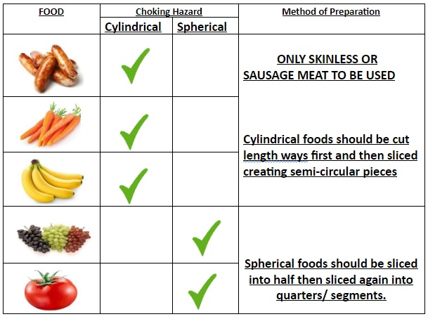
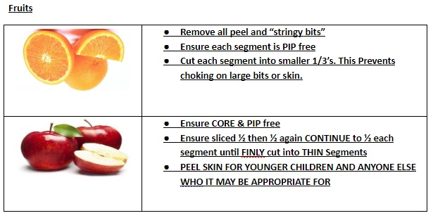
- Foods not to be consumed by children at Wild Oaks:
- Nuts
- Popcorn
- Marshmallows
- Sweets/candy
- https://assets.publishing.service.gov.uk/media/67f8e61c04146682e61bc84c/Nutrition_guidance_for_early_years_providers.pdf?fbclid=IwZXh0bgNhZW0CMTEAAR7_gJUXru9OnYympCMf6eWokEsIUAg7cqqaNQ5IscTGdvn3YlyGLxMub5NJmA_aem_g8W1SWLG4EFbzSPQcDBSag

