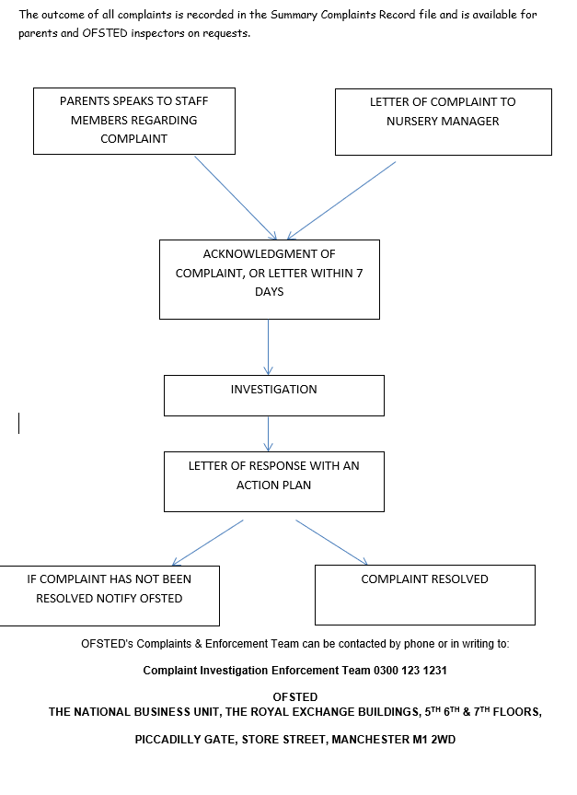

Making a Complaint
At Wild Oaks ELC, we are committed to maintaining the highest standards of care and education. We also value strong partnerships with parents and carers. However, we recognise that from time to time, concerns may arise that require attention.
We believe that all children and parents are entitled to expect courtesy, respect, and prompt attention to their needs. We welcome feedback and suggestions to improve our services and take all concerns seriously.

Informal Complaints
We encourage parents and carers to first discuss any concerns directly with the appropriate member of staff or the Manager. In most cases, we hope concerns can be resolved quickly and informally.

Formal Complaints Procedure
If your concern is not resolved informally:
- Submit a Formal Complaint:
  - Complete a Complaint Form and submit it in writing to the nursery office or management team.
- Acknowledgement:
  - The complaint will be acknowledged by the manager/owner within 24 hours.
- Investigation:
  - A thorough investigation will be carried out. A meeting will be arranged with the parent/carer to discuss the outcome.
- If the Complaint Remains Unresolved:
  - A further meeting may be held with all nursery managers and a witness of the parent/carer’s choice.
  - A written record of the meeting will be taken and signed by all present.
- Mediation:
  - If no resolution is achieved, an independent mediator, acceptable to both parties, may be invited to assist.
  - A final meeting with the mediator will be held, and an agreed action plan will be documented and signed. All parties will receive a copy.
- Right to Contact Ofsted:
  - At any stage, parents/carers may contact Ofsted:
Ofsted Complaints & Enforcement Team
Website: www.gov.uk/ofsted
Phone: 0300 123 1231

Complaints Record
All formal complaints and their outcomes are recorded in the Complaints Summary File, which is available to parents and Ofsted inspectors upon request.

Complaints Involving Staff or Incidents
If a parent/carer wishes to raise a concern involving a member of staff or an incident:
- Speak to a staff member or manager with as much detail as possible.
- If discussed with a staff member, they will inform the manager/owner immediately and complete a Complaint Form.
- The manager/owner will acknowledge the complaint within 24 hours.
- An investigation will be conducted and an action plan developed, if necessary.
- All complaints will be recorded and securely filed.
- If a parent/carer prefers, they may write directly to the manager/owner with the concern.

Duties as an Employer and Employee
As an employer, we have a duty of care to our staff. We are committed to:
- Providing support to any employee facing an allegation.
- Assigning a named contact if the staff member is suspended.
- Ensuring that any allegation is handled quickly, fairly, and in accordance with safeguarding guidelines, ensuring the safety of the child and support for the staff member.

Procedure for Allegations Against a Member of Staff or Volunteer
In the event of an allegation of abuse against a staff member or volunteer, the following steps must be taken:
- Notify Management Immediately.
- Contact the Local Authority Designated Officer (LADO): Nigel Hatton 01452 426994
- LADO Discussion:
  - Share details of the allegation, previous history, and the individual’s current contact with children.
  - Agree on a course of action.
- Police Involvement:
  - If the person presents an immediate risk or a criminal offence is suspected, the police will be contacted without delay.
- No Further Action (If Applicable):
  - If the LADO determines that no further action is required, this decision and the reasoning must be documented by both the LADO and the Case Manager.
  - Agree on who will communicate this outcome to the staff member.
- Informing the Accused:
  - The individual should be informed of the allegation as soon as possible, following LADO and/or police guidance.
  - Information will be shared only when appropriate and safe to do so.
- Consideration of Suspension:
  - Suspension will not be automatic.
  - Alternative measures will be considered before any decision to suspend is made.
- Strategy Discussion:
  - If there is reason to suspect significant harm to a child, a multi-agency strategy discussion will be convened, as per Working Together to Safeguard Children.
- Internal Actions:
  - If police or social services are not involved, the LADO and Case Manager will agree on internal next steps, which may include:
    - No further action
    - Formal disciplinary action
    - Termination of employment or service
- Further Investigation:
  - If more information is needed, the LADO will determine who will lead the investigation and how it should be conducted.

Confidentiality
Throughout any complaint or allegation process, all information will be kept confidential and handled in accordance with data protection legislation. Only relevant parties will be informed.

Review
This policy is reviewed annually or sooner if required by legislation or changes in best practice.
Last Reviewed By: H Watkins-Cave– Manager – 01/09/2025


