GENERAL DATA PROTECTION REGULATIONS (GDPR) POLICY

PURPOSE OF THIS POLICY
This policy outlines how Wild Oaks ELC ensures compliance with the UK General Data Protection Regulation (UK GDPR), which came into effect on 25th May 2018, replacing the Data Protection Act 1998. It provides individuals with greater control over their personal data and places obligations on organisations that collect, store, and process it.
As part of our operation, we are required to collect, store, and sometimes share personal data relating to children, parents/carers, and staff. We take our responsibilities under the GDPR seriously and are committed to handling personal data lawfully, transparently, and securely.

ICO REGISTRATION
Wild Oaks ELC is registered with the Information Commissioner’s Office (ICO)under registration number. , registered since . A copy of our registration certificate is displayed in the nursery for parents and carers to view.

PRINCIPLES OF DATA PROTECTION
Under the UK GDPR, we must adhere to the seven key principles of data processing:
- Lawfulness, Fairness, and Transparency
Personal data must be processed lawfully, fairly, and in a transparent manner.
- Purpose Limitation
Data is collected for specified, explicit, and legitimate purposes and not further processed in a way incompatible with those purposes.
- Data Minimisation
We only collect data that is adequate, relevant, and limited to what is necessary.
- Accuracy
Data must be accurate and kept up to date.
- Storage Limitation
Personal data will not be retained longer than necessary.
- Integrity and Confidentiality
Personal data is processed securely to prevent unauthorised access, loss, or damage.
- Accountability
We are responsible for, and must be able to demonstrate, compliance with these principles.

INDIVIDUAL RIGHTS UNDER THE UK GDPR
All individuals have the following rights regarding their personal data:
- The right to be informed
- The right of access
- The right to rectification
- The right to erasure (‘right to be forgotten’)
- The right to restrict processing
- The right to data portability
- The right to object
- Rights in relation to automated decision-making and profiling
We will respond to any request regarding these rights within one calendar month.

DATA CONTROLLER AND DATA PROCESSOR ROLES
As a childcare provider, Wild Oaks ELC is the Data Controller. We determine the purposes and means of processing personal data.
We may share data with third-party services (e.g., local authorities, software systems), making them Data Processors. We ensure that any Data Processor we use is GDPR-compliant and bound by appropriate contractual obligations.

LAWFUL BASIS FOR PROCESSING DATA
We must have a lawful basis for processing personal data. The six lawful bases under the UK GDPR are:
- Consent – the individual has given clear permission.
- Contract – processing is necessary for a contract.
- Legal Obligation – necessary to comply with a legal requirement.
- Vital Interests – necessary to protect someone’s life.
- Public Task – carried out in the public interest or in the exercise of official authority.
- Legitimate Interests – necessary for legitimate interests (except where overridden by the individual’s rights).
For most data collected, including names, contact information, medical details, and attendance, our legal obligation under the Statutory Framework for the Early Years Foundation Stage is the lawful basis.
Where data processing is not mandatory (e.g., photographs), explicit consent is required. Consent is sought via a clear opt-in process and can be withdrawn at any time.

PRIVACY NOTICES
We provide all staff and parents/carers with privacy notices explaining:
- What data we collect and why
- How data is stored and retained
- Who we may share data with and why
- Their rights under the UK GDPR
- How to raise concerns
These notices are updated regularly and issued at the point of data collection.

DATA RETENTION
We retain personal data only for as long as necessary and in line with statutory guidance and our internal Record Retention Policy. After the retention period, all data is securely disposed of.
For example:
- Accident records: 3 years (or until the child is 21 if relating to a child)
- Child records: Retained for a minimum of 3 years after the child has left the setting
A full retention schedule is available upon request.

DATA SECURITY
We are committed to ensuring personal data is secure by:
- Storing paper records in locked cabinets
- Ensuring electronic records are password-protected
- Limiting access to data to authorised staff only
- Regularly updating and monitoring our cybersecurity measures
Staff receive ongoing training in data security and are reminded of their confidentiality obligations.

DATA BREACHES
In the event of a personal data breach:
- The incident will be investigated promptly by the designated compliance leads.
- If the breach presents a risk to rights and freedoms, it will be reported to the ICO within 72 hours.
- Affected individuals will be informed when required.
All breaches are documented, regardless of severity.

RESPONSIBILITIES AND COMPLIANCE
The following individuals are responsible for data protection compliance within the setting:
- Hannah Watkins-Cave
- Amy Vizor

Their responsibilities include:
- Conducting data audits
- Ensuring policies are up to date
- Providing training to staff
- Investigating data breaches
- Monitoring compliance with current legislation

LEGAL FRAMEWORK
This policy is based on the following legislation:
- UK General Data Protection Regulation (UK GDPR)
- Data Protection Act 2018
- Human Rights Act 1998
- Freedom of Information Act 2000 (where applicable)
- Statutory Framework for the Early Years Foundation Stage (EYFS)

POLICY REVIEW
This policy is reviewed annually or in response to significant changes in data protection laws or nursery procedures.
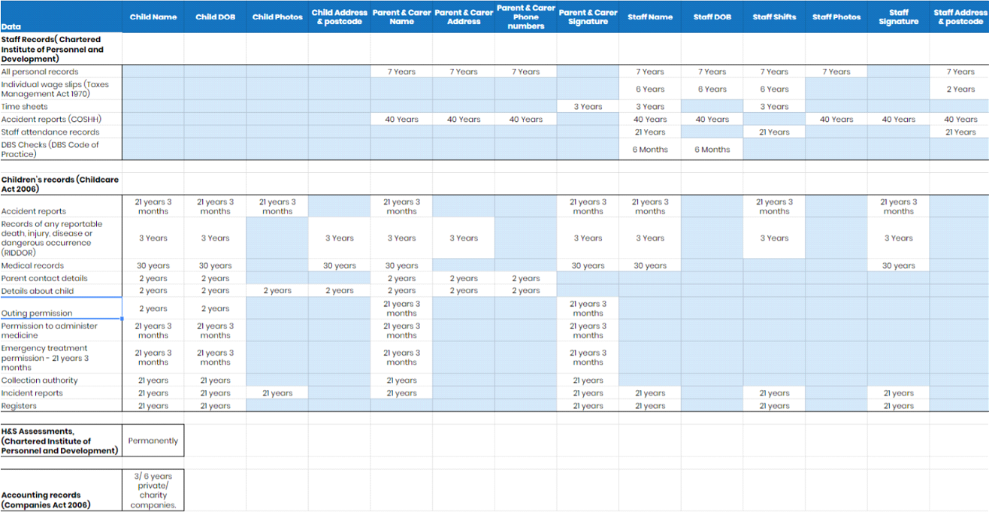
Reviewed by H Watkins-Cave – Manager – 01/09/2025

