COSSH IN YOUR DAILY WORK LIFE

While you are out and about on your work day and within your own personal life you will come into contact with a variety of chemicals and substances.

What is COSSH:
Control of substances hazardous for health, a body of regulations introduced in Britain to govern the storage and use of such substances.

Think about
- What do you do that involves hazardous substances?
- How can these cause harm?
- How can you reduce the risk of harm occurring?

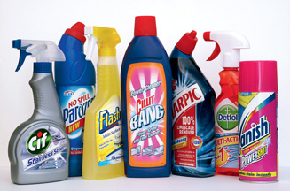Here are a few items you may see in someone’s home.

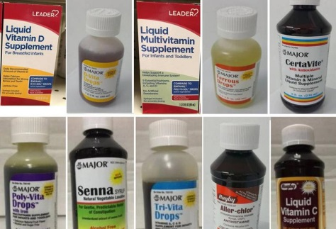 You will also come into contact with liquid medication.

Possible side effects of exposure to hazardous substances
Health effects depend on the type of hazardous substance and the level of exposure (concentration and duration). A hazardous substance can be inhaled, splashed onto the skin or eyes, or swallowed. Some of the possible health effects can include:
- poisoning
- nausea and vomiting
- headache
- skin rashes, such as dermatitis
- chemical burns
- birth defects
- disorders of the lung, kidney or liver
- Nervous system disorders.
Here's a list of some of the most dangerous household chemicals, including the ingredients to watch for and the nature of the risk.
- Air Fresheners. Air fresheners may contain a number of dangerous chemicals. Formaldehyde irritates the lungs and mucous membranes and may cause cancer. Petroleum distillates are flammable, irritate the eyes, skin, and lungs, and may cause fatal pulmonary edema in sensitive individuals. Some air fresheners contain p-dichlorobenzene, which is a toxic irritant. The aerosol propellants used in some products may be flammable and may cause nervous system damage if inhaled.
- Ammonia. Ammonia is a volatile compound that can irritate the respiratory system and mucous membranes if inhaled, can cause a chemical burn if it is spilled on skin, and will react with chlorinated products (e.g., bleach) to produce deadly chloramine gas.
- Antifreeze. Antifreeze is ethylene glycol, a chemical which is poisonous if swallowed. Breathing it can cause dizziness. Drinking antifreeze can cause serious brain, heart, kidney, and other internal organ damage. Ethylene glycol has a sweet flavour, so it is attractive to kids and pets. Antifreeze typically contains a chemical to make it taste bad, but the flavour is not always a sufficient deterrent. The sweet smell is enough to lure pets.

- Bleach. Household bleach contains sodium hypochlorite, a chemical that can cause irritation and damage to the skin and respiratory system if inhaled or spilled on the skin. Never mix bleach with ammonia or with toilet bowl cleaners or drain cleaners, as dangerous and possibly deadly fumes may be produced.
- Drain Cleaners. Drain cleaners typically contain lye (sodium hydroxide) or sulfuric acid. Either chemical is capable of causing an extremely serious chemical burn if splashed on the skin. They are toxic to drink. Splashing drain cleaner in the eyes may cause blindness.
- Laundry Detergent. Laundry detergents contain a variety of chemicals. Ingestion of cationic agents may cause nausea, vomiting, convulsion, and coma. Non-ionic detergents are irritants. Many people experience chemical sensitivity to dyes and perfumes present in some detergents.
- Mothballs. Mothballs are either p-dichlorobenzene or naphthalene. Both chemicals are toxic and known to cause dizziness, headaches, and irritation to the eyes, skin, and respiratory system. Prolonged exposure can lead to liver damage and cataract formation.
- Motor Oil. Exposure to the hydrocarbons in motor oil can cause cancer. Many people are unaware that motor oil contains heavy metals, which can damage the nervous system and other organ systems.
- Oven Cleaner. The danger from oven cleaner depends on its composition. Some oven cleaners contain sodium hydroxide or potassium hydroxide, which are extremely corrosive strong bases. These chemicals can be deadly if swallowed. They can cause chemical burns on the skin or in the lungs if the fumes are inhaled.
- Rat Poison. Rat poisons (rodenticides) are less lethal than they used to be, but remain poisonous to people and pets. Most rodenticides contain warfarin, a chemical which causes internal bleeding if ingested.
- Windshield Wiper Fluid. Wiper fluid is toxic if you drink it, plus some of the poisonous chemicals are absorbed through the skin, so it is toxic to touch. Swallowing ethylene glycol can cause brain, heart, and kidney damage, and possibly death. Inhalation can cause dizziness. The methanol in wiper fluid can be absorbed through the skin, inhaled, or ingested. Methanol damages brain, liver, and kidneys and can cause blindness. The isopropyl alcohol acts as a central nervous system depressant, causing drowsiness, unconsciousness, and potentially death.​
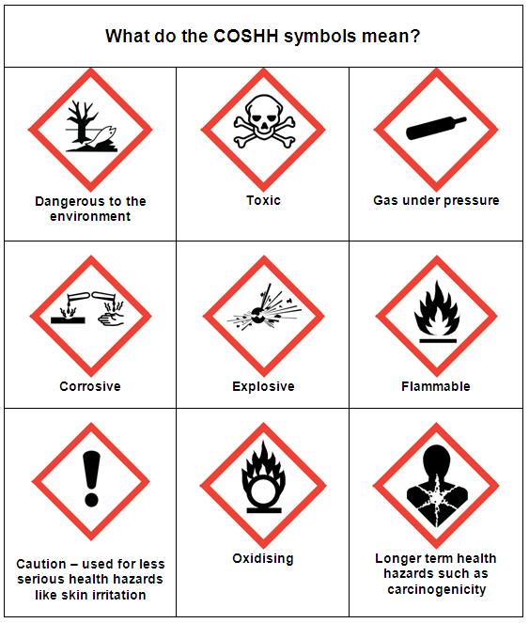
Although it may seem a bit daunting with all the information above a lot is common sense. What would you do in your daily lives?
Because we are helping vulnerable people in their own homes we need to be extra careful. We have to take in to account that our clients may not see the risks themselves or that restricted or no mobility may have an impact on how they deal with chemicals and hazards. We therefore have to adapt a “what if” attitude and work on the side of caution.

P.P.E SHOULD BE WORN AND DISPOSED OF CORRECTLY AT ALL TIME.
DO NOT REUSE ANY P.P.E

PLEASE SIGN TO SAY YOU UNDERSTAND ALL INFORMATION IN THIS TRAINING SHEET.
NAME………………………………………………………………….
DATE…………………………………………………………………...

