Catheter Care
As part of this training session we will be explaining and demonstrating how to maintain, use and dispose of equipment used for catheter care.
A catheter is used when an individual is either incontinent or needs assistance to urinate. Below you can see a male catheter inserted. It also shows that there is a small balloon that is inflated to hold it in place. As you can see from the picture there is a small slit either side if the inserted end of the tube that allows urine to flow. Always make sure that you DO NOT pull on the catheter tube. Also make sure that there are no bends or kinks to prevent the flow of urine. When you are assisting someone to stand, who has a catheter, DO NOT let the catheter bag hang down. You must attach straps or leg stocking. If you let the catheter hang down it pulls on the client’s bladder and cause trauma.
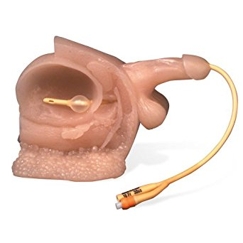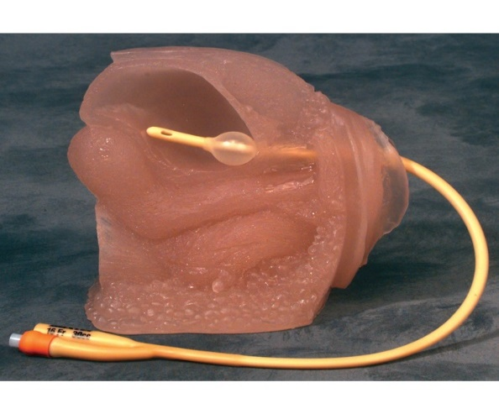
As you can see there is a rubber tube that is left hanging out of the penis or vagina.
Leg bags.

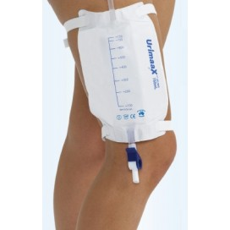
To attach the leg bag you will need to use two straps that that are to be fed through the slits that are provided on the leg bag. Do not place over the leg bag itself as it will stop the flow of urine, and forcing it back into the bladder causing discomfort and pain to the individual but also can cause additional medical complications. Make sure that the leg bag is on the locking position when attatched to the leg. You can do this by moving the leaving tap. You can check it is locked by looking through the end of the rubber tube. If you can see into the bag it is not locked.
Leg bags are to be changed every 7 days. To do this you must hold the rubber tube that is coming out of the penis or vagina to prevent pulling and leakage. Then disconect the leg bag and replace it with a new one. Dispose of the leg bag in the correct manner. The silicone strip as shown in the picture needs to be facing skin down.
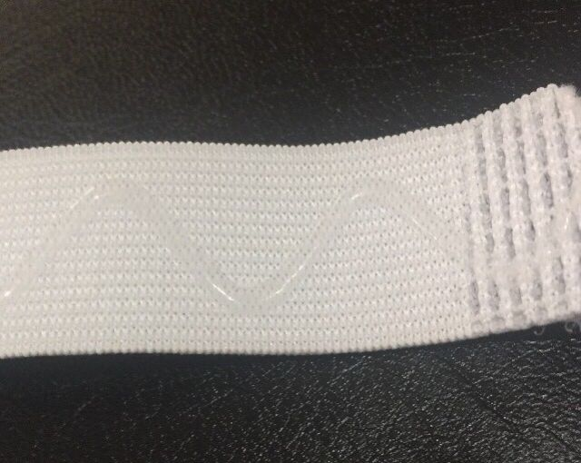
There is also a leg stocking that is available as an alternative if the individual has available. These can be one of two ways. They can be completely flat with a hole in the middle that you will need to fold half of it back on itself and insert the end of the leg bag tube through the hole. With it facing to the front of the leg. There is also one that is already folded and stitched in half with a pocket effect. This still has the hole for the end of the leg bag to be treaded trough. Again, facing the front of the leg.
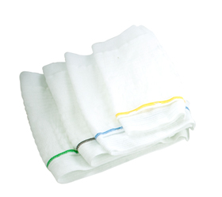
Night bags
Below you will see several pictures of night bags. These are what you are to attach to the leg bag when an individual is in bed. To attach this, you keep the leg bag attached to the Catheter tube as it has been during the day. You then connect the leg bag to the night bag by connect the two tubes together. Make sure you unlock the leg bag allowing the urine to flow freely. You must also take leg straps/stocking off again allowing movement for urine and preventing legs from being constricted and causing discomfort and possible sore areas.
To remove the night bag, make sure that you lock the leg bag before removing it. Once night bag is removed empty night bag into the toilet and dispose of in the correct manner. Then make sure you reattach the leg bag using the leg straps or stocking.
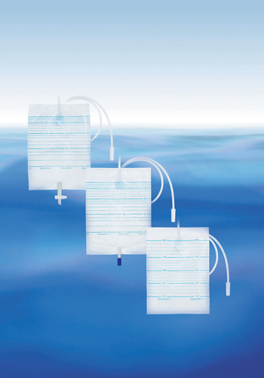
Catheter night bag stand
Below you will see a night bag stand. To use this, you must attach the night bag to the stand. You will see four prongs. On the night bag there is four hole (you might have to puncture the holes) these are to be place onto the four prongs. The top of the night bag tube will then be place between the insert at the top of the stand as seen in the picture. The bottom of the night bag then needs to be placed into the inserts on the night stand. Holding the night bag safely in place. Place stand in a safe place by the bed and preventing pulling on the tube.

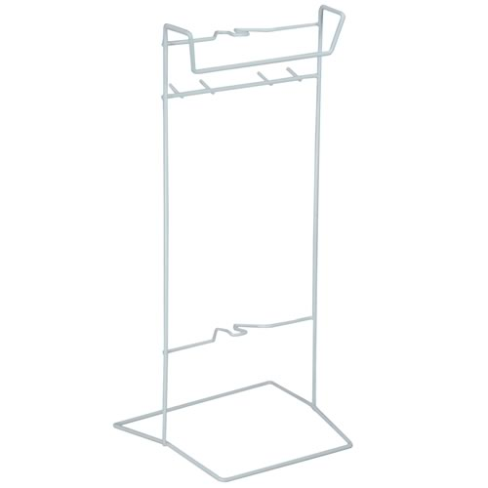

Convene catheter
Below you will see a selection of convenes. These are for men and are instead of an inserted catheter. These are placed on the penis by rolling from the tip of the penis to the base. You must make sure that there are no air bubbles in the end of the convene that is nearest the body or it will cause leakage. Once the convene is in place attach the leg bag/night bag as before.
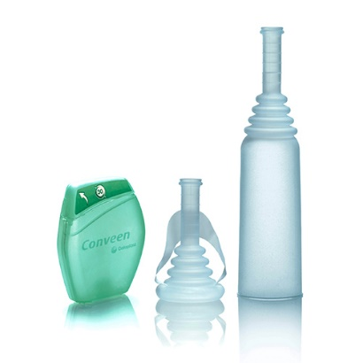
Catheter belly bag
Below you will see a belly bag catheter. This is inserting into the belly through an incision. The bag itself sits on the individuals belly and is held in place with a belt that goes around the waist. You will need to make sure that when you tighten the belt it is high enough on the individual’s body to prevent bends and creases in the pipe and bag. To empty the catheter belly bag, you will need to take the valve out from under the small plastic panel and unscrew the end of the outflow tap.
Belly bags are to be changed every 7 days. To do this you must hold the rubber tube that is coming out of the belly to prevent pulling and leakage. Then disconect the leg bag and replace it with a new one. Dispose of the leg bag in the correct manner.
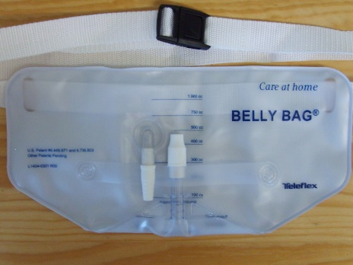

Urine bottle
Below you will see a urine bottle. These are used for men to urinate into. They are also used to empty leg bags/belly bags into. Make sure that you empty the contents into the toilet and clean after every use. Make sure they are always within reach of the individual when you leave the property.
