CONTINGENCY PLAN

Coronavirus Outbreak

MARCH 2020
Chapter Care (North Devon) Ltd
Last Updated 18th March 2020

What is the Coronavirus?

CORONAVIRUS

The Current novel coronavirus (COVID-19) outbreak, which began in December 2019, presents a significant challenge for the entire world.

The UK government and the developed administrations including the health and social care systems have planned extensively for over the years for an event like this and the UK is therefore well prepared to respond in a way that offers substantial protection to the public.

Of course, this is a new virus, and new technology and the increasing connectivity of our world means that plans need to be kept up to date, to reflect that illness.

What we know about the Coronavirus is that Coronaviruses are a family of viruses common across the world in animals and humans. Certain types cause illness in people.

For example, some coronaviruses cause the common cold; others cause disease which are much more severe such as Middle East Respiratory Syndrome (MERS) and Severe Acute Respiratory Syndrome (SARS), both of which often lead to pneumonia. CONVID_19 is the illness seen in people infected with a new strain of coronavirus not previously seen in humans.

As it is a new virus, the lack of immunity in the population (and the absence as yet of an effective vaccine) means that CONVID-19 has the potential to spread extensively. The current data seem to show that we are all susceptible to catching this disease.

Prevention Steps

Please do not visit clients if you have been in contact with someone who has been diagnosed with the virus.

Advice to all staff is not to travel to affected areas.

GOOD HYGIENE PRACTICE
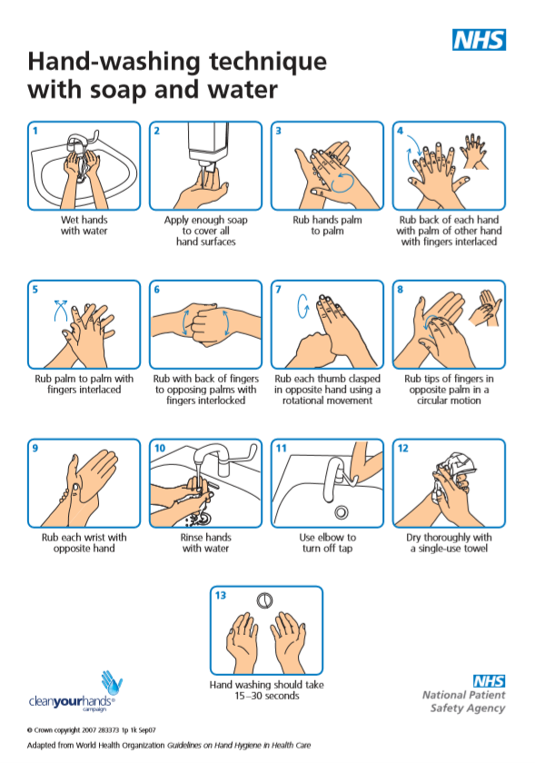
The main preventative measure is to ensure all staff are using correct hand washing techniques and effective hand hygiene.

PERSONAL PROTECTIVE EQUIPMENT
Care workers should use personal protective equipment (PPE) for activities that bring them into close personal contact, such as washing and bathing, personal hygiene and contact with bodily fluids.
Aprons and gloves should be used in these situations. If there is a risk of splashing, then eye protection will minimise risk.
New personal protective equipment must be used for each episode of care. It is essential that personal protective equipment is stored securely within disposable rubbish bags.
These bags should be placed into another bag, tied securely and kept separate from other waste within the room. This should be put aside for at least 72 hours before being put in the usual household waste bin.

PPE is provided and extra stock has been ordered to ensure that in the event PPE was limited we have sufficient supplies. Chapter Care will provide nappy sacks for used PPE to be placed in.

CLEANING
If care workers undertake cleaning duties, then they should use usual household products, such as detergents and bleach as these will be very effective at getting rid of the virus on surfaces. Frequently touched surfaces should be cleaned regularly.
Personal waste (for example, used tissues, continence pads and other items soiled with bodily fluids) and disposable cleaning cloths can be stored securely within disposable rubbish bags.
These bags should be placed into another bag, tied securely and kept separate from other waste within your own room. This should be put aside for at least 72 hours before being put in the usual household waste bin for disposal as normal.

LAUNDRY
If care workers support the individual with laundry, then they should not shake dirty laundry. This minimises the possibility of dispersing virus through the air.
Wash items as appropriate, in accordance with the manufacturer’s instructions.
Dirty laundry that has been in contact with an ill person can be washed with other people’s items. If the individual does not have a washing machine, wait a further 72 hours after the 7-day isolation period has ended; the laundry can then be taken to a public laundromat.
Items heavily soiled with body fluids, for example, vomit or diarrhoea, or items that cannot be washed, should be disposed of, with the owner’s consent.
What to do if you have symptoms of COVID-19

FOLLOW NHS ADVICE:
Stay at home for 7 days if you have either:
- a high temperature – you feel hot to touch on your chest or back
- a new, continuous cough – this means you've started coughing repeatedly
Do not go to a GP surgery, pharmacy or hospital.
You do not need to contact 111 to tell them you're staying at home.
Testing for coronavirus is not needed if you're staying at home.
If you are advised to self-isolate at home you should follow the stay at home guidance. This action will help protect others in your community while you are symptomatic.
If advised to self-isolate at home, you should not visit and care for individuals until safe to do so.
- Inform Chapter Care immediately so that correct measures can be taken.
- Separate yourself from other people and animals in your home
- plan ahead and ask others for help to ensure that you can successfully stay at home
- ask your employer, friends and family to help you get the things you need to stay at home
- stay at least 2 metres (about 3 steps) away from other people in your home if possible
- sleep alone, if possible
- wash your hands regularly for 20 seconds, each time using soap and water, or use hand sanitiser
- stay away from vulnerable individuals, such as the elderly and those with underlying health conditions, as much as possible
- If your symptoms worsen during home isolation or are no better after 7 days, contact NHS 111 online. If you have no internet access, call NHS 111. For a medical emergency dial 999

What to do if you have been in close contact with an individual displaying symptoms of COVID-19
This advice is intended for those living in households with someone who shows symptoms that may be caused by coronavirus
If you live with others and you are the first in the household to have symptoms of coronavirus, then then you must stay at home for 7days, but all other household members who remain well must stay at home and not leave the house for 14 days. The 14-day period starts from the day when the first person in the house became ill.
For anyone else in the household who starts displaying symptoms, they need to stay at home for 7 days from when the symptoms appeared, regardless of what day they are on in the original 14 day isolation period. It is likely that people living within a household will infect each other or be infected already. Staying at home for 14 days will greatly reduce the overall amount of infection the household could pass on to others in the community
If you can, move any vulnerable individuals (such as the elderly and those with underlying health conditions) out of your home, to stay with friends or family for the duration of the home isolation period
If you cannot move vulnerable people out of your home, stay away from them as much as possible
Do not go to a GP surgery, pharmacy or hospital.
You do not need to contact 111 to tell them you're staying at home.
Testing for coronavirus is not needed if you're staying at home.
Follow the stay at home guidance.
If you are living with children
Keep following the advice above to the best of your ability, however, we are aware that not all these measures will be possible.
What we have seen so far is that children with coronavirus appear to be less severely affected. It is nevertheless important to do your best to follow this guidance.

What to do if a client has symptoms of COVID-19

FOLLOW NHS ADVICE:
Advise to stay at home for 7 days if they have either:
- a high temperature – you feel hot to touch on your chest or back
- a new, continuous cough – this means you've started coughing repeatedly
Do not advise them to go to a GP surgery, pharmacy or hospital. However, if the client has an underlying health condition, they are advised to contact their GP to make them aware of their symptoms. Local GP surgeries are currently taking telephone appointments.
You do not need to contact 111 to tell them you're staying at home.
Testing for coronavirus is not needed if you're staying at home.
If the client is advised to self-isolate at home they should follow the stay at home guidance. This action will help protect others in your community whilst they are symptomatic.
If the individual receiving care and support has symptoms of COVID-19, then the risk of transmission should be minimised through safe working procedures.
- Inform Chapter Care immediately so that correct measures can be taken.
- Keep visitors to their home at a minimum
- plan ahead and ask others for help to ensure that they can successfully stay at home
- ask carers, friends and family to help them get the things they need to stay at home
- stay at least 2 metres (about 3 steps) away from other people in their home if possible
- sleep alone, if possible
- wash their hands regularly for 20 seconds, each time using soap and water, or use hand sanitiser
- stay away from other vulnerable individuals, such as those with underlying health conditions, as much as possible
- If their symptoms worsen during home isolation or are no better after 7 days, contact NHS 111 online. If they have no internet access, call NHS 111. For a medical emergency dial 999
Action

- Daily office meetings will be held to ensure all office staff are updated with latest government and NHS guidelines and ensure they are competent in the event of what to do, including our contingency plan.
- Daily communication to all staff via email with latest government and NHS guidelines. Staff advised to follow NHS guidelines if unwell.
- Weekly communication to clients to reassure and advise of steps we are taking.
- Reinforcement of regular and proper hand washing procedure
- Reinforcement of the importance of proper PPE use and disposal
- Additional supplies of PPE have been ordered in the event there is a shortage, or a delay in deliveries.
- Disposable ‘nappy sacks’ to be stocked and provided to staff to aid in the correct disposal of PPE
- Group meetings and training to be cancelled and reviewed weekly.
- Recruitment to be directed at qualified candidates with existing DBS to work alongside our existing staff in the event of a reduced workforce
- Ensuring client NOK details are up to date and relevant
- Clients to be RAG rated as per their needs and dependencies using but not limited to the following criteria:
  - Level of need and support from friend/family
  - Mobility needs
  - Medication needs
  - Nutritional needs
- Develop a list of clients that can be supported via telephone.
- Contact all care staff to identify potential reduced workforce as a result of possible future school closures/work closures/UK shutdown
- Contact those members of staff with annual leave booked within the next four weeks to establish their availability in the event of school closures/work closures/UK shutdown
- Ensure all office staff have access to Chapter Care system from home.
- Contact Devon Cares to update with available capacity
- Information sharing between local agencies and Devon Cares to establish how we can support each other in the event of reduced workforce.
Contingency Plan
- Office staff to work from home.
- Any office staff with care experience to cover care visits as required
- Use RAG rating to ensure those clients most at risk are prioritized
- Contact designated NOK to proceed with any individual contingency planning
- Contact those clients that have been identified within the action plan, via telephone, at regular intervals in the day.
- Support NDDH with hospital discharges if and when appropriate

