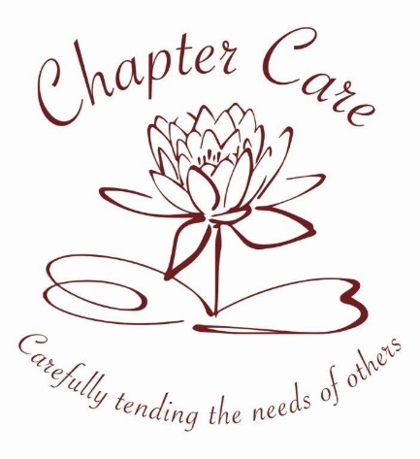
Health and Safety – Potential Risks in Service Users Properties

- Clutter in rooms/too much furniture
- Uneven floor surfaces (especially when moving and handling with equipment)
- Torn Carpets
- Electrical wiring in poor condition
- Problems with electrical sockets – not working
- Rugs
- Spilt liquids/food on floor
- Lights/light switches not working
- Lights flickering
- Problems with fridges/freezers/toasters/kettles
- Fridge doors not closing properly/not retaining the correct temperature
- Ovens not working properly/taking too long to heat up
- No stair rods/loose stair rods on stairs carpets
- Windows not opening/closing properly
- Doors sticking/loose on hinges
- Door locks not working/difficult to open/close
- Key safe not working/difficult to open/close
- Taps not working/dripping
- Sinks/baths leaking
- Chairs/tables/sofas in poor condition
- Open fires/no fire guards
- Gas/electric fires/heater in poor condition
- Controls not working properly
- Overflowing waste bins – health hazard
- Fire hazards – paper/combustible materials near fires/heaters
- No smoke alarms/carbon monoxide detectors
- Rodents – rat/mice/cockroaches etc infestation
- Pets – faeces on floor/stale food
- Dirty laundry/clothes lying around premises

