Incontinence pads

You will find there are a variety of different incontinent pads. These will be tailored to the individual’s needs. Some of our clients will supply their own and some will have had an incontinent assessment done. This is usually done when a bladder diary is recorded and the assessment team determine how many and what pads are required. Below you will see a range of different types of incontinent pads.
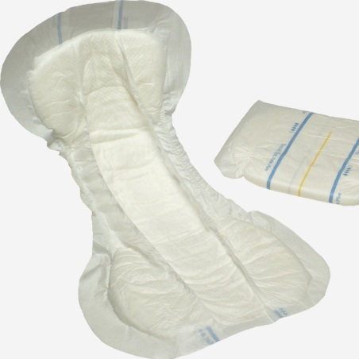
A lot of our clients use these slip pads. These are placed in the underwear of the client. The plastic area goes on the outside touching the underwear. The softer area goes skin side. The larger end of the pad goes to the back of the client. They are not to be put down the toilet. They are to be placed in a bag and into the bin provided by client.
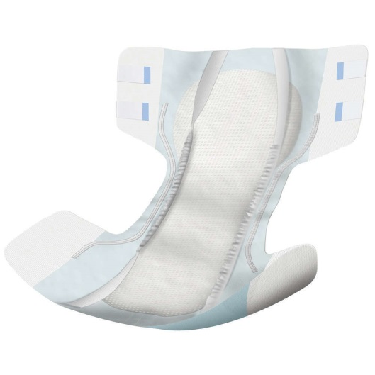
This is a pad that works the same way as a nappy pad. It has sticky tabs that once the pad is in place they stick to the front of the pad. The part of the pad that has the sticky tabs on is to be places at the back.
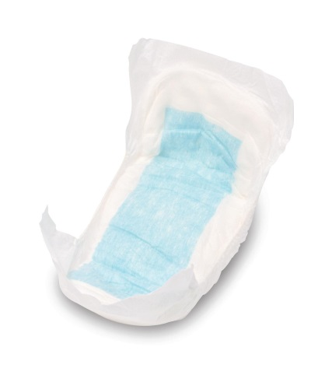
The picture above is a small slip pad. These are usually the same width both ends. They are place in the underwear of the client with the soft part touching the skin and the plastic area touching the underwear.
Before you put the pad on the client, you need to fold the pad lengthways in half, this helps create a bowl shape in the middle of the pad. You also need to ensure you put the pad on by passing it through the front of the client to the back to avoid cross infection from anus to vagina or penis (same rules as wiping front to back).
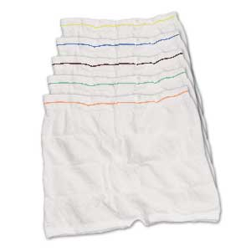
The picture above shows net pants, each colour band denotes the size. These are worn with incontinence pads to keep the pad in place correctly. When using the net pants you will need to pull up the leg parts so they tuck in around the pad and look more like a pair of pants instead of boxer shorts.

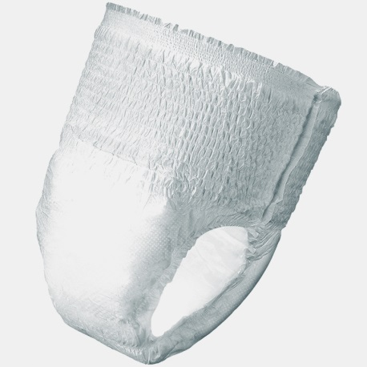

Above you will see a pull up pad. These work the same way as underwear. There is usually a sticker on the outside of the pad that indicates that it goes to the back of the client.
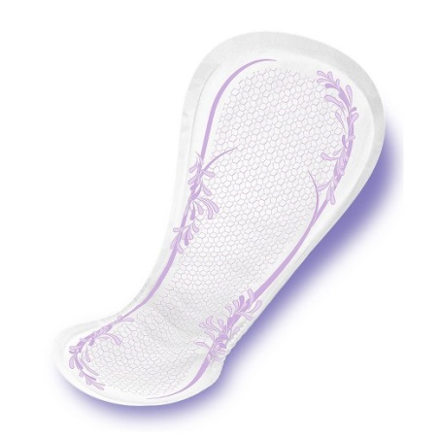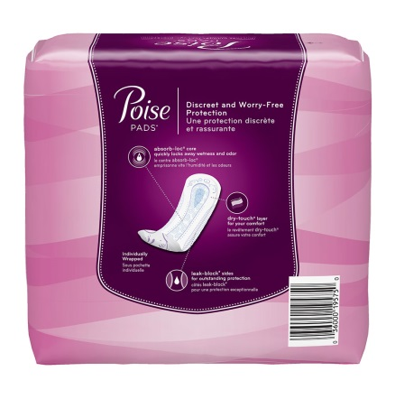

Above you will see sanitary towels. These are usually bought by the clients themselves. They have a sticky side that is placed and stuck onto the underwear.

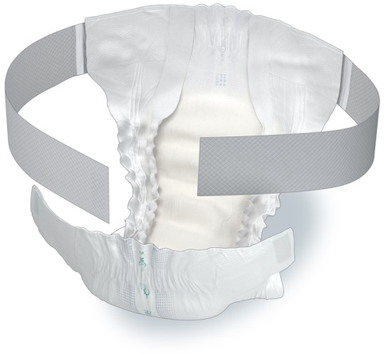
Above you will see a pad that has a wraparound section. It has a belt like attachment that is connected to the back of the pad. It wrapped around the waste of the client and the front sticks to the belt with small Velcro stickers.
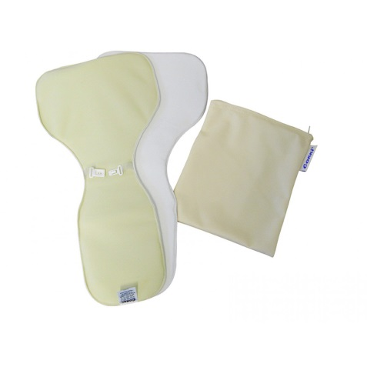
Above you will see reusable pads that are placed inside the underwear. They can be washed and reused. The larger end goes to the back of the client.

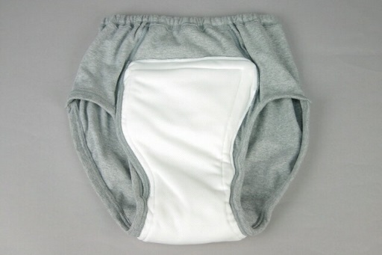
Above you will
Above you will see reusable pants. These work the same way that regular underwear works. They have a built in area that sits between the legs to absorb urine. These can be used again and can be washed in the washing machine.

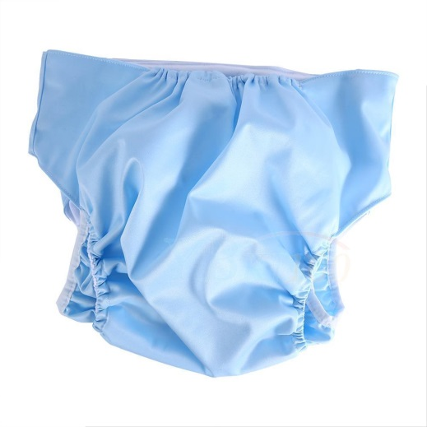
Above you will see a pair of waterproof pants. These can be worn in conjunction with pads. They can be washed in the washing machine but not put in the tumble dryer.
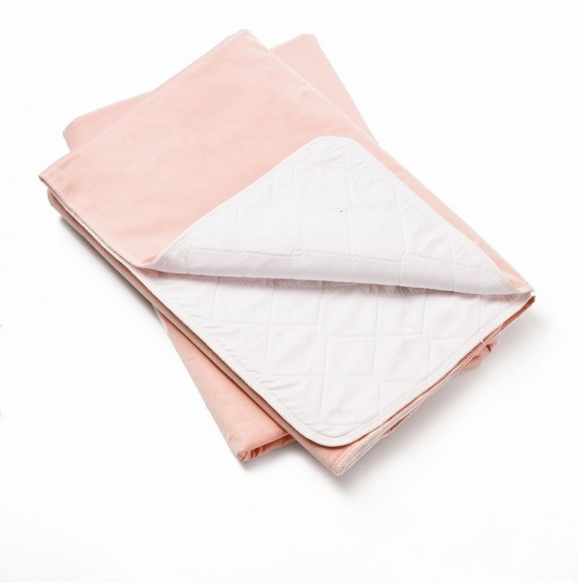
Above you will see a bed Kylie. It is waterproof and can be reused. It can be washed in the washing machine but it is advices not to put in the tumble dryer because it can affect the absorbency. These are placed on the bed. They are rectangle and go across the bed width ways.

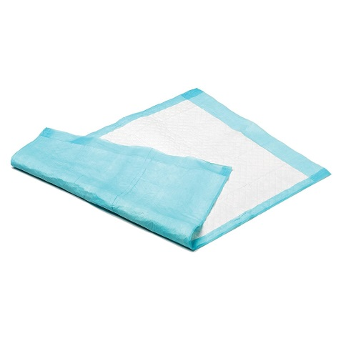
Above you will see a disposal Kylie. These get used on chairs and beds. They are not to be place in the washing machine. They are to be disposed of like all clinical waste. It is to be placed in a bag and then into the bin provided by the client.

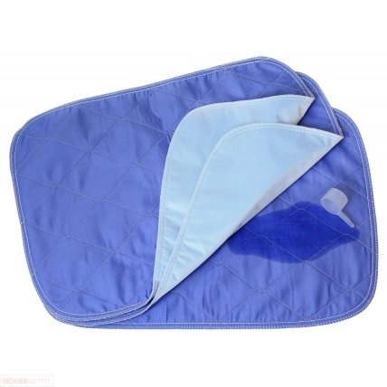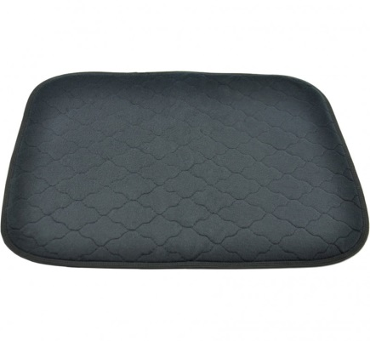
Above you will see two reusable chairs Kylie’s. These are places on the client’s chair. It is waterproof can be washed in the washing machine and reused but it is advices not to put in the tumble dryer because it can affect the absorbency.

