Manual handling equipment you may come into contact with.

You will see a variety of equipment that you may come into contact with within your job role.

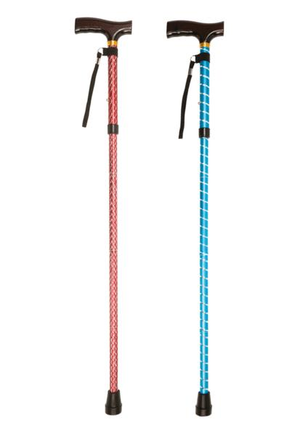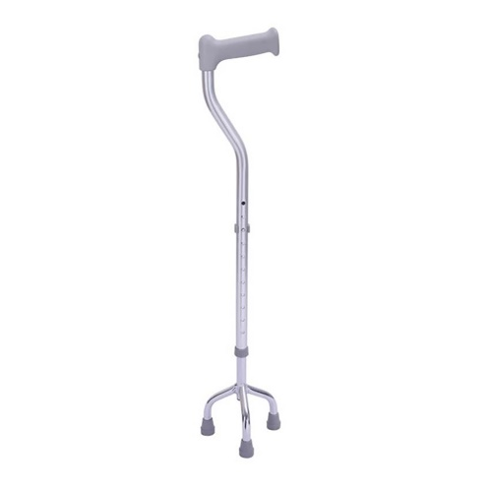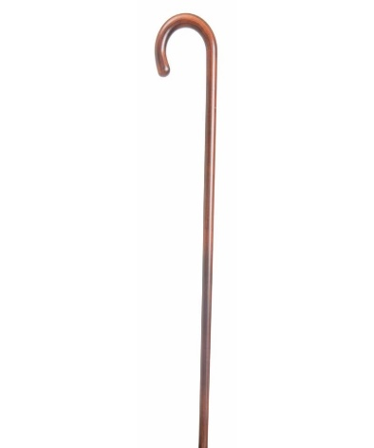
Above you will see a selection of walking sticks. People use a walking stick or a cane to support their balance. It can relieve pressure on painful joint, as well as pressure areas, keep the individual mobile and help promote independence. Although walking can be an advantage they can also be a hindrance because they can increase the chance of someone having a fall. They could trip over the walking stick itself or lean on it instead of using it correctly therefore causing the stick to topple and the client to fall with it.

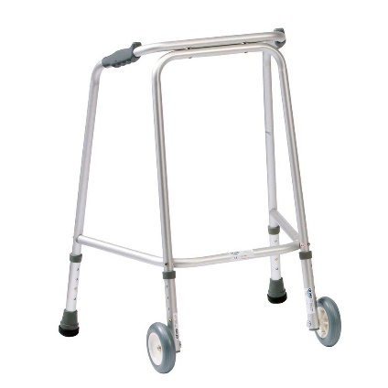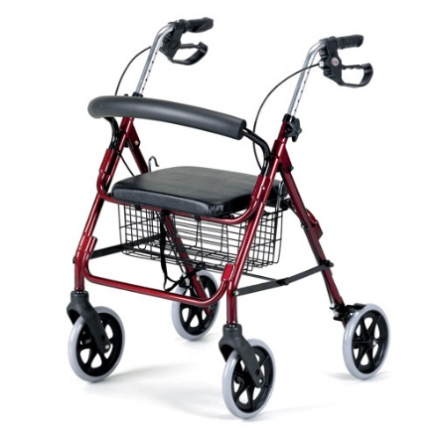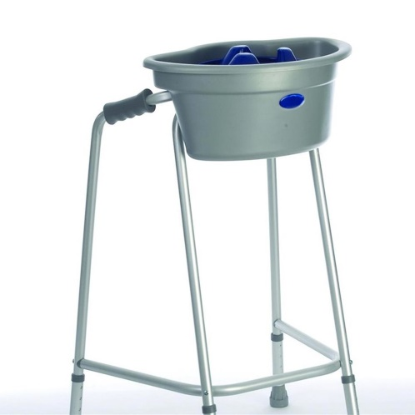
Above you can see several pictures of both Zimmer frames and a walkers. These are uses to help give addition support to someone when walking. To get he best use of a Zimmer frame the client should not take a step until all four legs are level on the ground. They should not push the walker/Zimmer frame to far ahead. Keep their body within the frame and make sure that they do not run over their toes or feet. Make sure they are wearing adequate footwear.

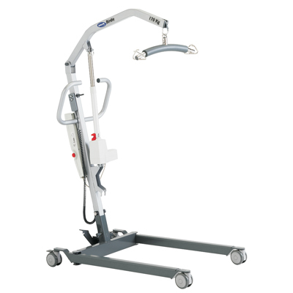

Above you will see a picture of a hoist. This is to be used with two carers. One carer is to use the controls and support the hoist itself. When moving a client in a hoist you must keep the legs closed whilst moving the hoist and open the legs to position the client. Put the brakes on once in the correct position. Whilst the other carer supports the client. You do this by holding onto the sling and steady the client whilst in mid-air. Also positioning the client so that when the other care is lowering the hoist and the client to either a bed or a seat you make sure that they don’t get knocked or trapped. For example when helping a client onto a bed the carer that is supporting the client would make sure that their legs are facing the bottom of the bed. You would then support the legs whilst the hoist is being put into position and lowered down. The bed should be at the correct manual handling level (elbow level to the shortest carer). When you are lowering someone into a chair then the carer that is using the controls and moving the hoist must keep the legs closed whilst moving the hoist. Open them to position the hoist around a chair. One leg either side. Place the breaks on then lower the client into position.

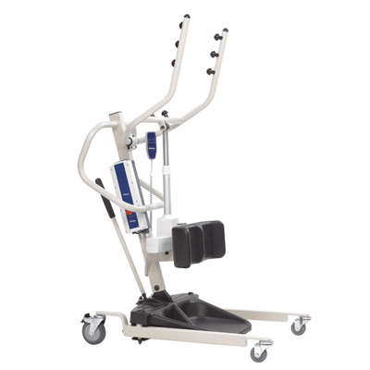 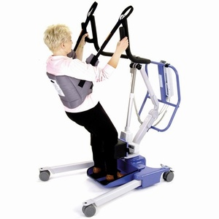 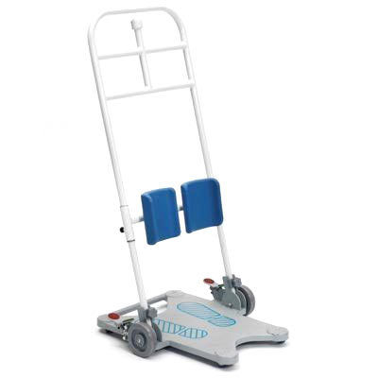 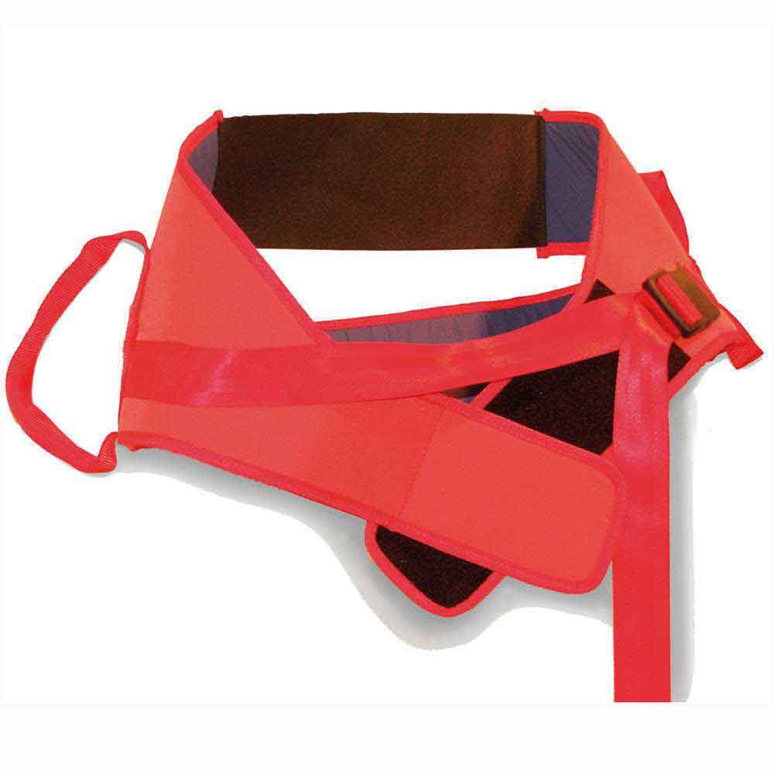Belt used with return stand
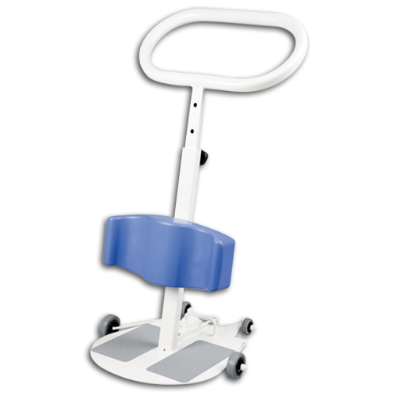

Above you will see a picture of standing aids. These can be used with one or two carers depending on the manual handling needs. It is used with a belt that is wrapped around the client. It can be used to help a client in and out of bed chair. If the client is in bed you will need to help the client to the sitting position on the edge of the bed. You position the stand aid in front of the client with the legs apart. Position their feet on the plate at the bottom of the stand aid. The client then holds onto the bars at the front of the machine. Some belts have a strap that is attached to each side of the belt. This clips together and is hooked over the metal knob in the centre top of the stand aid. The carer will then use the controls to lift the client to a height that is comfortable to the client. Move the stand with the legs closed and reposition the client. Once in place put the brakes on and lower the client using the controls. Remove the belt.

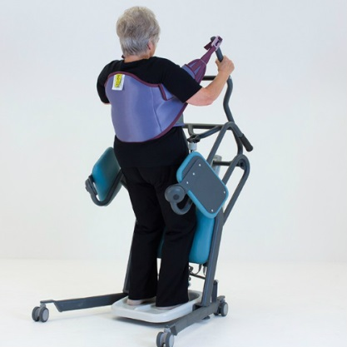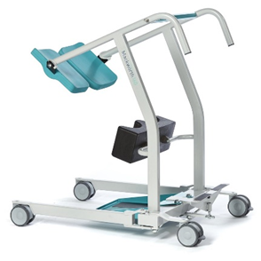
These pictures show you other types of stand aids that have two paddles either side. Once the client has been assisted into a standing position these paddles are moved under the bottom of the client and they can then sit down on them. The client can be transferred on this safely. These can be used to transfer clients short distances of less than 10ft, anything over this time you must transfer onto wheelchair or commode to wheel around.

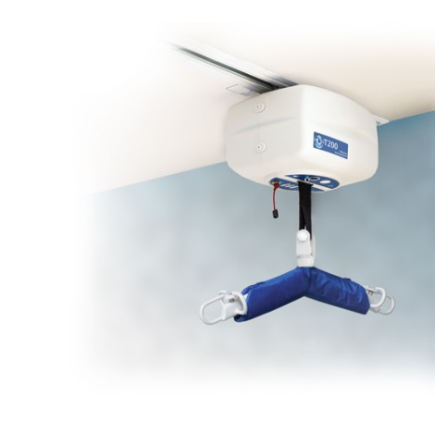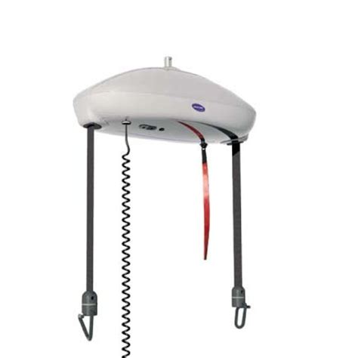

Above you will see a variety of ceiling hoist or track hoists. There is a fitted unit that has a framework fixed to the ceiling with a unit that runs along the track. It has a control box that used to raise and lower it. This can be used with one or two carers depending on the client’s needs. You will have already put the correct sling into place on the client. You lower the unit to the level of the client using the control. Attach the sling straps to the hooks that are either side of the unit making sure you are using the correct strap positions. The general rule is long legs short shoulders. Use the control to raise the client either off the bed or chair. Bu holding onto the client or the sling you can move the unit on the track. If you are helping someone into a chair make sure the chair is in the correct place beforehand. The track/ceiling hoist can only go where the track is fitted. Once you have lowered them into the desire position un hook the sling and use the controls to raise the hoist unit back up out of the way. Take sling out if not an all-day sling.
Below you will see a variety of slings of toileting slings. As you can see by the first picture the sling is place allowing a gap to be able to pull the lower garments down to assist with toileting needs. Picture two and three show you that the leg straps are to be crossed over. This is done to allow dignity to the client. These slings can be put in whilst the client on a bed or from a seated position. If you are putting it on from a bed you can lower the clothing before putting the sling in place. If you are assisting a male client make sure that you do no catch the genitals. Also when assisting someone with a catheter make sure that you are mindful of the pipe. It must not be pulled. You can do this by positioning the tube between the leg straps under the cross over part of the sling. As you can see in picture two the leg straps are looped through each other. Picture three shows that there is a fixed loop that is attached to one of the leg straps and the other leg strap is fed through. Make sure that you are supporting them whilst they are mid-air and the hoist is in motion.

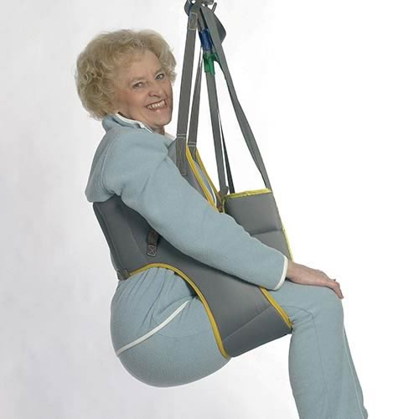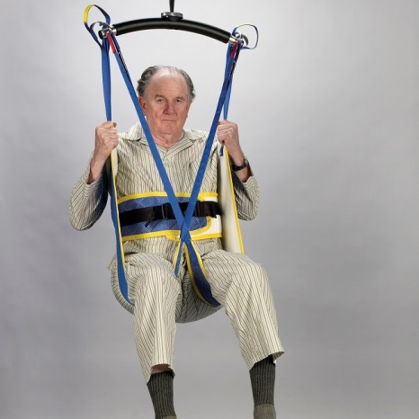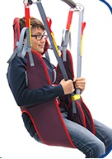

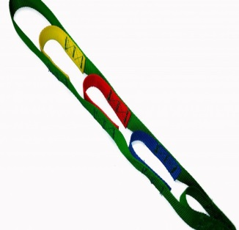 On the strap of the sling you can see there are different colour loops. As a general rule the saying is long legs short shoulders. By this I mean the straps that support the top part of the body would be on the lowest loop nearest to the body of the sling and the strap that supports the legs would be on the first loop on the strap so the furthest from the body. Unless the care plan or manual handling assessment states differently this is the rule that is to be applied.

Below you will see pictures of an all-day sling or a leave in sling. This would get put on the client whilst they are on the bed. Whereas the other sling is paces above to bottom to allow access, this sling is place under the bottom on the thigh to above the shoulder. This can be used for transferring the client and left in place throughout the day. The label would go facing the bed. In the middle bottom of the sling you will see a section that is like a pocket. There will be two small loops inside that you would thread a leg strap through each. Then attach to the hoist the same as you would with the other sling. Always be aware of the client. Make sure they feel comfortable and as safe as possible. Make sure that you are supporting them whilst they are mid-air and the hoist is in motion.
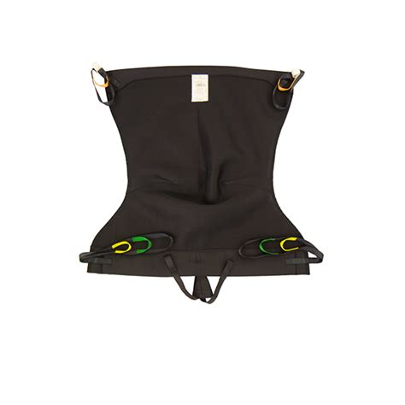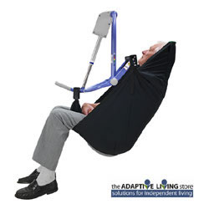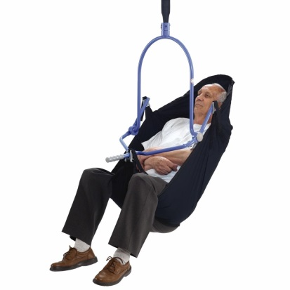

Below you will see wheeled commodes. These can be used to transfer a client to the bathroom for personal care. As you can see in the picture there is a bucket under the seat part that can be removed to place the commode over the toilet. When you are assisting someone onto a commode you must always put the brakes on beforehand. Before you move them for transfer you must make sure that the client’s feet are on the foot rests which you will find at the bottom on the wheeled commode. These are on hinges and pivots so they can be moved out of the way when assisting someone to sit on the commode. If the commode doesn’t have foot plates then make sure the client lifts their legs up before taking the brakes off the commode and moving it or they can get trapped underneath.
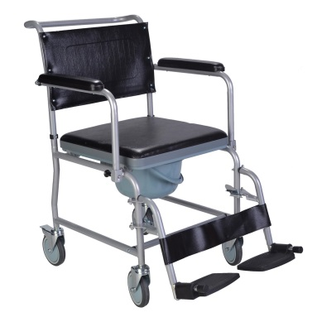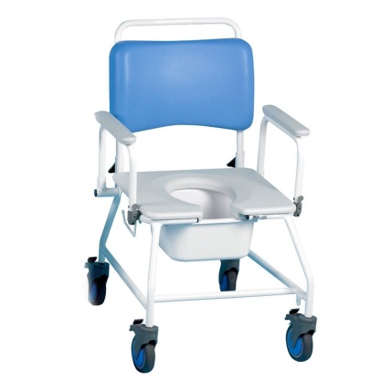

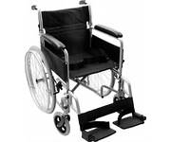This is a manual wheelchair. If you are using it for transferring a client it works the same as a wheeled commode. Again make sure that the client has their feet on the foot rests and that brakes are on before assisting someone to sit in the wheelchair.

Below you will see slide sheets and images illustrating how to use them:
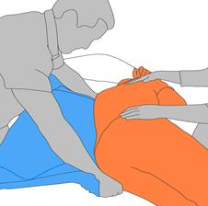
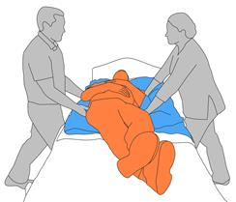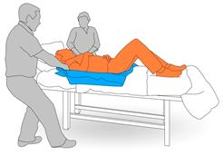
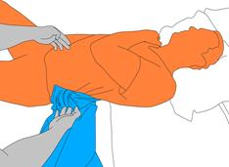

5 Easy Steps On How To Use Slide Sheets
- Safely roll the patient over to one side.
- Place the slide sheets together. flat on the bed parallel to the bed sheets.
- Roll the patient back on their back, and repeat on the other side.
- Pick up the top slide sheet by the sides and use it to move the patient. The top slide sheet slides against the bottom slide sheet, and creates a smooth and easy transfer for both the patient and the carer.
- You can now slide the patient, left to right, and forward and back with ease.

A Few Tips On How To Use Slide Sheets
Slide Sheets can be used singly (folded in half) or one sheet placed on top of another - the decision for this depends on the length of the transfer and the size of the sheet.
At all times, it is recommended that at least two carers are present to perform patient transfers. For sideways transfers place open ended folded sheet towards the patient and place under the patient at least from hip to shoulder. Pull in the direction of the open end.
Warning: slide sheets are slippery, so please perform transfers slowly making sure the patient's head does not hit the top of the bed.

Below you will see Wendylett sheets and illustrations on what they look like and how to use them:

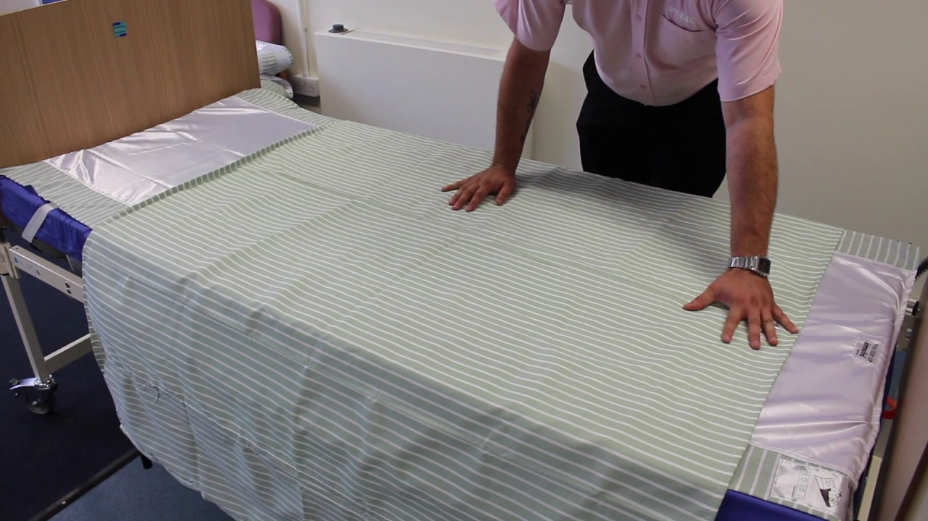

WendyLett Short Bottom Sheet

This bottom sheet is suitable for people who have trouble turning in bed and only spend time in bed when sleeping. The bottom sheet is made of smooth satin in the middle and has a safe anti-slip edge. Place the bottom sheet on top of your regular bedding so that you are lying on the WendyLett with your shoulder and hip.
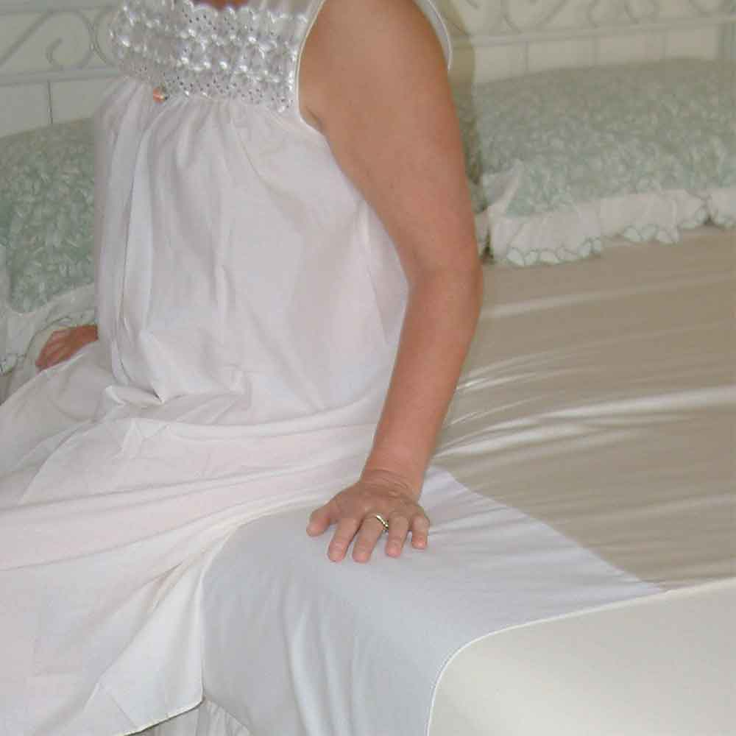

WendyLett Fitted Sheet
The fitted sheet is best suited for people who have trouble turning in bed and who spend most of their day in bed. It is comprised of smooth satin in the middle and has a safe, anti-slip edge. The smooth foot end makes it easier to move the feet when getting out of bed. The smooth satin gives hardly any friction so there is less chance of bedsores on the heels. Use the WendyLett fitted sheet instead of your regular bedding. Do you want to move up higher in bed? Use an anti-slip mat at your feet or wear anti-slip socks for a firmer grip. Simply lift your hips and move yourself up.
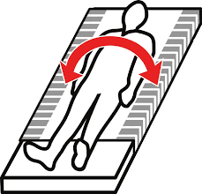

Turning in Bed and Sitting without Slipping
WendyLett2way bedding. This sheet is made of specially woven cotton. It only slides in the direction of the stripes. You can use it with the head end up in bed to prevent sliding down while also facilitating turning in bed. Place the WendyLett2way cover sheet on top of the WendyLett fitted sheet so that you can lie on top of it with your shoulder and hip. Simply tuck the sheet in. Set your bed at the correct height when help is needed when turning in bed. The bed is at the correct height if the caregiver can touch the bed with his or her fingertips. Raise the side rail on the side where the caregiver is not. Do not put your headboard fully upright. At halfway, the pressure is reduced.
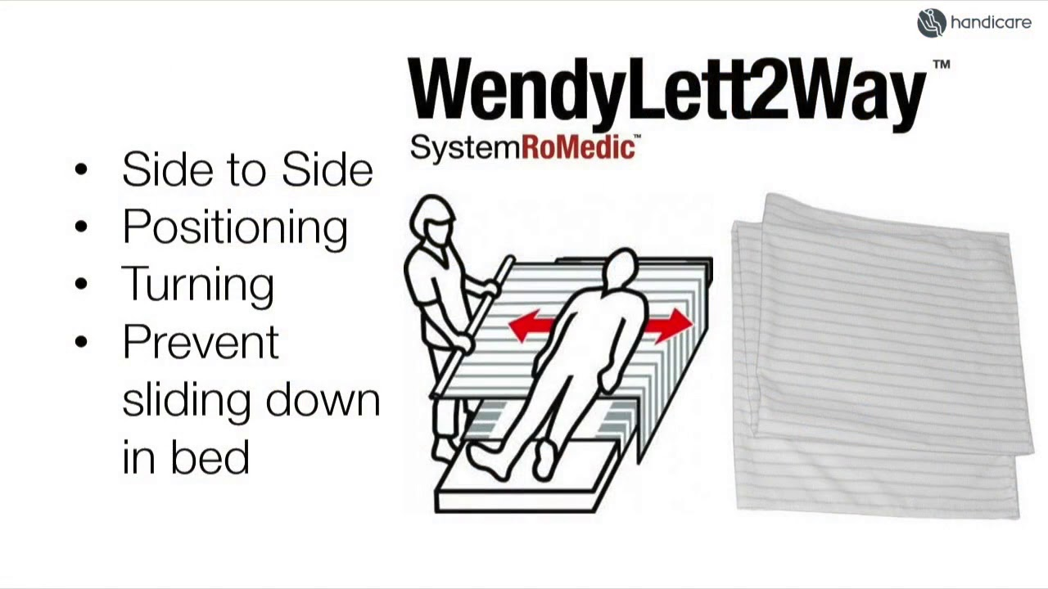

WendyLett4way bedding
This sheet has a satin bottom that glides in all directions. The top is made of specially woven cotton. You can use it for assistance with turning in bed and sliding to the head of the bed. Put the WendyLett4way bedding with the satin side down and on top of the WendyLett fitted sheet. The shoulder and hip must lie on top of the sheet. Tuck the sheet in. WendyLett4way bedding For assistance with turning in bed, the caregiver loosens the sheet on both sides. The caregiver then places one leg forward and one backward, grasps the pull sheet at shoulder and hip level and leans back with outstretched arms. If you want to sit up in bed, you can place WendyLett4way at the bottom with the checkered side down. This ensures that you do not slide down.
