PERSONAL PROTECTIVE EQUIPMENT
P.P.E
Any item of PPE creates a barrier between the wearer/user and the working environment. Personal protective equipment (PPE) refers to protective clothing, helmets, goggles, or other garments or equipment designed to protect the wearer's body from injury or infection. The hazards addressed by protective equipment include physical, electrical, heat, chemicals, biohazards, and airborne particulate matter. Within your role as a carer, you will be required to wear P.P.E on every clients visit.
You will be supplied with all P.P.E. You can collect it from the office. DO NOT RUN OUT. It is your responsibility to ensure you have enough PPE and when you need to replenish this you will need to come to the office to collect it.

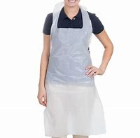In this picture you will see a disposable apron. You MUST wear one of these for every visit you do for personal care task that you perform. You must always change your apron before you perform any food preparation. These should be disposed of after every use by putting them in the bin. Wash your hands before and after you change your apron and gloves. Then put them in the bin. You might find that some clients have a clinical waste bag (yellow) or they just have it put in their normal bin.
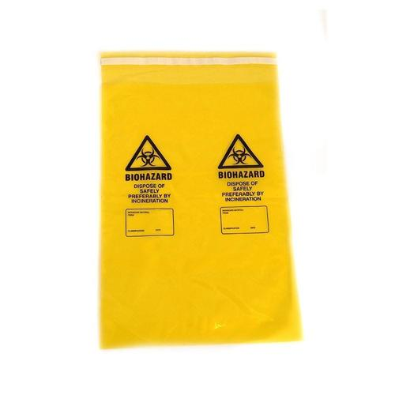This is a picture of a clinical waste bag. They are to only be filled ¾ full before tying up taking out to the correct bin area and replacing with a clean bag. If a client does have a clinical waste bag, they will also have a set collection day. You will see when that is by reading the care plan.

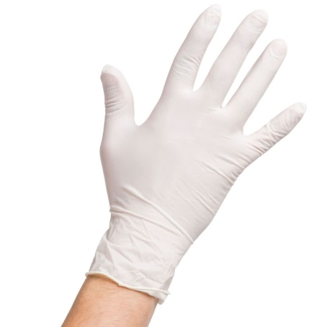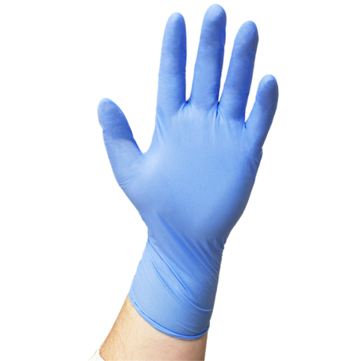Here you can see that there are two different colour gloves. The white gloves are used for personal care tasks. The blue ones are used for food preparation. You must use a clean pair of gloves for each client and task, NEVER re use. Always wash your hands before and after you put on clean gloves. Dispose of in the relevant bin in the client’s home.
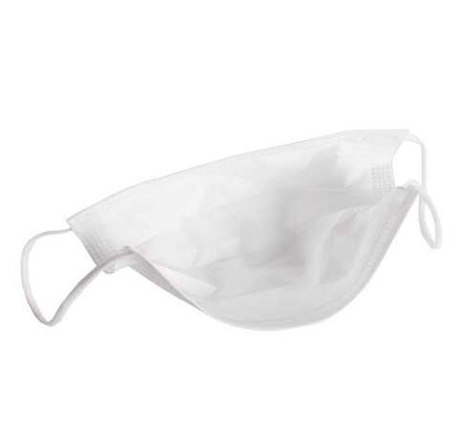This is a face mask. It is to be used if you as a carer are suffering from a cold or any other virus but are still well enough to work. The mask itself is also disposable. It covers your mouth and nose but allows you to breath as normal. It is to be disposed after every client just like all other P.P.E. (During the Corona Virus, to prevent a shortage of masks, guidelines have stated that you can wear a mask for sessional use (max of 2hrs) but IF YOU TOUCH THE MASK IN ANY WAY YOU MUST DISPOSE OF IT AND USE A NEW ONE.

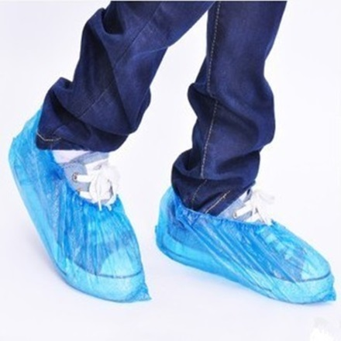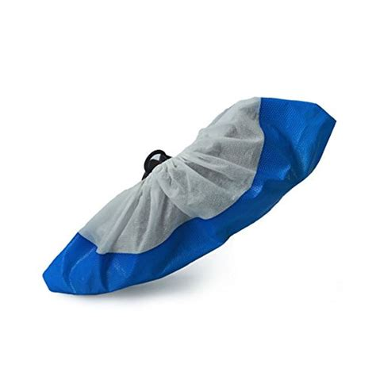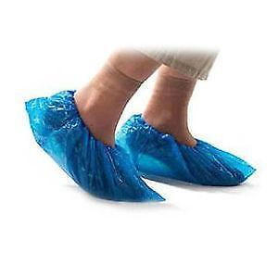
In these pictures you will see a selection of shoes covers. These are waterproof and can be re used. These are not supplied by us. They are a personal preference from our clients and are supplied by them. They will be kept in the client’s property. They can be re used. They are put on over your shoes. Some of our client’s like them to be used to protect their carpet in their home. Others will supply them for you to wear whilst you are assisting them with showering. They can be slippery when wet so be careful when using them. They also come in set sizes so they may be large so be careful not to stand on the opposite foot when walking.
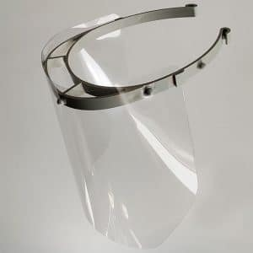
Face Visors:
These should be worn as per PPE guidance and Chapter Care policy. At present (Jan 2021) we are expected to wear these when we are doing any wet work and there is a risk of splash back into your eyes. For example when assisting with showering, washing, emptying catheter bags, commodes. These can be re-worn and need wiping down with antibacterial wipes after each visit. These will be provided to you from Chapter Care.

You are responsible for ensuring you have enough PPE at all times. If you are running low you must let the office know or come to the office to collect more.

