Areas most at risk of pressure sores:
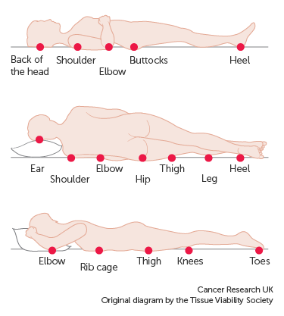

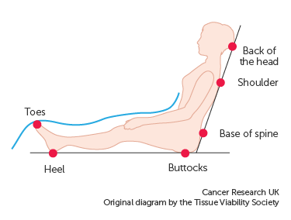

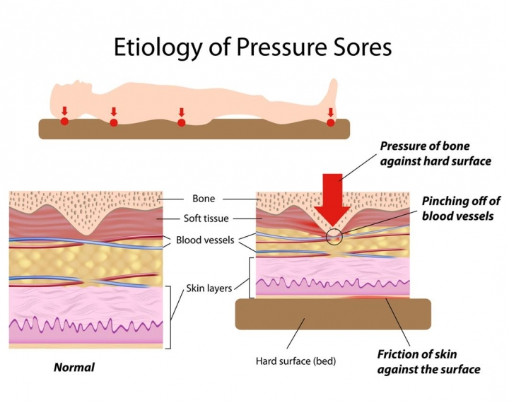

Fingertip Test to check for pressure damage:

Fingertip Test
Stop it,
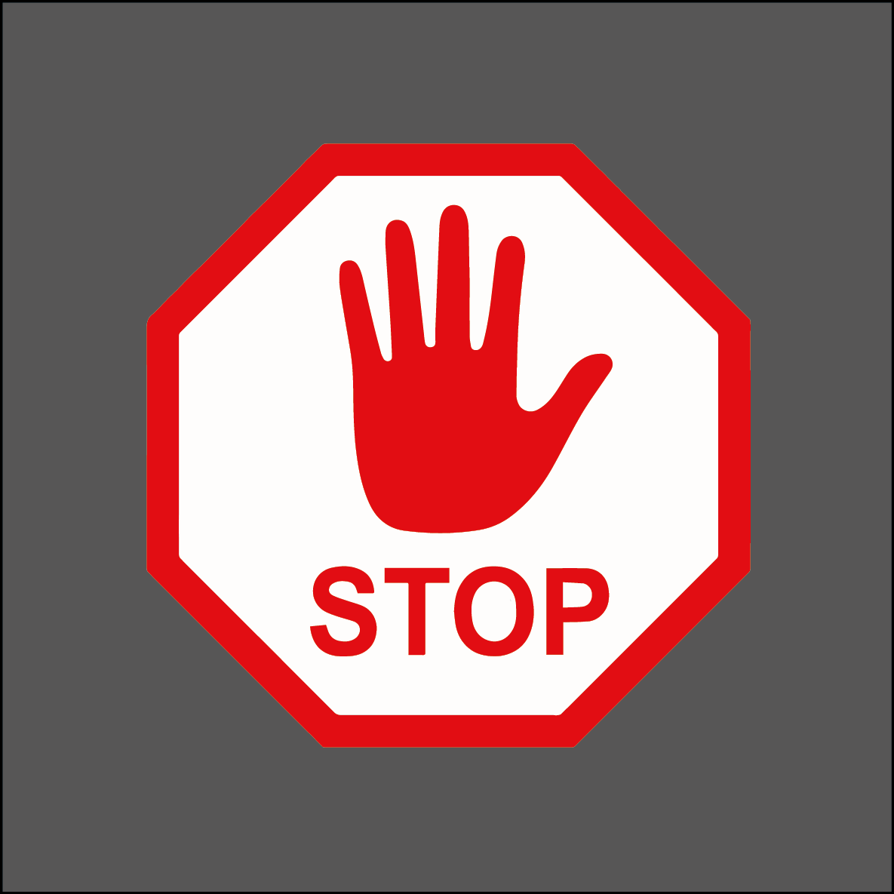
Look at it,

Press it
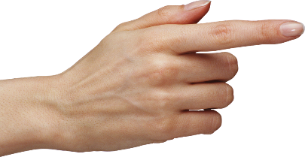
and Report it
Check pressure areas regularly, your client is more at risk of getting a
pressure ulcer if:
• they cannot move without help
• they lose their appetite and lose weight
• they are incontinent
• they are diabetic
• they cannot feel their skin properly
• they are unwell (eg chest infection, urinary tract infection)
Check the most at risk pressure points regularly.

If RED, do the Fingertip Test:

Fingertip Test
Gently press the reddened area of skin. If healthy the red area will turn (blanch) white, then turn red again normally within 3 seconds.
Blanching redness = normal reaction
Non blanching redness - grade 1 pressure
Pressure ulcers happen when patients sit or lie in the same position and are unable to move without help to relieve the pressure. They may not be able to feel or tell you that they are uncomfortable. This pressure disrupts the flow of blood through the skin, so it becomes starved of oxygen and nutrients and begins to break down and leads to a pressure ulcer. The first sign that there may be damage to the skin and tissue beneath is a red area where there has been pressure, if you see this DO THE FINGER TIP TEST. Gently press the reddened area if it blanches white (as the blood is pushed out of the capillaries) then goes red again (as the capillaries refill) this is a normal reaction. This is Blanching Erythema (redness). If the reddened area stays red when gently pressed, this is grade 1 pressure damage. RELIEVE THE PRESSURE, TELL YOUR MANAGER AND CONTACT YOUR LOCAL NURSING TEAM.
