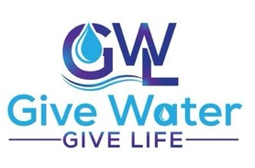
33170 Adelfa Street,
Lake Elsinore CA 92530

Phone # 310-309-7908
Email. Givewatergivelife1@gmail.com

Website: https://givewatergivelife.us

About the Organization
The organization was founded by Benedicta C Ogbonnaya and registered on August 11th, 2021, under California state law. It is IRS certified 501c3 nonprofit organization dedicated to providing clean drinking water to enhance quality of life in communities where people are sick and dying with waterborne diseases and sicknesses from contamination and pollution. The founder is a survivor from waterborne diseases and sicknesses.
Mission
Our mission is to provide clean drinking water wherever it is need, to enhance health and well-being, and make a difference in people’s lives.
Vision:
1. To improve impoverished communities around the world, promoting sanitation and hygiene for the well-being of all citizens.
2. To decrease water borne deaths and diseases
3. To promote school attendance for children
4. To Reduce risk of being kidnapped for human/sex traffic.
5. to support for economic sustainability
We focus on empowering communities to work together through ownership of shared water area, where everyone in the community has access to clean drinking water that belongs to them.
Our Impact
From the time of formation of Give Water Give Life to the present we have span to two nations in African content. We started in Nigeria West African the birth community of our founder and created generational clean drinking water in four (4) communities. In 2023 we began work in Uganda East Africa and have provided eight (8) communities with clean drinking water. So far, we have provided clean drinking water in 12 communities with average of 2,500 persons. Roughly total of 30,000 people now have access to clean drinking water through our services.
Two of our greatest joy are as follow: Orphanage/school called God’s Love in Southern Uganda that was condemned to be shut down by the Uganda Ministry of Health department by September 8, 2023, due to lack of hygiene due to lack of clean water. When this information came to Give Water Give Life we quick intervened by providing clean drink water for the orphanage and as a result saved the place that now serves over 1000 children. Second was the visually impaired community in Tosoro village in Eastern Uganda, suffering from lack of water, and who often falls on the ditch in search for water. When the news came to Give Water Give Life, we got into action and provided clean drink water for the community and now they have access to clean drinking water right where they live. We have noticed that our waiting list increases after we complete a community and we currently have 90 communities on the waiting listing in need of our services. The cost to provide clean )drinking water for a community in Uganda is $10,000.
List of community we have provided clean drinking water

West Africa: Nigeria

1. Aniyi Amagunze
2. Ihuoma Amofia Community
3. Obeau Umuiba
4. Umuiba Nara Unateze community

East Africa: Uganda

5. Kibwa Nansana
6. Kiwala Nama
7. Iringa – South Uganda
8. Kyabasitta Lyantonde
9. Magamaga Jinja
10. Ntawo Mukono
11 Tosoro Village

Samples of communities we served

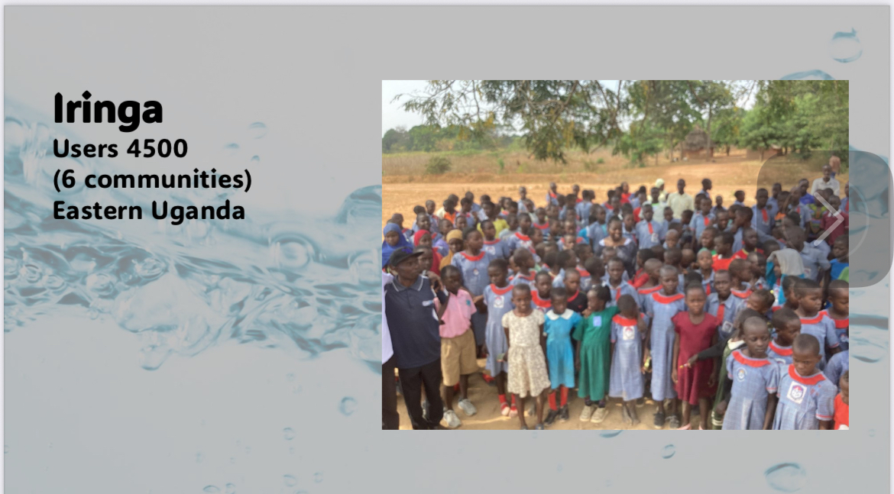
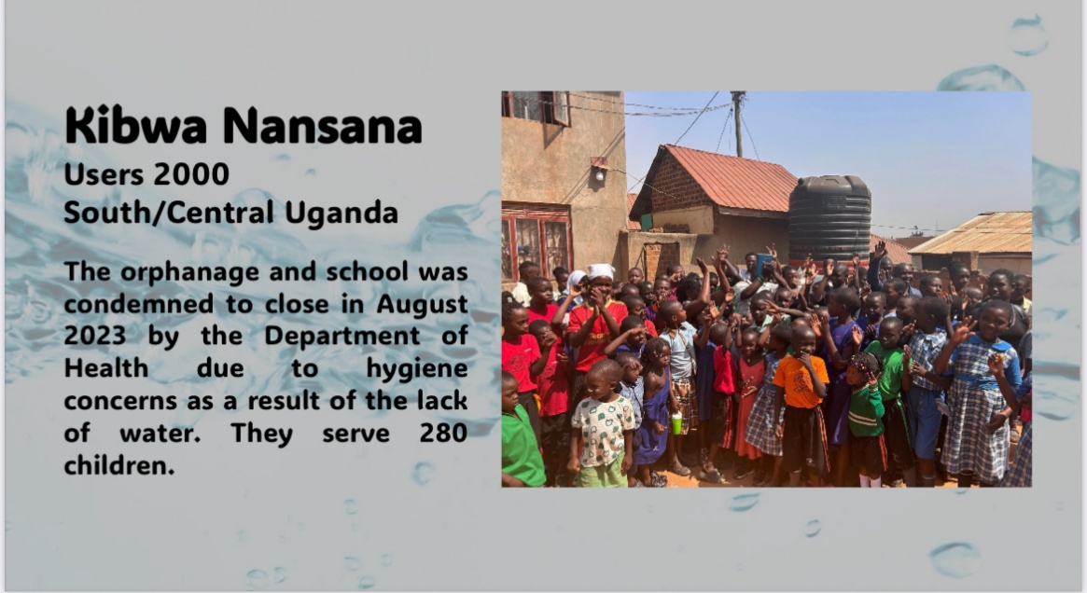
Magamaga Jinja- Eastern Uganda
Users 3500+
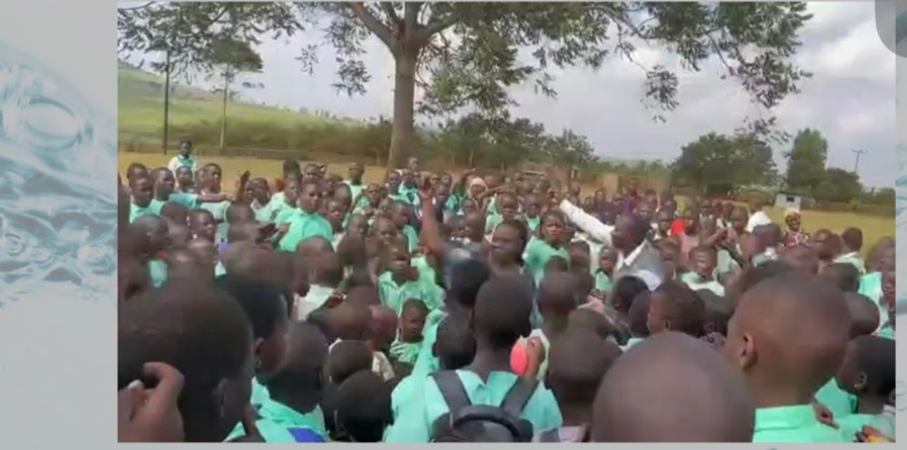
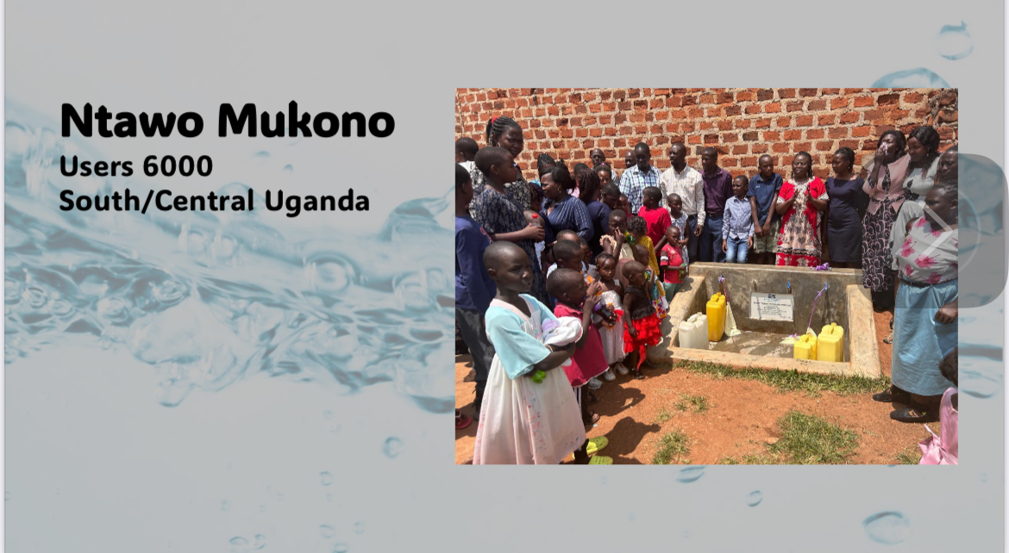
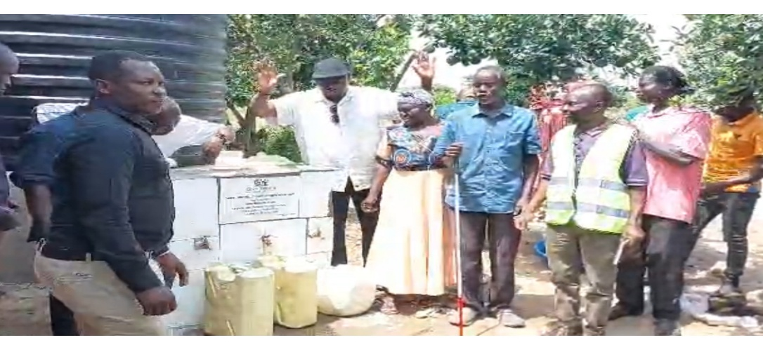
Tosoro Village: Eastern Uganda
visually impaired community

Partner Spotlight: Vanessa Skidmore
How to support our mission:
- Sponsorship: you can sponsor a community :when you sponsor a community, that community water system will be dedicated with a plank in your name or your organization name.
- Add Give Water Give Life in your giving budget- Make a weekly, monthly or yearly donation

Clean water is a basic human right. Your support and contributions will enable us to continue to provide this vital need to everyone in need, to enhance health and well-being and make a difference in people’s lives. Partner with us to give life.

