Bear Lake West Irrigation Enhancement and Stock water State Ag BMPs Project

**Project S754**

Final Report

December 2023

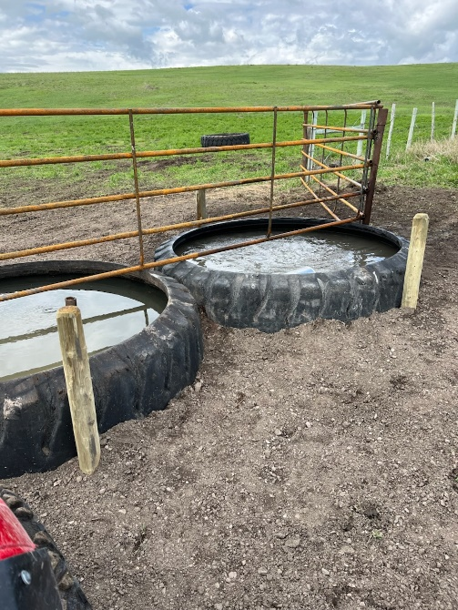

Above. Two water troughs were installed to provide livestock water. Installing water troughs work to reduce livestock impacts in sensitive riparian areas. BLW Photos.

Prepared by:

# Conservation Basics LLC

In Cooperation with:

Bear Lake Soil and Water Conservation District

Idaho Soil and Water Conservation Commission

Idaho Department of Environmental Quality

Index

Abbreviations 2

Location Map 3

Project Map 4

Overview 7

Goals 8

Background 8

Load Reductions 9

Monitoring 9

Tours and Outreach 9

Financial Summary 10

Conclusions 10

Acknowledgements 10

Before and after photos, selected projects 11

Addendum 1 14

**Abbreviations**

Idaho Soil and Water Conservation Commission - ISWCC

Conservation Basics LLC-CBLLC

USDA Natural Resources Conservation Service - NRCS

Idaho Department of Environmental Quality - IDEQ

Environmental Protection Agency – EPA

Total Maximum Daily Load – TMDL

Hydrologic Unit Code - HUC

Best Management Practices – BMPs

Stream Evaluation Control Indicator-SECI

Stream Visual Assessment Protocol- SVAP

Bonneville Cutthroat Trout-BCT

Bear Lake Soil and Water Conservation District-BLSWCD

Bear Lake West Project

Project **S754**

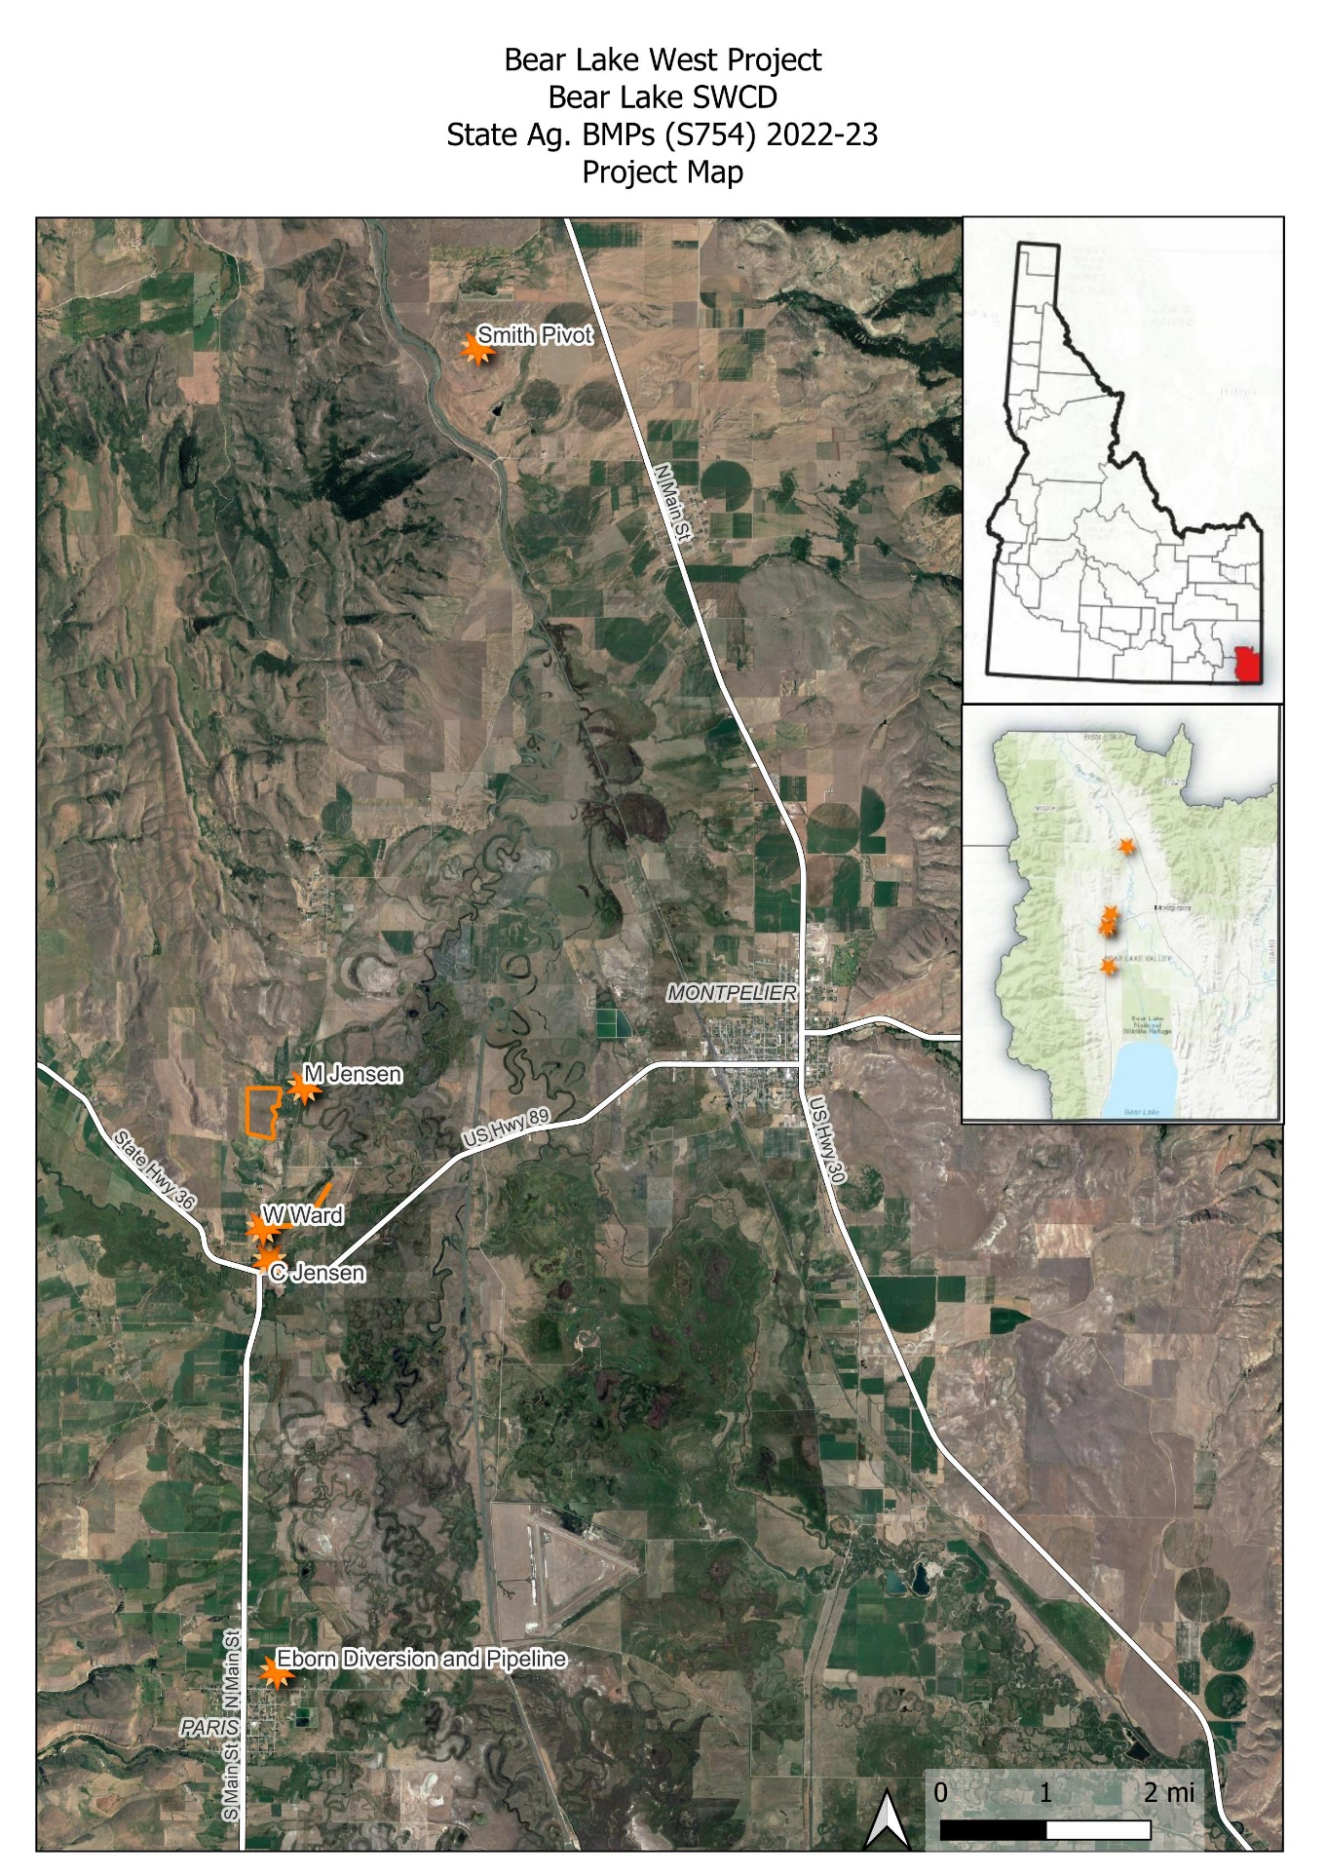

**Overview**

The Bear Lake Soil and Water Conservation District has been very active in promoting voluntary conservation projects the past few years. In April of 2022, BLSWCD began working on a grant application through the State Ag BMP program. This grant would focus on sprinkler-to-sprinkler conversions for two different landowners, and an off-stream watering facility to reduce livestock impacts on sensitive riparian areas. The project wanted to address sediment and nutrient loads to Ovid Creek, Paris Creek, and Georgetown Creek.

The primary goal of the Bear Lake West project was to focus on a couple different aspects of agriculture throughout the subwatershed. Areas of focus were as follows: Irrigation Improvement, Irrigation Efficiency, Grazing Management, Riparian Zone Protection, and Water Quality and Quantity.

This photo shows a newly installed fence. BLW Photos.

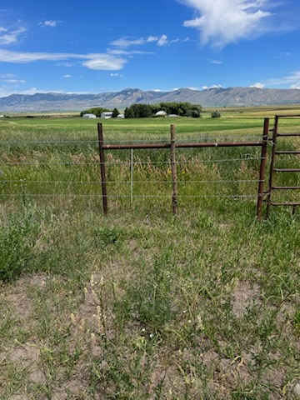

***Goals***

The goals of the Bear Lake West Project were to convert a lateral ditch to pipe off of the Paris irrigation system, install perimeter and cross fencing with an off-stream watering system, install a small-scale irrigation system near Ovid creek, drill a well and install another off-stream watering system, and convert 60 acres from flood to pivot irrigation system.

These installed BMPs are estimated to last a minimum of 20 years. The focus of the BLSWCD is to provide quality projects which will benefit the landowner and the natural resource.

**Background**

The Paris, Ovid, and Georgetown Subwatersheds consist of irrigated, non-irrigated/dry farms, and high elevation range/pastures. Bear Lake County is prone to dry summers and heavy wet winters, which provide for large amounts of runoff in the spring of the year. Summer rain events also provide large amounts of run-off. The high elevations are also prone to frost events and extremely dry conditions characteristic of a high mountain desert.

**Organizational Structure**

The Bear Lake SWCD is comprised of five locally elected board supervisors who serve on a voluntary basis. There is one full-time district employee who is non-voting and serves in an advisory capacity. Technical assistance for this project was provided by Conservation Basics LLC., and the Idaho Soil and Water Conservation Commission.

The Bear Lake SWCD set a goal to implement BMPs within the Bear River Basin, as part of their five-year plan established in 2022. The district wanted to address soil health, overgrazed range and pasture issues, riparian degradation, and irrigation system upgrades for water quantity savings.

The Bear Lake SWCD would like to continue work in the Bear River Basin. The Bear Lake SWCD has a developed list of landowners who have expressed their interest in participating in voluntary conservation projects. The Bear Lake SWCD and Conservation Basics plan to continue submitting 319, State Ag BMP, and WQPA applications to assist the interested parties.

### 

### Cumulative Load Reductions:

The Estimated sediment reductions for the Bear Lake West Project located in the Paris, Ovid and Georgetown Subwatersheds are:

## Monitoring

Monitoring of the Bear Lake West State Ag BMP project consisted of photo monitoring. Monitoring took place with the help of ISWCC Technical Assistance, Bear Lake SWCD Administrative Assistant, participating landowners, and Project Coordinator. Photos are also used to showcase installed BMPs within this report.

**Photo points-**

Photo points were established to show the progress of each BMP before, during, and after installation. These photo points will also be used to track the condition of the BMPs throughout the life span of each project. Photos taken throughout the project are also being used in this final report, as well as in future presentations about this project to showcase to other landowners who might be interested in participating in future 319 or State Ag BMP projects. These projects show other landowners’ different types of BMPs which can be installed to not only improve the environment, but their bottom line as well. The photos shared in this document captured the great work which has taken place through this focused effort to improve water quality in the Paris Creek, Ovid Creek, and Georgetown Creek Subwatersheds. Photos were taken extensively during the entire project. These photos will be used to show the before, during, and after aspects of the project.

## Tours & Outreach

The Bear Lake Board toured portions of this project during the fall of 2022. BLSWCD is planning a tour for the summer of 2024 for the board and other community members and landowners to come and view the work which has been completed. Also, representatives from the Idaho Soil and Water Conservation Commission, IDEQ, and State Senators and Representatives will be invited to attend. The tour will increase awareness of the DEQ Non-Point Source, State Ag BMP, and §319 program and showcase the water quality work that could be accomplished with this and similar funding sources.

**Financial Summary \***

|  |  |  |
| --- | --- | --- |
| 319 Payment | Match Amount | Description |
| $11,500 | $0 | Indirect Costs |
| $98,511.29 | $135,701.81 | Subcontractual Costs |
| $3,500 | $2,567.04 | Travel Costs |
| $0 | $0 | Personnel |
| $0 | $0 | Other/Supplies/Equipment |
| **Total- $113,511.29** | **Total- $138,268.35** | **Total Project- $251,779.64** |

**Conclusions**

The Bear Lake West Project was very successful. The participating landowners were very motivated to accomplish their projects regardless of the challenges of a very long winter and extremely wet summer. The District Supervisors are very satisfied with the quality of work and the amount of conservation which was implemented within the grant timeframe.

The enthusiasm of the participants in completing their projects on time, the hard work of the project coordinator, and the dedication of the engineer helped to make sure this project was completed and that the installed BMPs will have a lasting impact for good stewardship in Bear Lake County.

**Acknowledgements**

## Current Bear Lake SWCD Board Members Jennifer Jenson, Devon Boehme, James Hardcastle, Todd Lloyd, and Mark Parker wish to thank the project participants, cooperating agencies, and irrigation companies for their support, assistance and hard work enabling the design, implementation, and completion of Bear Lake West Project.

The Bear Lake Soil and Water Conservation District sends thanks to Chris Banks, project coordinator, of Conservation Basics, LLC. Also, the Bear Lake SWCD would like to thank Brandee Wells, Bear Lake SWCD District Administrative Assistant, for her efforts in keeping track of all the financials and managing the paperwork coming from each of the different aspects of the project. BLSWCD, thanks George Hitz, ISWCC. Also, Steven Smith and Sherry Thomas were amazing to assist us when needed throughout the lifespan of the project.

# Photo Documentation of BMPS Installed Throughout the Project

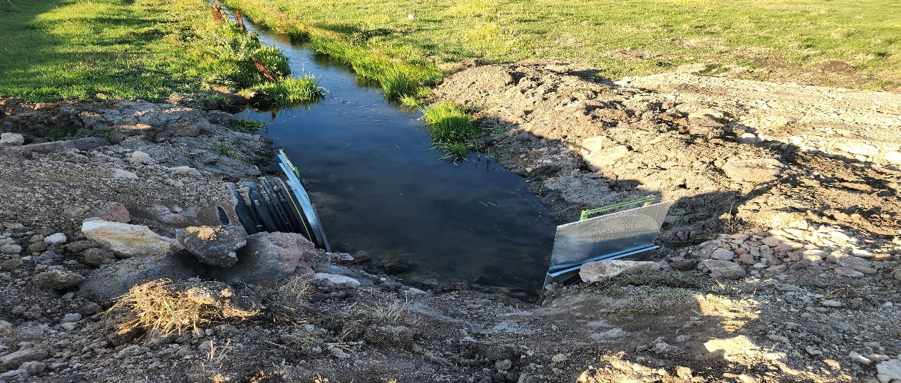

The above photo shows a newly installed diversion structure on the Paris Irrigation canal. BLW Photos.

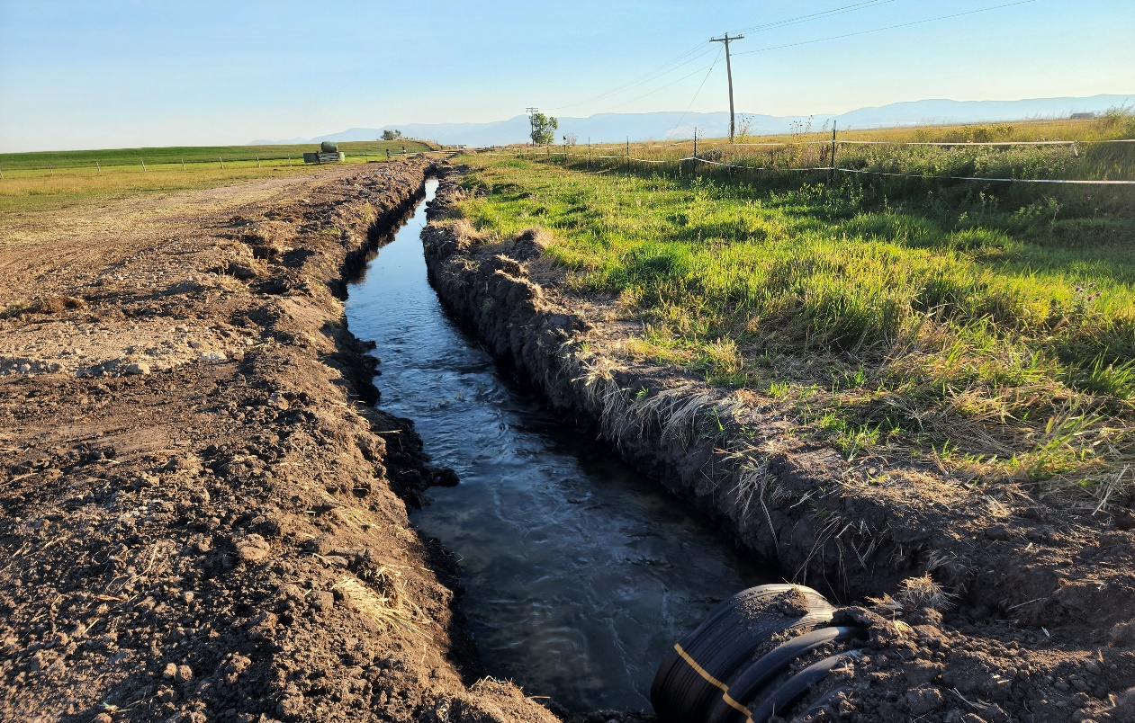

The above photo shows the cleaned canal extending from the other side of the new diversion structure. BLW Photos.

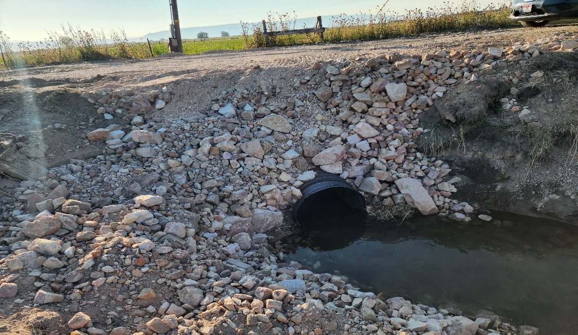

The above photo shows one of the newly installed road crossings on the Paris Irrigation system. BLW Photos.

**Addendum 1**



Darcy Sharp

[Darcy.Sharp@deq.idaho.gov](mailto:Darcy.Sharp@deq.idaho.gov)

(208) 373-0133

December 27, 2023

Load Reduction Estimations for Final Reporting

Prepared for Conservation Basics, LLC.

Bear Lake West Projects

M. Jensen: This project focused on developing a spring for livestock water, fencing the spring/riparian area ~1 Acre, providing off-stream watering for 125 head of cattle. This results in 174 feet of streambank protection. PLET prediction is 1.4 tons sediment.

Windon Ward: This project focused on drilling a well, installing an off stream watering system. This reduced livestock impacts to Ovid Creek by pulling ~200 head of cattle off of Ovid Creek, resulting in 1800 feet of streambank protection. PLET prediction is 13.4 tons sediment.

C Jensen: This project focused on a flood to sprinkler conversion on ~10 acres. Water is taken directly from Ovid creek and returns to Ovid creek. The new system installed a pump and sprinkler system (stationary sprinkler heads) to eliminate flooding and return to the stream. SISL prediction is 5.3 tons per acre per year.

L Eborn: This project focused on Installing a new diversion structure, cleaning the canal, and installing a new road crossing. Improving the diversion structure from rock and tarp to slide gates reduces the amount of in-stream activity. Prior to this work, 6 cubic yards of deposited sediment were removed from the canal every year. Convert the volume of soil to weight using the dry density of silt loam at 0.0425 tons per cubic feet; Convert 6 cubic yards to 162 cubic feet; result is 6.9 tons per year.

C Smith: This project focused on the conversion from flood to sprinkler irrigation. The project saw 160 acres converted from flood to Center Pivot Irrigation. SISL prediction is 4.2 tons per acre per year.

Off-stream watering projects allow eroding streambanks to restore natural functioning. Sediment load reductions are estimated by the direct volume of eroding streambank, calculated in accordance with DEQ’s streambank erosion inventory methods (DEQ 2013). Natural background erosion is subtracted from the current erosive condition. The Pollutant Load Estimation Tool is used to calculate the load reduction for spring development and offsite watering to allow streambank restoration (Table 1).

SISL predictions are used for converting irrigation from flood/furrow to sprinkler. Soil losses from furrow irrigation are widely variable depending on volume and velocity of incoming irrigation water, field slope, soil types, and management practices. However, Bjorneberg (2007) measured soil loss due to furrow irrigation in six plots and found an average 5.2 tons sediment loss per acre. State agronomists consider that conversion to sprinkler irrigation will reduce erosion to near zero.

**Table 1. Sediment and nutrient load reductions from implementing conservation practices in Bear Lake County, ID.**

|  |  |  |  |  |  |
| --- | --- | --- | --- | --- | --- |
| **Project Name/Acreage** | **Model** | **Watershed** | **Load Reduction** | | |
|  |  | **(HUC 12 Code)** | **Sediment**  **(tons/yr)** | **Nitrogen**  **(lbs/yr)** | **Phosphorus**  **(lbs/yr)** |
| M. Jensen Spring Development | PLET | Ovid Creek  (160102010503) | 1.4 | 5 | 2 |
| Ward Stockwater Well  Streambank erosion control | PLET | 13.4 | 43 | 21 |
| C. Jensen 10-acre irrigation conversion | SISL | 53 | 170 | 85 |
| Eborn Diversion Structure | Direct Volume Calculation | Sleight Canyon – Outlet Bear Lake  (160102010306) | 6.9 | 22 | 11 |
| C. Smith 160-acre irrigation conversion | SISL | Threemile Creek – Bear River (160102010604) | 672 | 2150 | 1075 |
|  |  | Totals | 747 | 2390 | 1194 |

References

Bjorneberg, D.L., E.T. Westermann, N.O. Nelson. 2007. Sprinkler and surface irrigation effects on return flow water quality and quantity. USDA ARS Kimberly, ID: 7 p.

Bjorneberg, D.L., C.J. Prestwich, R.G. Evans. 2007. Evaluating the Surface Irrigation Soil Loss (SISL) Model. Applied Engineering in Agriculture. Vol. 23(4): 485-491.

DEQ. 2013. *Standard operating procedure for streambank erosion inventory to measure instream sediment load in wadeable streams.* Boise, ID: Idaho Department of Environmental Quality. 32 p.

Michigan DEQ. 1999. *Section 319 watersheds training manual*. Surface water quality division. Nonpoint source unit. Lansing, MI: 59 p.--Nutrients sorb to silt particles in sediment at an approximate ratio of 1.6 pounds per ton for phosphorus and 3.2 pounds per ton for nitrogen

NRCS. (Natural Resources Conservation Service). 2023. Web Soil Survey.

Sharkoff, J.L. and J.W. Peel. 2013. Estimating soil loss from surface irrigation on cropland: the Surface Irrigation Soil Loss (SISL) model. Agronomy Technical Note No. 63.

Tetra Tech, Inc. 2018. Spreadsheet Tool for the Estimation of Pollutant Load (STEPL) [Spreadsheet Tool for Estimating Pollutant Loads (STEPL) | US EPA](https://www.epa.gov/nps/spreadsheet-tool-estimating-pollutant-loads-stepl?msclkid=8f26c265bcc511ec8d9b9c056fbba388#oldas)

Tetra Tech, Inc. 2022. User’s Guide: Pollutant Load Estimation Tool (PLET) Version 1.0. Developed for U.S. Environmental Protection Agency by TetraTech, Inc.