Geneva Irrigation Final Report

Project S753

Final Report

December 2023

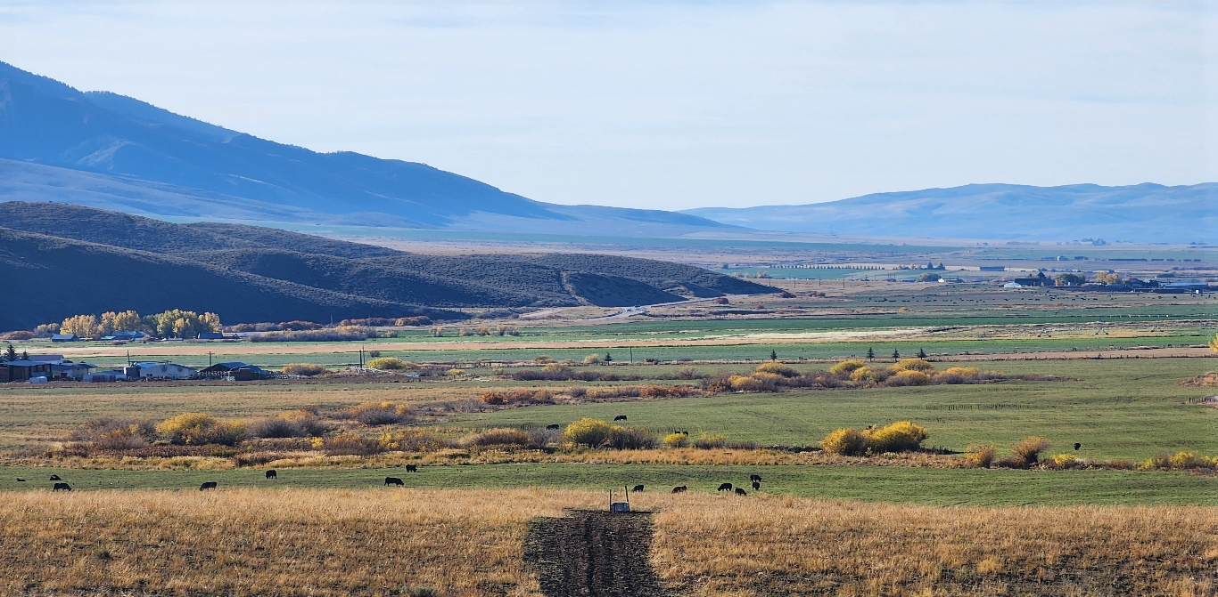

Above. Overview of Price Farms. A newly installed stock water line and trough in the foreground with the pivot irrigation systems installed earlier for this project in the distance. GIP Photos.

Prepared by:

# Conservation Basics LLC

In Cooperation with:

Bear Lake Soil and Water Conservation District

Idaho Soil and Water Conservation Commission

Idaho Department of Environmental Quality

Index

Abbreviations 2

Location Map 3

Project Map 4

Overview 5

Goals 6

Background 7

Load Reductions 8

Monitoring 8

Tours and Outreach 9

Financial Summary 10

Conclusions 10

Acknowledgements 10

Before and after photos, selected projects 12

**Abbreviations**

Idaho Soil and Water Conservation Commission - ISWCC

Conservation Basics LLC-CBLLC

USDA Natural Resources Conservation Service - NRCS

Idaho Department of Environmental Quality - IDEQ

Environmental Protection Agency – EPA

Total Maximum Daily Load – TMDL

Hydrologic Unit Code - HUC

Best Management Practices – BMPs

Stream Evaluation Control Indicator-SECI

Stream Visual Assessment Protocol- SVAP

Bonneville Cutthroat Trout-BCT

Bear Lake Soil and Water Conservation District-BLSWCD

Geneva State Ag Project

Project **S753**

**Overview**

The Bear Lake Soil and Water Conservation District has been very active in promoting voluntary conservation projects the past few years. In April of 2022, BLSWCD began working on a grant application through the State Ag BMP program. This grant would focus on sprinkler-to-sprinkler conversions for two different landowners, and an off-stream watering facility to reduce livestock impacts on sensitive riparian areas. The project wanted to address sediment and nutrient loads to Dry Creek and Thomas Fork Creek.

The primary goal of the Geneva Irrigation project was to focus on a couple different aspects of agriculture throughout the subwatershed. Areas of focus were as follows: Irrigation Improvement, Irrigation Efficiency, Grazing Management, Riparian Zone Protection, and Water Quality and Quantity.

Photo. This photo shows a newly installed solar array and sump well. GI Photos.

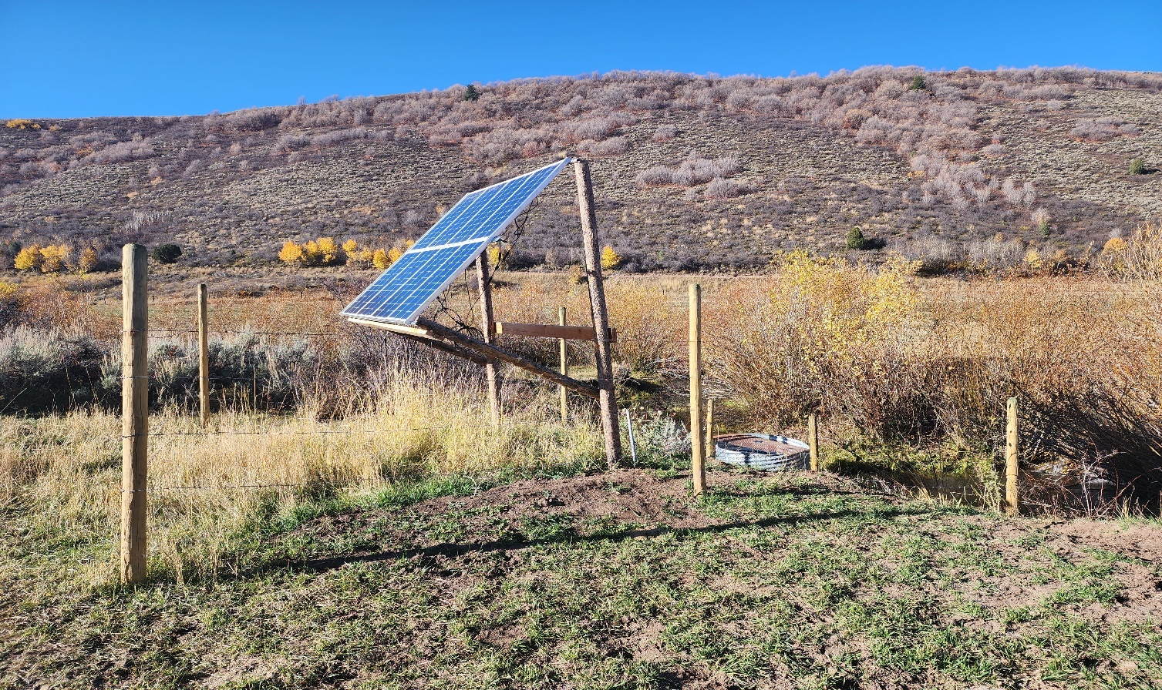

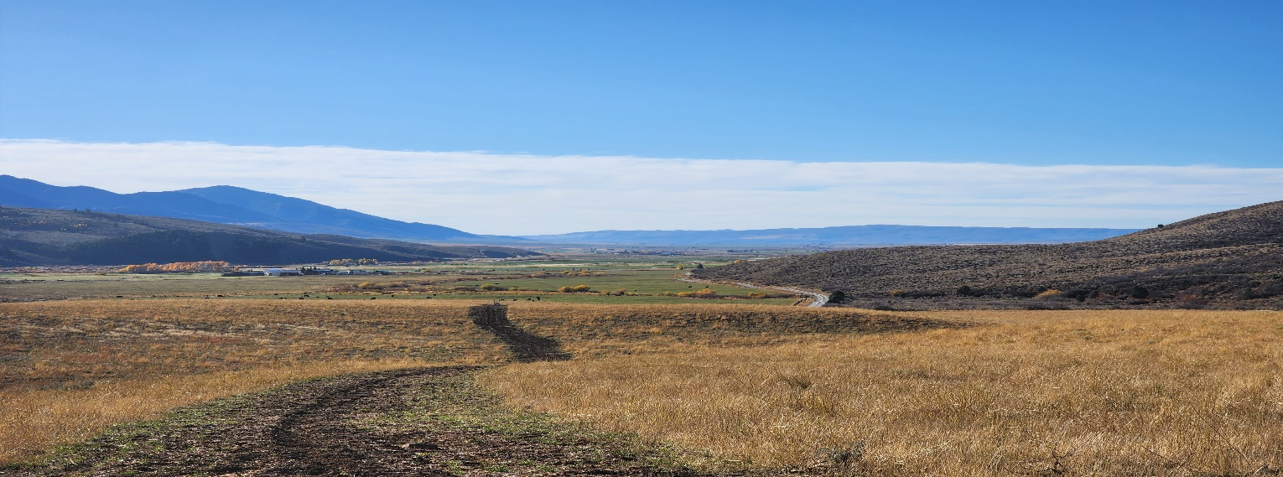

Photo- (Above) This photo shows the trench with the pipe extending from a new spring development and leading to new troughs for livestock . (Below) This photo shows the newly installed riparian fence along Dry Creek. GI Photos. 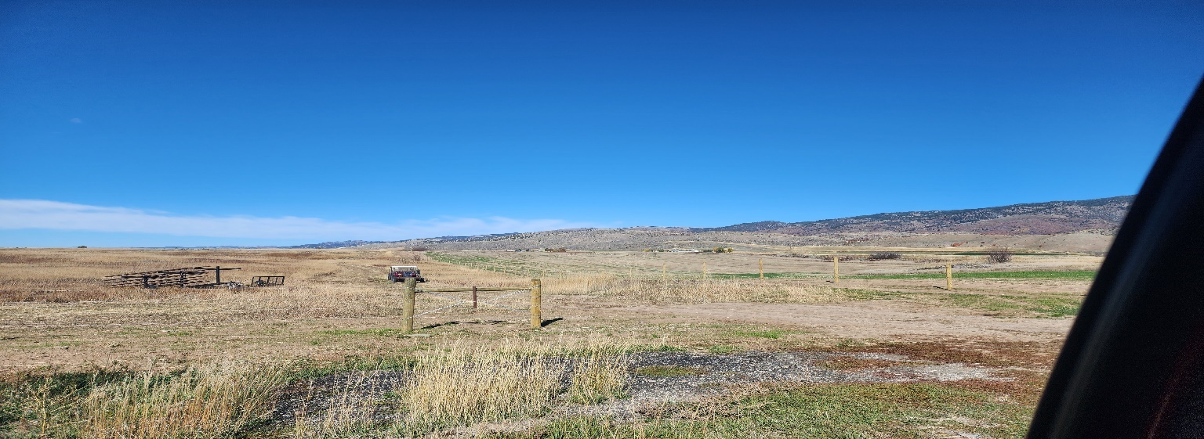

***Goals***

The goals of the Geneva Irrigation Project were to install four center pivot irrigation systems and install a riparian fence along Dry Creek. The project would also focus on installing an off-stream watering system for livestock and to reduce impacts to Dry Creek and the subsequent riparian zone.

These installed BMPs are estimated to last a minimum of 20 years. The focus of the BLSWCD is to provide quality projects which will benefit the landowner and the natural resource.

### Background

The Thomas Fork Subwatershed consists of non-irrigated/dry farms and high elevation range/pastures. Bear Lake County is prone to dry summers and heavy wet winters, which provide for large amounts of runoff in the spring of the year. Summer rain events also provide large amounts of run-off. The high elevations are also prone to frost events and extremely dry conditions characteristic of a high mountain desert.

Conservation efforts in the Bear River Basin support the following criteria which are not only part of Bear Lake SWCD’s five-year plan and goals, but also adheres to the agendas of our participating partners as well.

#### Protect

-Stream habitat and sensitive riparian zones

-Field/Riparian convergence zones

-Permanent vegetative cover

#### Restore

-Riparian habitat, water quality, and water quantity

-Field/Riparian convergence zones

#### Sustain

-Clean water and watersheds through conservation efforts

-Education of landowners and operators within the Thomas Fork Sub Watershed

#### Conservation Impact

The Thomas Fork Subwatershed represents an area which is surrounded by agricultural practices, which can negatively affect the local watershed. By improving and protecting natural resources with conservation practices and willing landowners, the Bear Lake Soil and Water Conservation District is taking large strides to ensure the watershed and the lands throughout the county are being taken care of and will be here for generations to come.

Organizational Structure

The Bear Lake SWCD is comprised of five locally elected board supervisors who serve on a voluntary basis. There is one full-time district employee who is non-voting and serves in an advisory capacity. Technical assistance for this project was provided by Conservation Basics LLC., and the Idaho Soil and Water Conservation Commission.

The Bear Lake SWCD set a goal to implement BMPs within the Bear River Basin, as part of their five-year plan established in 2022. The district wanted to address soil health, overgrazed range and pasture issues, riparian degradation, and irrigation system upgrades for water quantity savings.

The Bear Lake SWCD would like to continue work in the Bear River Basin. The Bear Lake SWCD has a developed list of landowners who have expressed their interest in participating in voluntary conservation projects. The Bear Lake SWCD and Conservation Basics plan to continue submitting 319, State Ag BMP, and WQPA applications to assist the interested parties.

### Cumulative Load Reductions:

The Estimated sediment reductions for the Geneva Irrigation Project located in the Thomas Fork Drainage near Geneva Idaho are:

## Monitoring

Monitoring of the Geneva Irrigation State Ag BMP project consisted of photo monitoring. Monitoring took place with the help of ISWCC Technical Assistance, Bear Lake SWCD Administrative Assistant, participating landowners, and Project Coordinator. Photos are also used to showcase installed BMPs within this report.

*Photo Points*

Photo points were established to show the progress of each BMP before, during, and after installation. These photo points will also be used to track the condition of the BMPs throughout the life span of each project. Photos taken throughout the project are also being used in this final report, as well as in future presentations about this project to showcase to other landowners who might be interested in participating in future 319 or State Ag BMP projects. These projects show other landowner’s different types of BMPs which can be installed to not only improve the environment, but their bottom line as well. The photos shared in this document captured the great work which has taken place through this focused effort to improve water quality in the Thomas Fork Subwatershed. Photos were taken extensively during the entire project. These photos will be used to show the before, during, and after aspects of the project.

## Tours & Outreach

The Bear Lake Board is planning a tour for the summer of 2024 for the board and other community members and landowners to come and view the work which has been completed. Also, representatives from the Idaho Soil and Water Conservation Commission, IDEQ, and State Senators and Representatives will be invited to attend. The tour will increase awareness of the DEQ Non-Point Source, State Ag BMP, and §319 program and showcase the water quality work that could be accomplished with this and similar funding sources.

**Financial Summary \***

|  |  |  |
| --- | --- | --- |
| 319 Payment | Match Amount | Description |
| $25,000 | $0 | Indirect Costs |
| $217,310.40 | $152,273.60 | Subcontractual Costs |
| $3,500 | $2,500 | Travel Costs |
| $0 | $6,750 | Personnel |
| $0 | $2375 | Other/Supplies/Equipment |
| **Total- $245,810.40** | **Total- $163,898.60** | **Total Project- $409,709** |

**Conclusions**

The Geneva Irrigation Project was very successful. The participating landowners were very motivated to accomplish their projects regardless of the challenges of a very long winter and extremely wet summer. The District Supervisors are very satisfied with the quality of work and the amount of conservation which was implemented within the grant timeframe.

The enthusiasm of the participants in completing their projects on time, the hard work of the project coordinator, and the dedication of the engineer helped to make sure this project was completed and that the installed BMPs will have a lasting impact for good stewardship in the Cottonwood Subwatershed.

## Acknowledgements

Current Bear Lake SWCD Board Members Jennifer Jenson, Devin Boehme, James Hardcastle, Todd Lloyd, and Mark Parker wish to thank the project participants, cooperating agencies, and irrigation companies for their support, assistance and hard work enabling the design, implementation, and completion of the Geneva Irrigation Project.

The willingness of the participants to undertake these projects allowed for a great deal of work to be accomplished in the watershed throughout the past year. Thanks to Julia Achabal, Bonnie Yoshizaki, Jenifer Cornell, and Steven Smith of IDEQ for their support and assistance.

The Bear Lake Soil and Water Conservation District sends thanks to Chris Banks, project coordinator of

Conservation Basics, LLC. Also, the Bear Lake SWCD would like to thank Brandee Wells, Bear Lake SWCD District Manager, for her efforts in keeping track of all the financials and managing the paperwork coming from each of the different aspects of the project.

Bear Lake SWCD wishes to thank Shad Mills Bear Lake and Caribou NRCS team lead. BLSWCD Thanks George Hitz, ISWCC. He is amazing and has been a huge asset to our team!

# Photo Documentation of BMPS Installed Throughout the Project

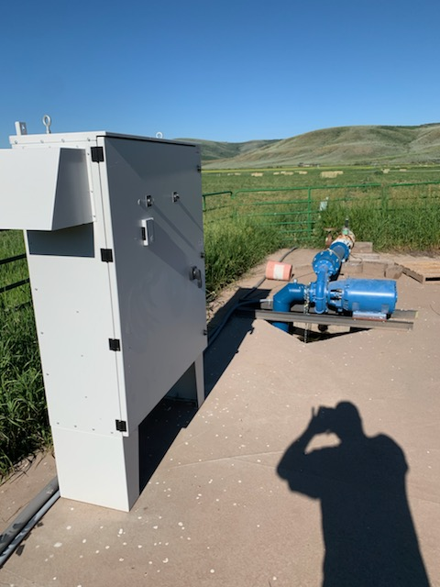

The above photo shows a newly installed VFD and Pumping Plant which supplies water to both newly installed pivots. GI Photos.

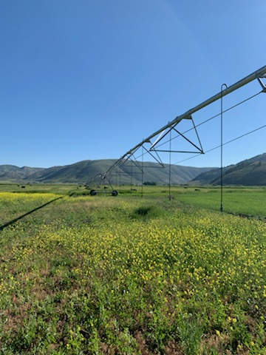

The above photo shows one of the newly installed Pivots. The below photo shows one of the pivot centers with a dragon filter. GI Photos.

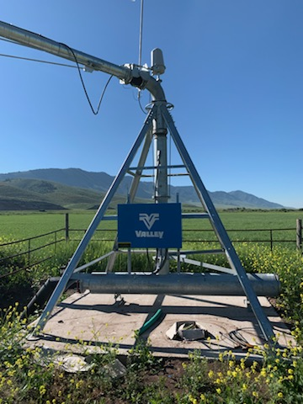

The below photo shows one of the newly installed Boehme pivots. GI Photos.

