Georgetown Irrigation Final Report

Project S755

Final Report

December 2023

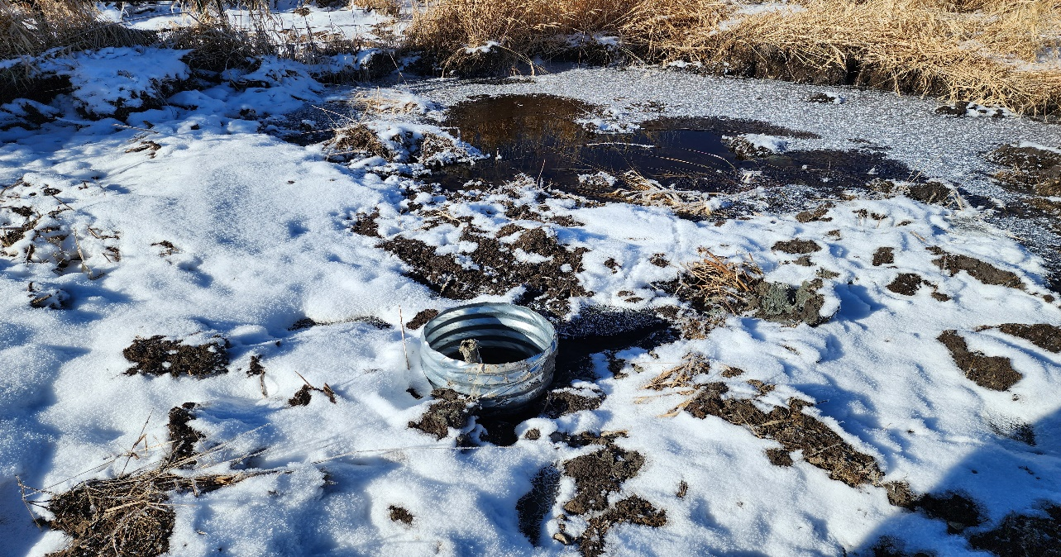

Above. Newly installed sump on the edge of a spring which will supply stock water and reduce livestock impacts to the riparian area. Gtwn Photos.

Prepared by:

# Conservation Basics LLC

In Cooperation with:

Bear Lake Soil and Water Conservation District

Idaho Soil and Water Conservation Commission

Idaho Department of Environmental Quality

Index

Abbreviations 2

Location Map 3

Project Map 4

Overview 5

Goals 6

Background 6

Load Reductions 7

Monitoring 8

Tours and Outreach 8

Financial Summary 9

Conclusions 9

Acknowledgements 10

Before and after photos, selected projects 11

Addendum 1 14

**Abbreviations**

Idaho Soil and Water Conservation Commission - ISWCC

Conservation Basics LLC-CBLLC

USDA Natural Resources Conservation Service - NRCS

Idaho Department of Environmental Quality - IDEQ

Environmental Protection Agency – EPA

Total Maximum Daily Load – TMDL

Hydrologic Unit Code - HUC

Best Management Practices – BMPs

Stream Evaluation Control Indicator-SECI

Stream Visual Assessment Protocol- SVAP

Bonneville Cutthroat Trout-BCT

Bear Lake Soil and Water Conservation District-BLSWCD

Georgetown Irrigation State Ag Project

Project **S755**

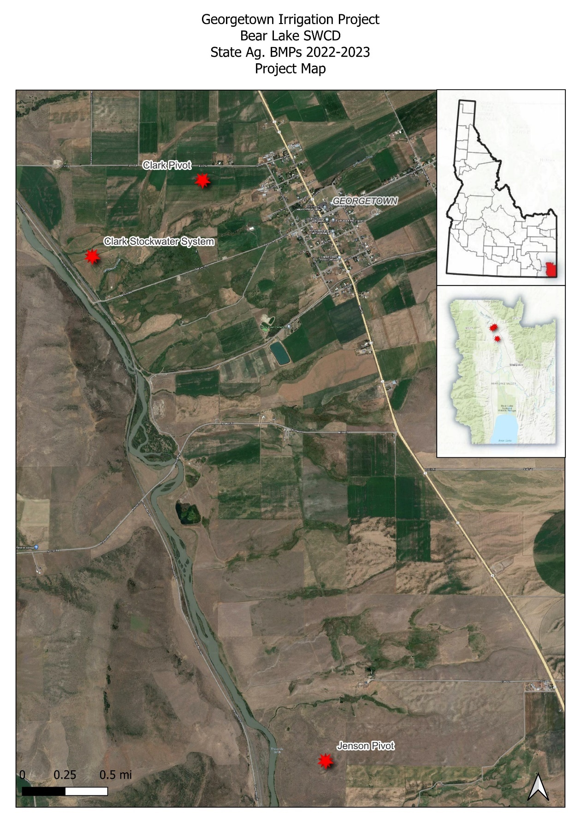

**Overview**

The Bear Lake Soil and Water Conservation District has been very active in promoting voluntary conservation projects the past few years. In April of 2022, BLSWCD began working on a grant application through the State Ag BMP program. This grant would focus on sprinkler-to-sprinkler conversions for two different landowners, and an off-stream watering facility to reduce livestock impacts on sensitive riparian areas. The project wanted to address sediment and nutrient loads to Georgetown Creek and the Bear River.

The primary goal of the Georgetown Irrigation project was to focus on a couple of different aspects of agriculture throughout the subwatershed. Areas of focus were as follows: Irrigation Improvement, Irrigation Efficiency, Grazing Management, Riparian Zone Protection, and Water Quality and Quantity.

Photo. This photo shows a newly installed water trough. Steven Smith, IDEQ, visits the site with Chris Banks, Conservation Basics LLC., Gtwn. Photos.

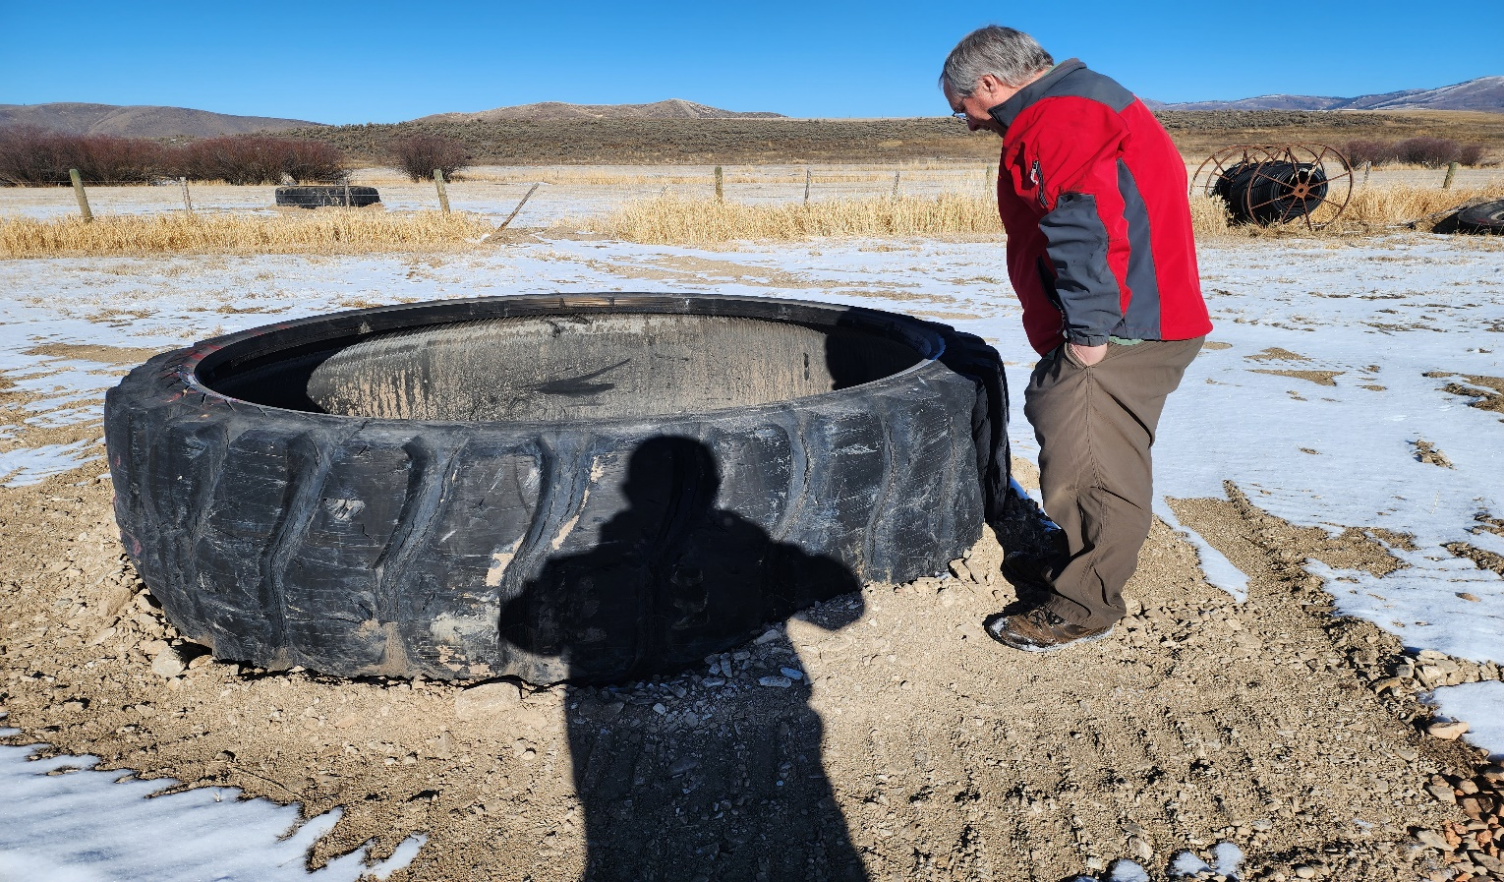

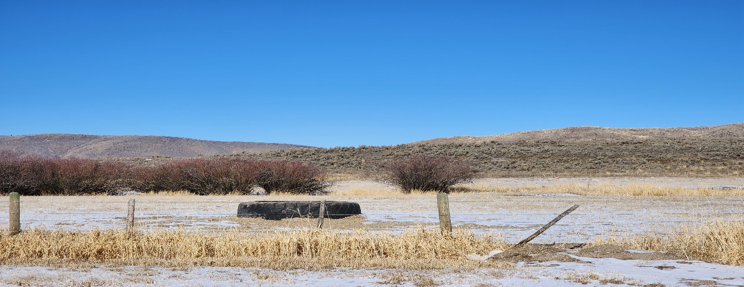

Photo- (Above) This photo shows one of the two troughs installed as part of the Georgetown Irrigation Project. Grgtwn Irrigation Photos.

***Goals***

The goals of the Georgetown Irrigation Project were to install two center pivot irrigation systems and install a riparian fence around spring/seep. The project would also focus on installing an off-stream watering system for livestock and to reduce impacts to a spring/seep and the subsequent riparian zone.

These installed BMPs are estimated to last a minimum of 20 years. The focus of the BLSWCD is to provide quality projects which will benefit the landowner and the natural resource.

**Background**

The Georgetown Creek Subwatershed consists of non-irrigated/dry farms and high elevation range/pastures. Bear Lake County is prone to dry summers and heavy wet winters, which provide for large amounts of runoff in the spring of the year. Summer rain events also provide large amounts of run-off. The high elevations are also prone to frost events and extremely dry conditions characteristic of a high mountain desert.

Conservation efforts in the Bear River Basin support the following criteria which are not only part of Bear Lake SWCD’s five-year plan and goals, but also adhere to the agendas of our participating partners as well.

**Conservation Impact**

The Georgetown Creek Subwatershed represents an area which is surrounded by agricultural practices, which can negatively affect the local watershed. By improving and protecting natural resources with conservation practices and willing landowners, the Bear Lake Soil and Water Conservation District is taking large strides to ensure the watershed and the lands throughout the county are being taken care of and will be here for generations to come.

**Organizational Structure**

The Bear Lake SWCD is comprised of five locally elected board supervisors who serve on a voluntary basis. There is one full-time district employee who is non-voting and serves in an advisory capacity. Technical assistance for this project was provided by Conservation Basics LLC., and the Idaho Soil and Water Conservation Commission.

The Bear Lake SWCD set a goal to implement BMPs within the Bear River Basin, as part of their five-year plan established in 2022. The district wanted to address soil health, overgrazed range and pasture issues, riparian degradation, and irrigation system upgrades for water quantity savings.

The Bear Lake SWCD would like to continue work in the Bear River Basin. The Bear Lake SWCD has a developed list of landowners who have expressed their interest in participating in voluntary conservation projects. The Bear Lake SWCD and Conservation Basics plan to continue submitting 319, State Ag BMP, and WQPA applications to assist the interested parties.

### Cumulative Load Reductions:

The Estimated sediment reductions for the Georgetown Irrigation Project located in the Georgetown Creek Subwatershed near Georgetown, Idaho are:

## Monitoring

Monitoring of the Georgetown Irrigation State Ag BMP project consisted of photo monitoring. Monitoring took place with the help of ISWCC Technical Assistance, Bear Lake SWCD Administrative Assistant, participating landowners, and Project Coordinator (Conservation Basics LLC.) Photos are also used to showcase installed BMPs within this report.

**Photo points**

Photo points were established to show the progress of each BMP before, during, and after installation. These photo points will also be used to track the condition of the BMPs throughout the life span of each project. Photos taken throughout the project are also being used in this final report, as well as in future presentations about this project to showcase to other landowners who might be interested in participating in future 319 or State Ag BMP projects. These projects show other landowners’ different types of BMPs which can be installed to not only improve the environment, but their bottom line as well. The photos shared in this document captured the great work which has taken place through this focused effort to improve water quality in the Georgetown Creek Subwatershed. Photos were taken extensively during the entire project. These photos will be used to show the before, during, and after aspects of the project.

## Tours & Outreach

The Bear Lake Board toured both the Jenson and Clark sites in the fall of 2022 as part of their annual project tour. Several landowners and other community members came to view the work which had been completed. Also, representatives from the Idaho Soil and Water Conservation Commission, IDEQ, and State Senators and Representatives were invited to attend. The tour will increase awareness of the DEQ Non-Point Source, State Ag BMP, and §319 program and showcase the water quality work that could be accomplished with this and similar funding sources.

**Financial Summary \***

|  |  |  |
| --- | --- | --- |
| 319 Payment | Match Amount | Description |
| $21,500 | $0 | Indirect Costs |
| $183,428.57 | $127,370.71 | Subcontractual Costs |
| $3,500.00 | $4,500 | Travel Costs |
| $0 | $750.00 | Personnel |
| $0 | $6,214.48 | Other/Supplies/Equipment |
| **Total- $208,428.57** | **Total- $138,835.19** | **Total Project- $347,263.76** |

**Conclusions**

The Georgetown Irrigation Project was very successful. The participating landowners were very motivated to accomplish their projects regardless of the challenges of a very long winter and extremely wet summer. The District Supervisors are very satisfied with the quality of work and the amount of conservation which was implemented within the grant timeframe.

The enthusiasm of the participants in completing their projects on time, the hard work of the project coordinator, and the dedication of the engineer helped to make sure this project was completed and that the installed BMPs will have a lasting impact for good stewardship in the Georgetown Subwatershed.

## Acknowledgements

Current Bear Lake SWCD Board Members Jennifer Jenson, Devon Boehme, James Hardcastle, Todd Lloyd, and Mark Parker wish to thank the project participants, cooperating agencies, and irrigation companies for their support, assistance and hard work enabling the design, implementation, and completion of the Georgetown Irrigation Project.

The willingness of the participants to undertake these projects allowed for a great deal of work to be accomplished in the watershed throughout the past year. Thanks to Sherry Thomas and Steven Smith of IDEQ for their support and assistance.

The Bear Lake Soil and Water Conservation District sends thanks to Chris Banks, project coordinator of Conservation Basics, LLC. Also, the Bear Lake SWCD would like to thank Brandee Wells, Bear Lake SWCD District Administrative Assistant, for her efforts in keeping track of all the financials and managing the paperwork coming from each of the different aspects of the project.

Bear Lake SWCD wishes to thank Shad Mills Bear Lake and Caribou NRCS team lead. BLSWCD Thanks George Hitz, ISWCC. He is amazing and has been a huge asset to our team!

# Photo Documentation of BMPS Installed Throughout the Project

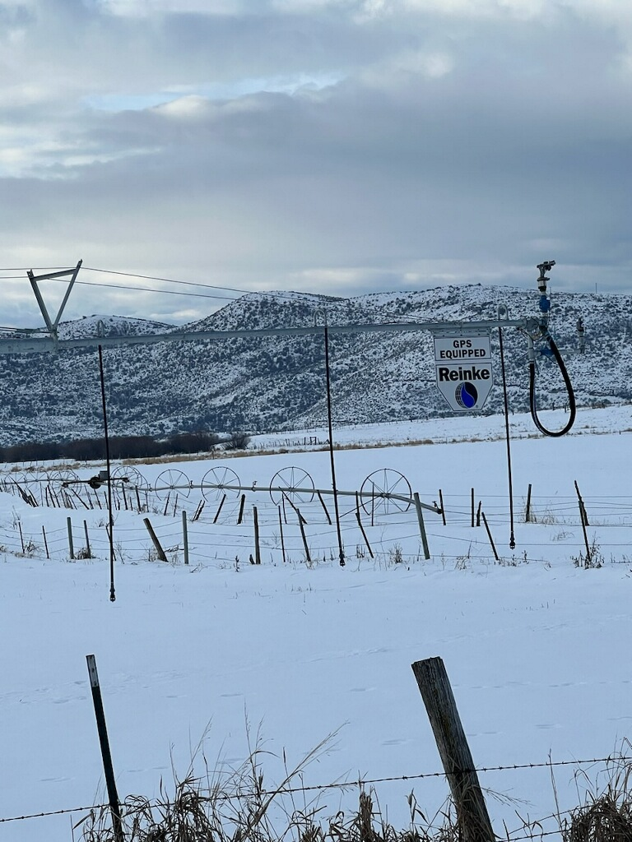

The above photo shows a newly installed pivot. Gtwn Irrigation Photos.

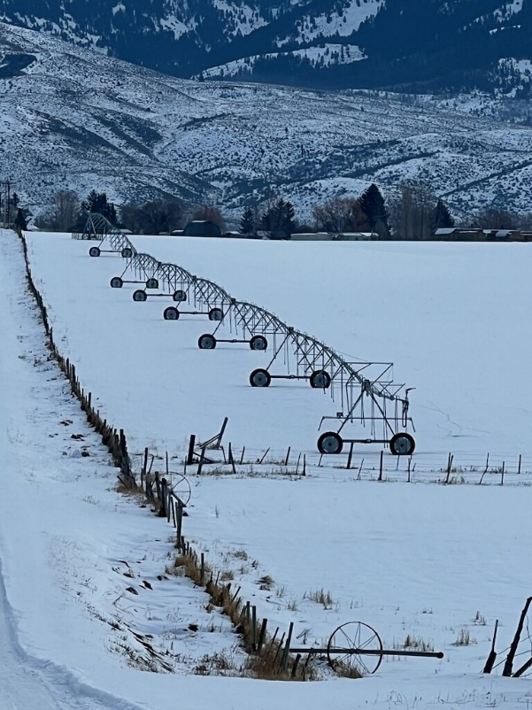

The above photo shows one of the newly installed Pivots. The below photo shows one of the pivot centers with a dragon filter. Gtwn Irrigation Photos.

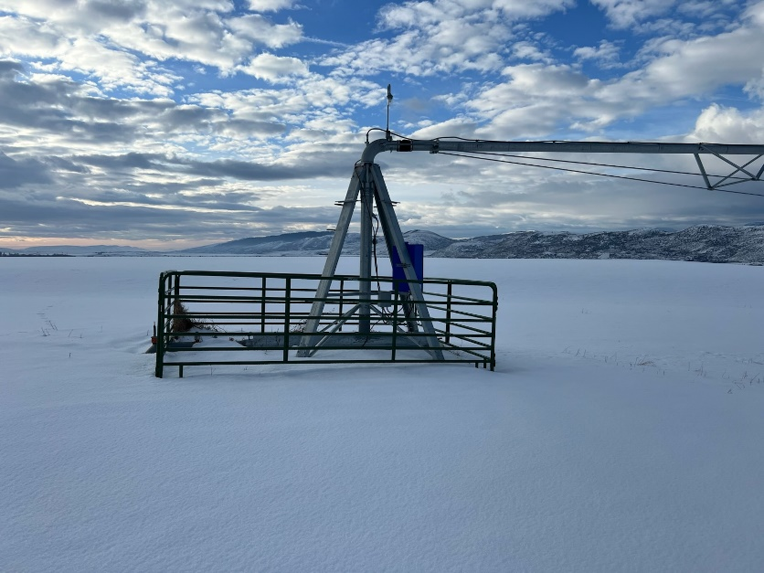

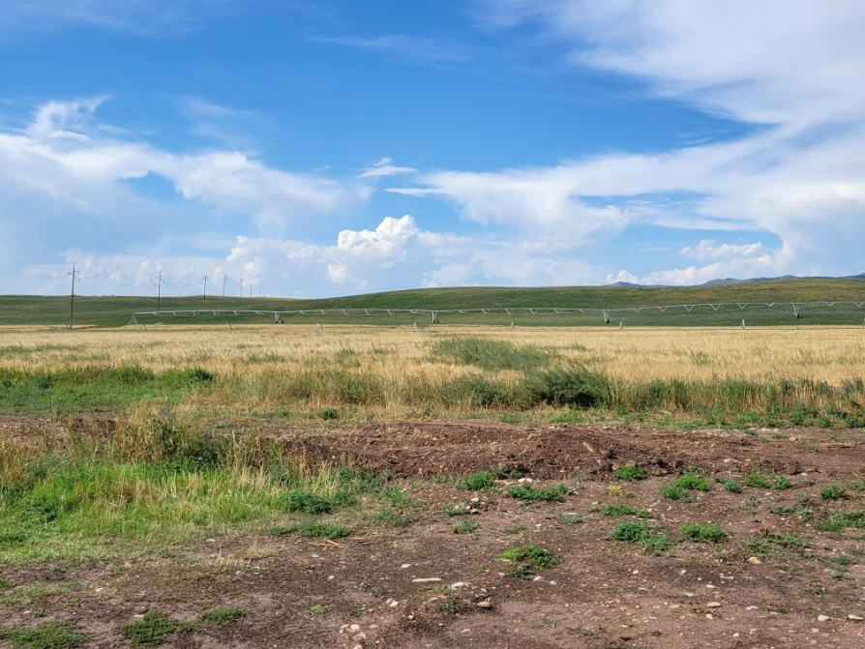

(Above) This photo shows the Jenson Pivot after installation and the trench with the buried mainline. Gtwn Irrigation Photos.

**Addendum 1**

**Load Reduction Report**

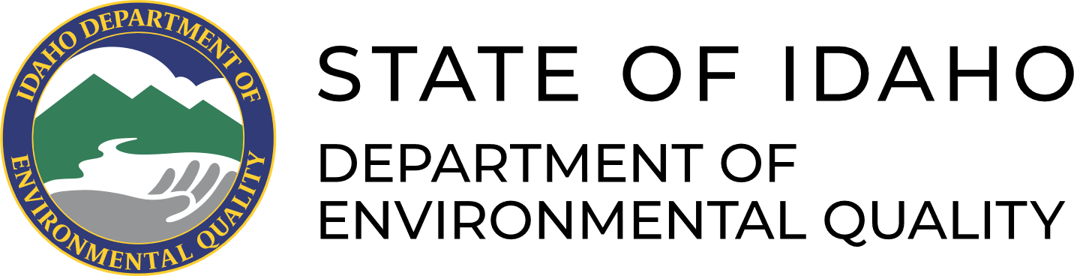

Darcy Sharp

[Darcy.Sharp@deq.idaho.gov](mailto:Darcy.Sharp@deq.idaho.gov)

(208) 373-0133

December 27, 2023

Load Reduction Estimations for Final Reporting

Prepared for Conservation Basics, LLC.

Georgetown Irrigation Projects

Jenson Sprinkler to Sprinkler: This project focused on installing new mainline and converting 3 old mainlines to center pivot irrigation. The acreage affected by this change in irrigation was approximately 160 acres. Handlines = 0.1 tons per acre per year.

Clark Sprinkler to Sprinkler: This project focused on replacing 4 wheelines to a pivot irrigation system. 160 Acres were affected by this change. Handlines = 0.1 tons per acre per year.

Clark Spring Development and Riparian Fence: This project focused on developing a spring and installing an off-stream watering system. This system will provide water for approximately 125 head of cattle. 125 feet of streambank were protected through this project.

SISL predictions are used for converting irrigation from flood/furrow to sprinkler. Soil losses from furrow irrigation are widely variable depending on volume and velocity of incoming irrigation water, field slope, soil types, and management practices. However, Bjorneberg (2007) measured soil loss due to furrow irrigation in six plots and found an average 5.2 tons sediment loss per acre. State agronomists consider that conversion to sprinkler irrigation will reduce erosion to near zero.

Off-stream watering and fencing projects allow eroding streambanks to restore natural functioning. Sediment load reductions are estimated by the direct volume of eroding streambank, calculated in accordance with DEQ’s streambank erosion inventory methods (DEQ 2013). Natural background erosion is subtracted from the current erosive condition. The Pollutant Load Estimation Tool is used to calculate the load reduction for spring development and offsite watering to allow streambank restoration (Table 1).

**Table 1. Sediment and nutrient load reductions from implementing conservation practices in Bear Lake County, ID.**

|  |  |  |  |  |  |
| --- | --- | --- | --- | --- | --- |
| **Project Name/Acreage** | **Model** | **Watershed** | **Load Reduction** | | |
|  |  | **(HUC 12 Code)** | **Sediment**  **(tons/yr)** | **Nitrogen**  **(lbs/yr)** | **Phosphorus**  **(lbs/yr)** |
| Jensen Sprinkler | SISL | Threemile Creek – Bear River (160102010604) | 16 | 51 | 26 |
| Clark Sprinkler | SISL | Big Canyon – Bear River (160102010606) | 16 | 51 | 26 |
| Clark Riparian Fencing | PLET | 1 | 3 | 2 |
|  |  | Totals | 33 | 105 | 54 |

References

Bjorneberg, D.L., E.T. Westermann, N.O. Nelson. 2007. Sprinkler and surface irrigation effects on return flow water quality and quantity. USDA ARS Kimberly, ID: 7 p.

Bjorneberg, D.L., C.J. Prestwich, R.G. Evans. 2007. Evaluating the Surface Irrigation Soil Loss (SISL) Model. Applied Engineering in Agriculture. Vol. 23(4): 485-491.

DEQ. 2013. *Standard operating procedure for streambank erosion inventory to measure instream sediment load in wadeable streams.* Boise, ID: Idaho Department of Environmental Quality. 32 p.

Michigan DEQ. 1999. *Section 319 watersheds training manual*. Surface water quality division. Nonpoint source unit. Lansing, MI: 59 p.--Nutrients sorb to silt particles in sediment at an approximate ratio of 1.6 pounds per ton for phosphorus and 3.2 pounds per ton for nitrogen

NRCS. (Natural Resources Conservation Service). 2023. Web Soil Survey.

Sharkoff, J.L. and J.W. Peel. 2013. Estimating soil loss from surface irrigation on cropland: the Surface Irrigation Soil Loss (SISL) model. Agronomy Technical Note No. 63.

Tetra Tech, Inc. 2018. Spreadsheet Tool for the Estimation of Pollutant Load (STEPL) [Spreadsheet Tool for Estimating Pollutant Loads (STEPL) | US EPA](https://www.epa.gov/nps/spreadsheet-tool-estimating-pollutant-loads-stepl?msclkid=8f26c265bcc511ec8d9b9c056fbba388#oldas)

Tetra Tech, Inc. 2022. User’s Guide: Pollutant Load Estimation Tool (PLET) Version 1.0. Developed for U.S. Environmental Protection Agency by TetraTech, Inc.