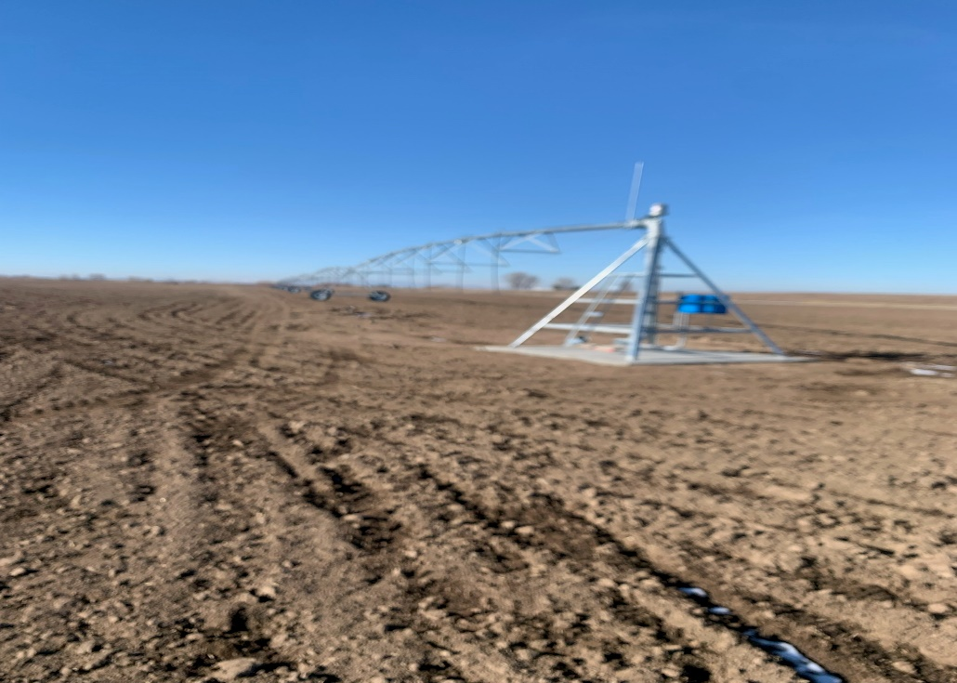

Kinghorn Farms Project Final Report
December 2023
Project #3514

Prepared by Conservation Basics LLC

Background
Kinghorn farms in partnership with conservation basics applied for a state ag bmp grant in April 2023. Calvin Kinghorn approached conservation Basics with the project proposal and working together an application was submitted. The primary goals and focus of this project were to reduce sediment and nutrient inputs to the Snake River through the conversion of flood irrigation to sprinkler irrigation. 191 acres were converted from flood to sprinkler.

Project Location
The Kinghorn Farms project is located approximately five miles West of Lewisville, Idaho. Kinghorn Farms receives water from the Snake River which travels through ditches and canals to their farm. Then when water leaves the fields its goes back to the river through a series of other canals and ditches. Also, the proximity of the field to the river allows for some runoffs to return to the river. Converting from flood to sprinkler will nearly eliminate sediment and nutrient inputs to the Snake River.
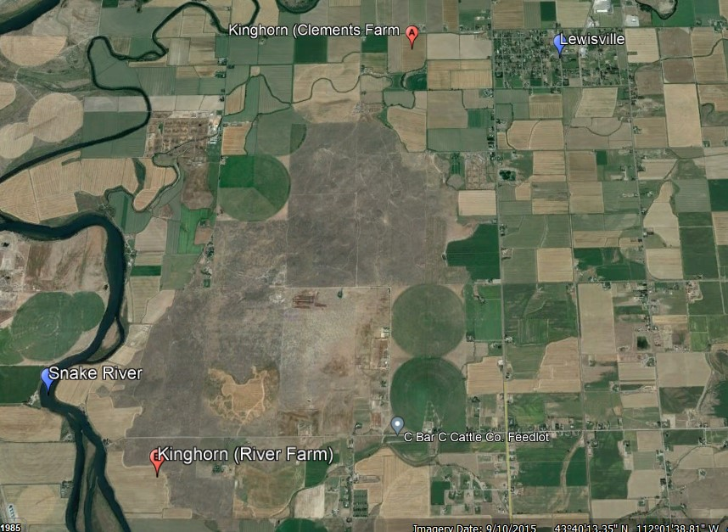

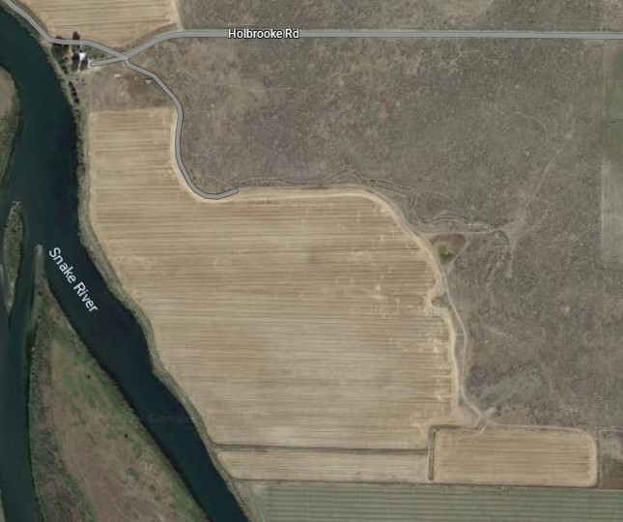

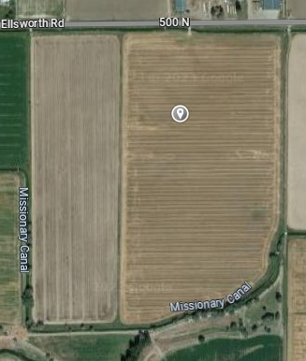

Load Reductions
Nitrogen | 1005 | Lbs./Year
Phosphorus | 502 | Lbs./Year
Sediment | 314 | Tons/Year
*Calculations for load reductions provided by Darcy Sharp, IDEQ.

Financial Summary
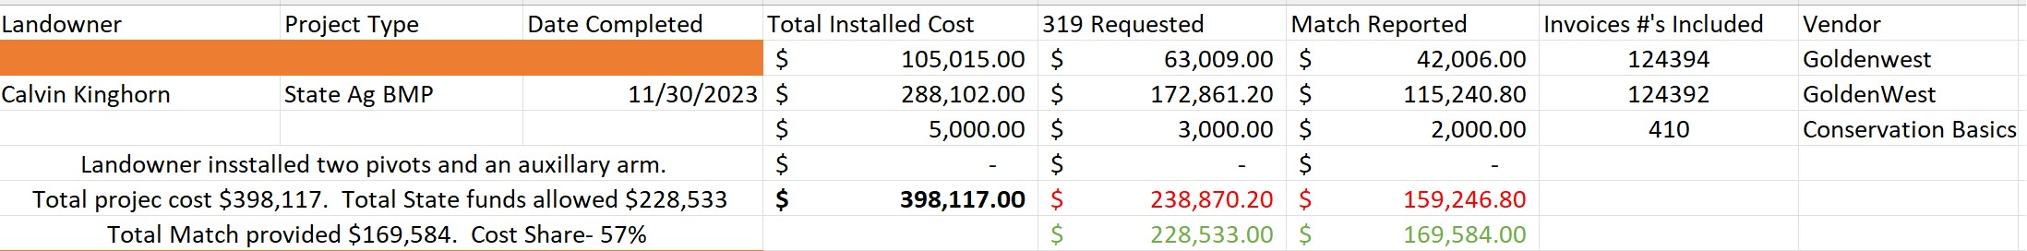
Conclusions
The Kinghorn Farms project was very successful. The Kinghorn family was very easy to work with and were eager to complete the project. Golden West Irrigation was able to work in a timely fashion and install the needed mainline and center pivot irrigation systems. Chris Banks, Conservation Basics, would like to thank IDEQ for their support and efforts throughout the course of the project. Sherry Thomas (IDEQ) was extremely helpful and great to work with throughout the installation and closeout of the project.
Photo Documentation

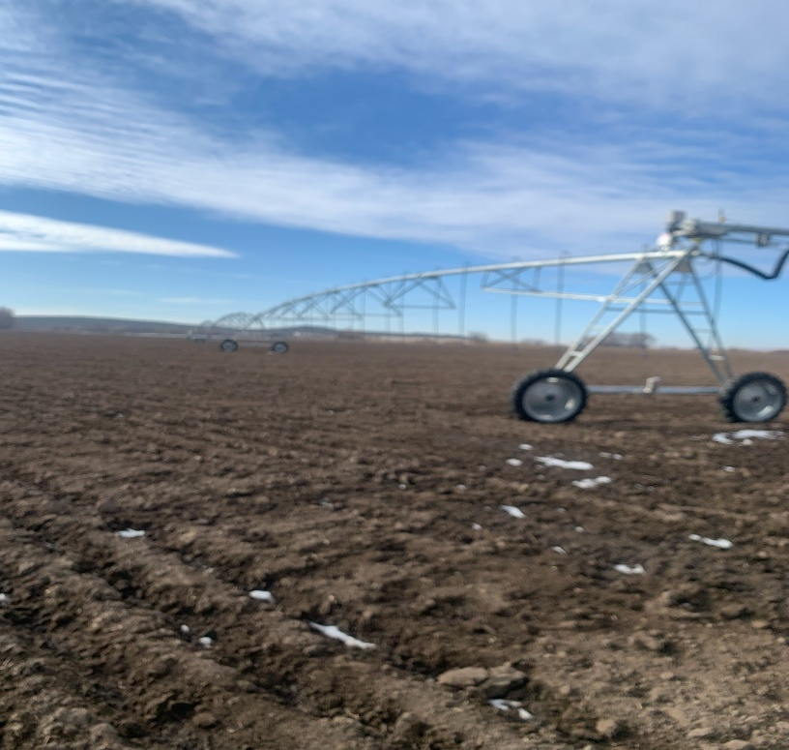

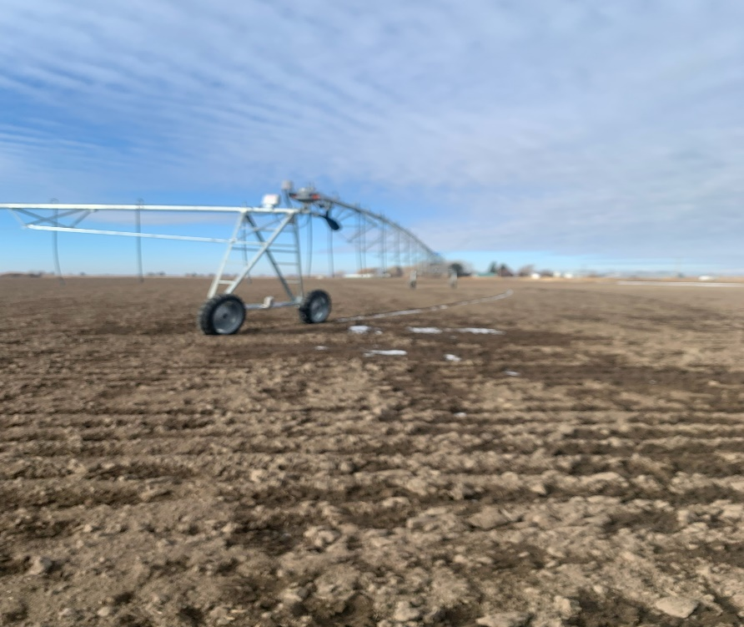
The above photos show the smaller of the two pivots installed with the auxiliary or corner arm system. This is one of the pivots installed in conversion from flood to sprinkler.

