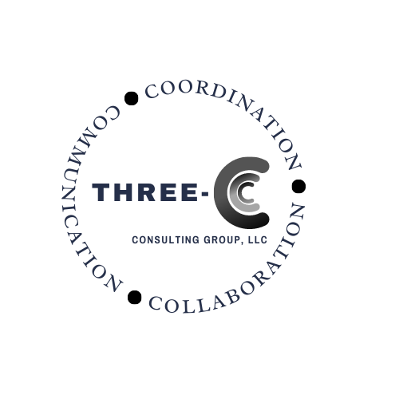

**Mitchel Craig Rothholz, R.Ph., MBA**

Mitchel C. Rothholz is a pharmacist with almost 40 years of organizational, advocacy and practice management experience. He retired from full-time employment after 28 years from the American Pharmacists Association. His last positions were Chief of Governance & State Affiliates and Executive Director of the APhA Foundation responsible for the development and coordination of the organization’s strategic plan/direction, governance and policy development activities, state relations, public health initiatives and activities of the APhA Foundation. He served in numerous roles as an APhA staff member since 1994. He also currently serves as Secretary for the Joint Commission of Pharmacy Practitioners (JCPP), a collaborative forum of 13 national pharmacist organizations. He is a 1984 graduate of the University of Florida, College of Pharmacy, and earned a Masters in Business Administration, Healthcare Management, from Regis University in 2005. He has served as the Executive Director of the Alabama Pharmacy Association (1989-1994) and worked in numerous roles for the Florida Pharmacy Association (1984-1989). He has practical experience in community (both chain and independent) pharmacy, nursing home, hospital, and managed care practice settings.

Rothholz is a globally recognized expert on Pharmacy-Based Immunization Delivery and has actively engaged in activities to expand pharmacist authority and recognition as valued members of the healthcare team, and patient access to pharmacists’ patient care services. He has been recognized for coining the concept of “immunization neighborhoods”, a patient-centered approach where stakeholders, through collaboration, coordination and communication address the needs of individuals and communities. This same approach can be utilized across numerous chronic diseases and public health issues. He was a voting member of the United States Health and Human Services (HHS) National Vaccine Advisory Committee (NVAC) from September 2012-February 2017. He currently serves on the Leadership Steering Committee of the National Adult and Influenza Immunization Summit (NAIIS), Adult Vaccine Access Coalition, and HHS - NVAC Working Groups. He was a member of the American College of Physicians (ACP) Advisory Board for Patient Partnership in Healthcare, the Advisory Board of the Immunization Action Coalition, and a Subject Matter Expert for the American Medical Group Association (AMGA) Immunization Collaborative. He is a board member of the Unity Coalition (Adolescent Health Coalition), board member of the National Down Syndrome Congress (NDSC) and co-chair of the Pennsylvania Down Syndrome Advocacy Coalition (PDSAC) and CHOP T-21 Buddy Walk. In 2019 he completed a Fellowship in the US Senate Aging Committee under Senator Bob Casey (PA).

He has assisted numerous pharmacists globally in implementing immunization and other patient care services. He has worked on projects involving collaboration among pharmacists, physicians and other healthcare professionals. In addition to public health, he has actively engaged in activities related to pharmacists’ patient care processes, healthcare professional well-being, payment reform, disability advocacy, and policy development related to pharmacy practice, immunizations, disabilities and organizational management.

During COVID he is an active member of numerous task forces and workgroups, Co-chair of the ASTHO/APhA National Association’s COVID Vaccine Leadership Council, collaborator with HHS and CDC, active contributor within APhA’s and the profession’s COVID response efforts, and media spokesperson. He is a member of the leadership team for the Skippack Pharmacy COVID Task Force whose work with 700 community volunteers has led to more than 80,000 COVID-19 vaccinations being administered within his community.